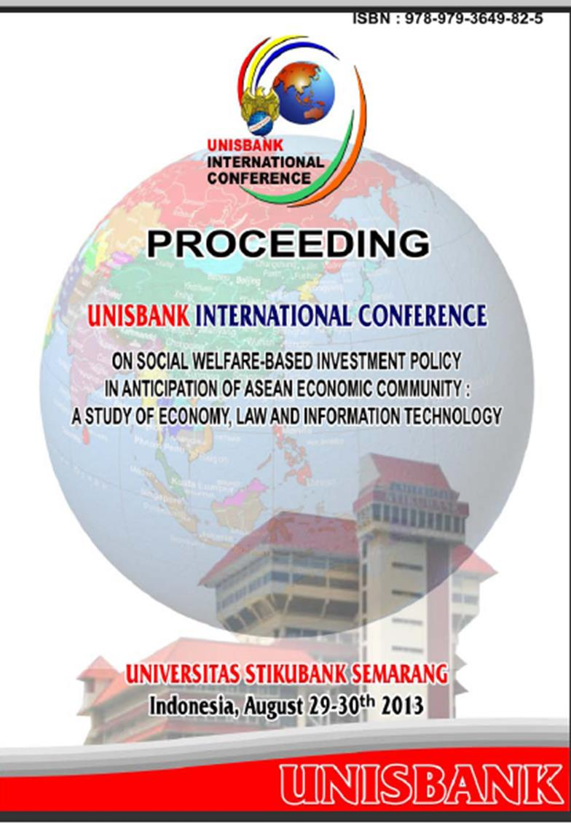

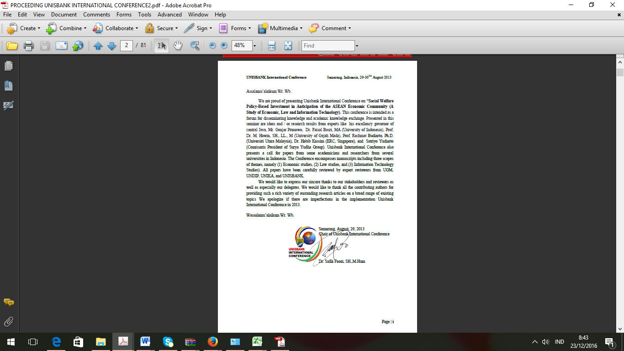

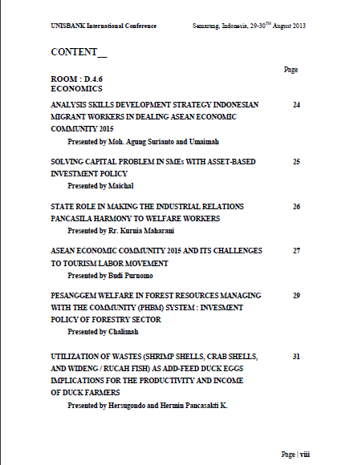

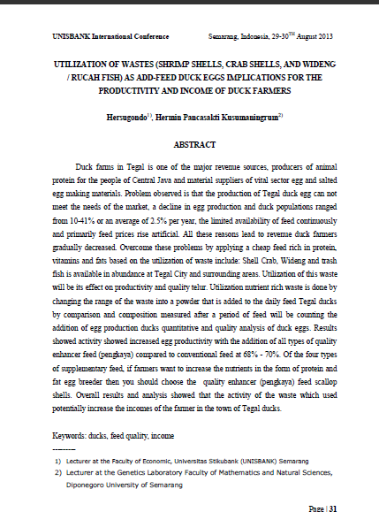

Utilization og Wastes (Shrimp Shells, Crab Shells and Wideng/Rucah Fish)as add feed Duck Eggs : Implication for The Productivity and Income of Duck Farmer
Hersugondo¹⁾, Hermin Pancasakti Kusumaningrum²⁾,
- Fakultas Ekonomi Universitas Stikubank, Jl. Kendeng V Bendan Ngisor. Semarang
- Jurusan Biologi, Fakultas Matematika dan Ilmu Pengetahuan Alam, Universitas Diponegoro,
Jl. Prof. Soedarto, UNDIP, Tembalang, Semarang. 50275.

Abstract

The production and the quality of eggs ducks tending to decrease comparing with their demand. High producing of sustainable scallops shell wastes as marine by product offering potency as a source of feed alternative that can be used feed supplement for ducks .Their utilization will also reduce environmental problems.The research carried out by application of scallops shell wastes as daily feed additive for ducks to increase their egg production comparing with natural feed. Their effect on duck growth and survival will also recorded followed by economic value analysis. The research result shoed that application of scallops shell wastes as feed enrichment was increase egg number 65-70% and weigh 1-4,3%. Their also supported the growth and survival of ducks. This result have the implication with the income of duck farmer in Tegal. Economic calculation also supported the result although their effect was not so significant.

Keywords : suck, shell scallops, income, feed

- Introduction
Indonesia having third position related with duck egg production after China and Vietnam. Meanwhile, Tegal which was one of the cities on the northern coast of Java, has a very high population of ducks in Central Java after Brebes regency and Klaten ie 257 to 490 in 2008 (Central Java, in Figures 2009). Breeding ducks in Tegal is one of the main source of livelihood which the egg became a source of animal protein and a supplier of raw material for making salted eggs. In Tegal and surrounding areas we can found about 778 of duck farmers and clustered into 10 groups of duck farmer (KTTI). Unfortunately, duck egg production in Tegal tend to decreases which approximately 2.5% each year. One of the major problem was the limited availability of sustainability food source, especially in the wet season was very difficult to get fish as feed mixtures. Source and composition of the feed is very important for duck egg production. Fish is one of main source of protein production for ducks egg. The protein reduction by 2% will drop egg production untill 15%. However, decreased egg production can be overcome by using high feed nutrition enrichment from another sources like scallop shells (Amosium pleuronectes). It was very abundance in Tegal which about 6 tons each day so they becomes waste. Instead of scallop shells, Tegal also produce a lot of waste of crab (Scylla serrata), wideng ( Sesarma spp.) and trash fish. This various wastes were rich in protein, vitamins, fats and minerals which has not been used optimally as feed ducks enrichment. The influence of waste to the production and weight of duck eggs also has not been measured untill now. Waste of scallop shells is expected to be one way of application of natural feed as an alternative feed sources, feed diversification and feed enrichment. It can also be a help solve environmental problems due to the impact of waste through the revitalization of environmental capacity feed resources.

b. Material and Methods
The research was conducted on Duck Ranch on Pesurungan Lor, District Margadana, Tegal. The laboratory analysis was performed on Genetics Laboratory, Faculty of Mathematics and Natural Sciences, Diponegoro University, Semarang. The material used is scallop shells waste, which is modified into flour using a grinding machine. The feed enrichment was weighted according to the duck feed formula calculated from comparison needs of supplement feed and nutritional needs. Experimental animals used in this study is Tegal ducks (Anas moschata). Observations were made on five cage using 25 ducks which were divided into two groups. One group as treatment group consist of 5 laying ducks and one group as a control group. Each treatment were repeated 3 times. Group 1 were consumed duck daily feed consist of a mixture of Aking rice, rice bran, and trash fish. Group 2 was applicated the daily feed with enrichment duck feed using scallop shells flour. Production of duck eggs were counted and weighed periodically of in accordance with the period of laying ducks. Each group of ducks were fed 2 times for each day ie morning and afternoon. Portions of each day feed consisted of 1.5 kg of daily feed consisting of 600 grams of parched and bran with a ratio of 2: 1 and 900 grams of trash fish. The treatment group was given additional feed of crab shell waste flour as 1.2 ounces per one meal, while the control is given the same feed as the daily feed ducks. Each ducks cage is sized about 1 x 2 meter. Ducks cages were placed in the shade and ducks not allowed to roam. Ducks cagea were located away from the hustle. The number of ducks cage consists of 6 plots. Determination of egg production is calculated bu amount of duck eggs for each spawning period. The eggs was weighing in the laboratory using Sartorius analytical balance. The nutrition of each feed was also analyzed in the laboratory.

Result and Discussion
a. Design of Duck Feed Formula
The utilization of natural waste as feed enrichment like scallops shell, crabs, wideng and trash fish as rich protein nutrient is needed in breeding ducks. Formulation of feed enrichment from scallops shell, crabs, wideng and trash is desaigned based on common daily duck feed formula (Table 1). The nutritional needs was considering the age of the duck (Table 2), the ratio of the nutrient content on the waste ( Table 3) and the percentage of the nutritional needs that should be given to adult ducks for nutritional adequacy (Table 4). Some research were recomended nutritional needs based on duck age which was showed on Table 2. Calculation of the formula is then performed to find the best feed formula for adult ducks. Wastes that are added in the feed formula had increase the nutritional amount of feed and provide for the feeding of ducks which are shown in Table 5. The fish as a common feed added in duck farms also make in doubled concentration as one of the treatment.

b. Applications of Enrichment Feed Formula
Applications of the enrichment feed formula on a duck farm in Pesurungan Lor Margadana Subdistrict Tegal was illustrated in Figure 1. Enrichment feed were made using waste materials of trash fish, crab shells, scallop shells, and daily feed as a control. Each material is in the form of flour as shown in Figure 2 before being mixed into daily feed to be consumed (Figure 3).

c. Egg production after the application of Enrichment Feed Formula
Egg productivity from the treatment ducks showed to increase after after the application of enrichment Feed Formula (Table 6 and Figure 4). Production of eggs obtained in this activity was very high, reaching an average of 45-58 eggs of 25 ducks per day comparing with control. Poster (2000) also supperted this result in stated that duck generally produced 10 eggs from 25 ducks each day. This result showed the potential and an excellent opportunity to increase the duck egg production. Several other additional waste as enrichment feed for ducks also showed a positive effect on increasing the productivity of duck eggs (data not shown).
the results showed that the feed is which was not given additional enrchment feed showed egg productivity around 65% on average. The ducks which being supplemental bu enrichment fed revealed higher egg productivity about 68% - 70%.

d. Duck Egg Weight After application of scallop shells enrichment feed
The size and weight of duck eggs is one of the prerequisites for the good quality of duck eggs. The egg weight was at least reach about 70 grams. As illustrated in Figure 3.5, it was shown an increased egg weight after application of enrichment feed. The highest increase in duck egg weight is achieved by adding the scallop shells as enrichment feed in achieving 1- 4.3% increment compared to the weight of the egg using regular feed. The results of the research also showed that the application of additional feed from scallop shells waste, have increased weight of ducks. This is due to the ducks need adequate nutrients for their growth. Protein is require for growth, body tissue replacement and the formation of antibodies. Protein is an important nutrient needs for ducks based on the content of carbohydrates, fats, minerals, vitamins, and other elements. The protein requirement for laying ducks was around 15% - 17%. Laying ducks periods require feed with high protein content (18%) to produce better eggs. Energy metabolism needed for the egg-laying duck is 2700 Kcal / kg. The lower protein content will cause the size of eggs became smaller, whereas lower energy levels on feed will cause a drop in egg production. Protein feed materials that are favored by ducks in fresh form is trash fish. According to Kennamer (1997), Widodo (2010) and Hartono (2011), the calcium from trash fish was needed for repair and growth of tissues and bone, improvement and growth of fur, horns and hooves, soft tissue and blood cells. Results result also showed that calcium (Ca) and phosphorus (P) inside the shell of scallop shells, crab shells, and wideng is a mineral substance they were most needed. This means that the waste can be used by Tegal duck farmers to achieve the nutritional requirements of the ducks so that it can be used as an alternative feed source that is easy, inexpensive and available in abundance in their own environmental.

e. Survival Analysis of Duck after aApllication of Enrichment Feed
Survival analysis on the treatment ducks was higher than control, proved with their resistance to disease and the number of of living duck were increase. The utilization of scallop shells waste as enrichment feed has the advantage in containing the chitinase enzyme which can reduce the number of microorganisms that cause disease in ducks, also contains a very high protein so that the risk of death is lower than conventionally fed ducks.

f. Business analysis
The tables data of business Analysis covering 500 individuals with application of enrichment feed using scallop shell showed that the treatment was better than conventional feed and showing more profitable. This mean that additional costs for procurement of the egg from add-feeding of ducks with waste scallop shells result in greater profits value compared with the eggs from control duck. The increase in revenue derived from the enrichment feed of scallop shells waste. This is due to the application of scallop shells which is a waste, make farmers can take free of charge for groups of craftsmen. The producers of scallop shells waste also benefited by ruduced the the cost for disposal of their waste. However, the farmaers also taken charge in milling wates into flour to make it easier to gastrointestinal absorption of ducks.

4. Conclusion
Application of technology using waste from Scallop Shells Waste as feed enrichment through community service programs have increased production, quality of duck eggs and duck survival. The application technology also increasing the cost benefit of the farmer. The research results also showed that this feed enrichment was potential to increased on an industrial scale to meet the needs of natural local feed.

5. Acknowledgements
The project was funded by the Directorate General of Higher Education, Ministry of National Education that has funded science and technology activities in 2011 to the Community in accordance with the Grant Agreement Community Service Program Mono Fiscal Year 2011 No .: 013 / O06.2 / PP / SP / 2011 dated April 4, 2011, which was gratefully acknowledged. Special thanks to Mr Sutari and Livestock Farmers Group in Sumurpanggang and Pesurungan Lor Margadana District of Tegal as a Partner where the project is implemented.
6. Daftar Pustaka

Agasta, MT. 2007. Manajemen Beternak Itik. Cahaya Nusantara. Diunggah 20 Maret 2010.

Badan Penelitian dan Pengembangan Pertanian.2000. Penyusunan Ransum untuk Itik Petelur. Instalasi Penelitian dan Pengkajian Teknologi Pertanian BPPP. Jakarta.

Balitbang Pertanian, Penyususnan Ransum Untuk Itik Petelur, Instalasi Penelitian dan Pengkajian Tehnologi Pertanian, Jakarta, 2000.

Biro Pusat Statistik, Kota Tegal Dalam Angka 2009.

Biro Pusat Statistik, Jawa Tengah Dalam Angka 2009.

Blount, J. D., D. C. Houston, P. F. Surai, and A. P. Møller, 2003. Egg-Laying Capacity is Limited by Carotenoid Pigment availability in wild gulls Larus fuscus. The Royal Society Journal. UK.

Bourre, J. M. 2005. Where to Find Omega-3 Fatty Acids and How Feeding Animals with Diet Enriched in Omega-3 Fatty Acids to Increase Nutritional Value of Derived Products for Human : What is Actually Useful. The Journal of Nutrition, Health & Aging, 9, no. 4.
Burhanudin, M. 2009. Ketika Beternak Itik Menjadi Pilihan (Sebuah Pengalaman). Diunggah 20 Maret 2010.

Hapsari, TD. 2010. Strategi Pemberdayaan Pelaku Usaha Kerang Simping (Amocium pleuronectes) yang berorientasi pasar di Kab. Brebes Propinsi Jawa Tengah. Tesis Program Pasca Sarjana Undip. Semarang

Hartono. E., E. S. Rejeki. & A. A. Puspitasari. 2011. Pengaruh Asupan Makanan Undur-Undur Laut Terhadap Kandungan Omega 3 pada Telur Itik. Fakultas Farmasi, Universitas Setia Budi. Surakarta.

Kennamer, R. A., S. K. Alsum. Dan S. V. Colwell. 1997. Composition of Wood Duck Eggs in Relation to Egg Size. Savannah River Ecology Laboratory. South Carolina USA.

Prasetya, J. D., J.Suprijanto, & J. Hutabarat, 2009. Potensi Kerang Simping (Amusium pleuronectes) di Kabupaten Brebes Jawa Tengah. UNDIP. Semarang.

Saleh, E. 2006. Pengelolaan Ternak Itik di Pekarangan Rumah. Jurusan Peternakan. Fak Pertanian. USU Sumatera Utara.

Subandiyah, Eli. 2008. Analisis Usaha Peternakan Itik pada Kelompok Tani Ternak di Kab. Tegal. Skripsi. Fak. Peternakan Undip. Semarang

SubihartaDM, Yuwono D. Pramono HL. Prasetyo YC. Rahajo S. Prawirodigdo dan Hartono. 2000. Laporan Hasil Pengkajian, Uji Adapatasi Teknologi Ternak Itik di Pantai Utara, Departemen Pertanian, Badan Litbang Pertanian, BPTP Ungaran, P2KP3/ARMP-II Jawa Tengah.

Subiharta DM, Yuwono A Hermawan dan Hartono. 2006. Produktivitas Itik Tegal di Daerah Sentra Pengembangan pada Pemeliharaan Intensif. Lokakarya Nasional Inovasi Teknologi Dalam Mendukung Usahaternak Unggas Berdayasaing. BPTP Ungaran, Jawa Tengah.

Sugiono, D. 2011. Bebek Tegal Pesurungan Lor, (Online), (http://deni-sugiono.blogspot.com/2011/06/bebek-tegal-pesurungan-lor.html, diakses 10 Desember 2011).

Suryadi, D. Anissa K., Mubarak MH. 2009. Usaha Ternak Itik di Tegal. SWA. Down Load 20 Maret 2010. (peternakandody.blogspot.com)

Trubus, 2000. Peluang dan Kendala Bisnis Itik. Hal 6-18.

Widodo, Wahyu. 2010. Nutrisi dan Pakan Unggas Kontekstual. Universitas Muhammadiyah Malang. Malang.

8. Table

Table 1. Feed Formula of Laying Duck
No | Material | Percentage
1 | Rice milling | 36.140
2 | Dry rice (aking) | 45.125
3 | Consentrate | 2.700
4 | Trash Fish | 14.180
5 | Lysine | 0.655
6. | Metionin | 0.172
7 | Top mix | 0.050
8 | Mineral B 12 | 0.978
 | Total | 100.00

Table 2. Nutrition need for duck feed
Description | 0-8 weeks | 8-20 weeks | > 20 minggu (adult)
Protein (%) | 17-20 | 15-18 | 17-19
Ca (%) | 0.60-1.10 | 0.6-1.10 | 2.90-3.25
P (%) | 0.60 | 0.60 | 0.60
Energy (Kkal/kg) | 3.100 | 2.700 | 2.800

Table 3. Nutrition percentages requirement for ducks
No | Parameter | Scllops shells flour (%)
1 | Water | 2.20
2 | Protein | 11.20
3 | Lemak | 2.44
4 | Carbohydrate | -
5 | Abu | 83.56
6 | Calsium (Ca) | 17.23
7 | Phosphor (P) | 0.79
8 | Rendement | 53.97
9 | pH | 6.98
Wahyuni (2008) in Hapsari (2010)
Poultry Indonesia in Wahyuni (2008) in Hapsari (2010)
Agustina (2008) in Hapsari (2010)

Tabel 4. Calculation of feed supplement for adult ducks

No | Material | Enrichment feed with Scallops shells flour | Daily feed
1 | Rice milling | 374 | 361,4
2 | Dry rice (aking) | 467 | 451,25
3 | Concentrate | 28 | 27
5 | Lysine | 7 | 6,55
6. | Metionin | 1,5 | 1,72
7 | Top mix | 0,5 | 0,5
8 | Mineral B 12 | 10 | 9,78
9 | Tepung Ikan | 165 | 165
10 | Pakan Pengaya | 112 | 141,8

Table 5. Egg Number for 5 Ducks

SAMPLE | Scallops shell enrichment feed | Daily feed
1 | 3,29 | 3,20
2 | 3,39 | 3,17
3 | 3,33 | 3,16
4 | 3,34 | 3,18

Table 6. Business analysis
Business analysis of laying duck (500 duck) | Scallop shell enrichment feed | Daily feed
- Investation cost  - 500 duck @ Rp. 45.000  - Cage  - Feed (1 month)  Total Investation | 22.500.000 3.000.000. 6.750.000. 36.175.000. | 22.500.000. 3.000.000. 6.750.000. 36.175.000.
- Operational Cost of /month  -feed 0,15 kg x 500 x Rp. 3.000 x 30 day  -Feed supplement  -Scallops shell 3 Kg x 30 day x Rp. 200  - Antibiotics 1 %  -person in charge 1 people/month @ Rp. 450.000.  -Cage maintenance (2 year)  -Dick groth reduction (1 year)  -feed reduction  -Lethal risk 2%  -Lethal risk 5 %  Cost Total | 6.750.000.  18.000.  67.500. 450.000. 125.000. 1.875.000. 562.500. 37.500.  9.885.500. | 6.750.000.  67.500. 450.000. 125.000. 1.875.000. 562.500.  93.750. 9.923.750.
- Month reception (egg selling)  -Egg 65%x475 duck x 30 day x (25 % weight < 60 gr @ Rp. 1.000;75% weight > 60 gr @ Rp. 1.200)  -Egg 65% x 475 duck x 30 day x(40% weight < 60 gr @ Rp. 1.000;60% weight > 60 gr @Rp. 1.200)  - unproductive duck Rp.30.000 x 40 duck  Total | 10.651.875  1.200.000.  11.851.875. | 10.374.000.  1.200.000.  11.574.000.
- Profit/month | 1.966.375. | 1.650.250.

Notes:
1. The price is valid on July 2011
2. Waste shells of mussels to procurement costs, only the smoothing process takes into flour milling costs Rp. 200 / kg.
3. Productivity eggs in ducks calculated with an average of 65% of the duck population. Of these eggs weighing less than 60 grams priced at Rp. 1000 / grains, while the eggs with a minimum weight of 60 grams priced at Rp. 1,200 / item.

Table 5. Formula Comparison for Duck between treatment and Control

No | Material | Enrichment feed with scallop shell flour  (gr) | Daily feed  (gr)
1 | Rice milling | 37 | 37
2 | Dry rice (aking) | 47 | 47
3 | Trash fish | 90 | 101
4 | scallop shell flour | 11 | 0
 | Total | 185 | 185

Figure 1. Effect of enrichment duck feed with Scallop shell comparing with control

