Appendix 1a
INSTRUMENT OF RESEARCH

Nama : ..........................
Kelas : Elementary
Institution : Kurnia Excellent Course, Demak
Hari / Tanggal : 20 ONovember 2010.
Waktu : 90 menutes

- TEST OF READING COMPREHENSION

DIRECTION:
Choose the most suitable answer and cross its number in the brackets provided.

For example :
First choosing (1) (2) (3) (4) answer 1 wrong replaced 3
Last choosing (1) (2) (3) (4)

Read the passage carefully
Until recently, chemicals were thought to be the best weapon against insects that damage crops and spread diseases. These chemicals, called pesticides, were easily sprayed over wide areas. They could be sprayed from aeroplanes, trucks or even by humans carrying spray tanks.
However, scientists and farmers now realise that the use of these pesticides can make things worse. If used over a long period of time, the insects that the pesticides were meant to kill can have offspring that can survive the most poisonous of the sprays. These poisonous chemicals can enter soils, rivers and even the food we eat, therefore harming both animals and humans. Due to this danger, scientists have tried newer and safer ways of dealing with pests. They have introduced 'biological pest control'. This means using the natural enemies of pests to control the pests' numbers. These natural predators eat the pests without damaging the crops.
For example, the scale insect feeds on fruit like lemons and oranges. It sucks the sap or liquid from the leaves, stems and fruit. However, this insect can cause the tree to die slowly and the fruit to spoil.
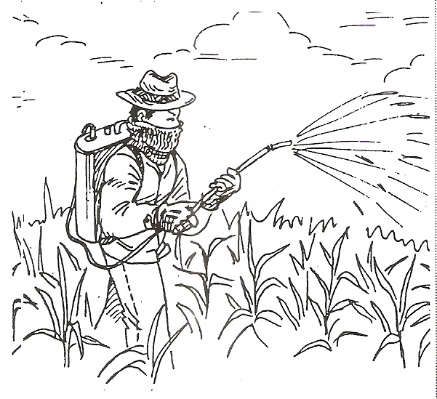
Thus, growers of such fruit are making use of parasitic wasps to stop this. The growers release these wasps in the fruit orchards to feed on the scale insects. In this way, money is saved as growers need not buy chemicals to kill the scale insects, and the oranges and lemons we eat would not have in them either.
Choose the most suitable answer and cross its number in the brackets provided

- Chemicals were thought to be the best weapon against pests because they … .
(1) could make things worse
(2) were a new and safe way of dealing with pests
(3) were easily used over large areas
(4) could go into soils, rivers and the food we eat

- What was the disadvantage of using pesticides?
(1) Pests could adapt themselves over time to the chemicals.
(2) There were many ways to spray the pests.
(3) The chemicals could be dangerous to the pests' offspring.
(4) It could encourage the pests' natural enemies to grow. (

- Biological pest control is a safer way to deal with pests because ….
- The natural predators can get rid of pests faster
- The natural predators of the pests will also damage the crops
- Farmer can save money
- It does mot use poisonous chemicals

4. Why is the scale insect such a nuisance to the growers of lemons and oranges?
(1) It can adopt itself to pesticides over time.
(2) It is poisonous.
(3) It kills the trees and causes the fruit to turn bad.
(4) It forces the farmers to use chemicals.

5. Making use of parasitic wasps to feed on scale insects means that ….
(1) the growers can sell the fruit cheaply
(2) the fruit will be free from chemicals
(3) this method is more harmful to people
(4) fruit will lost longer

Read the passage carefully.

Explosives have always been used by man to mine for minerals.
Nitroglycerin used to be the most common chemical used in explosives. It was a mixture of acids and glycerol.

Man used nitroglycerin for many purposes. It was used to blow up rocks so that roods could be made across mountainous areas or man could mine for gold and other minerals. A nitroglycerin explosion was actually a chemical reaction of gases that was started off by heat. This reaction was strong enough to break rocks apart. However, nitroglycerin was found to be very dangerous. It could go off even if it was slightly disturbed.

Alfred Nobel was a Swedish chemist who opened a nitroglycerin factory together with his family. One day, an explosion in the factory killed a member of his family Nobel decided to find ways to make nitroglycerin safer to use. He managed to mix nitroglycerin with a soft, soil-like material called 'diatomite'. The mixture was a dry, powder-like substance which Nobel called 'dynamite'. Dynamite had the some power of explosion as nitroglycerin. However, it was much safer to use and was not so affected by shock.

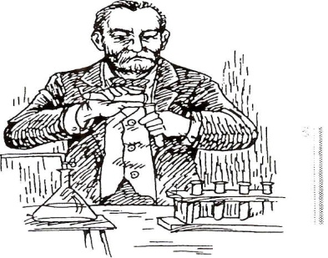
Another invention by Nobel mode using dynamite safer. It was called a 'blasting cop'. It used electricity that passed through a long piece of wire to start the explosion. The person who set off the explosive could be for away and safe from the explosion. Nobel become a very rich man from his inventions.

With his wealth, he created the Nobel Prize. The Prize to this day is awarded to scientists who make valuable discoveries. It is also given to other people whose actions help mankind.

Choose the most suitable answer and cross its number in the brackets provided

- Nitroglycerin comprises … .
(1) acids and glucose
(2) acids and glycerol
(3) acids or glycerol
(4) acids only

2. What was one way nitroglycerin was used?
(1) It was used to blow up rocks.
(2) It was used to mine for gold.
(3) It was used to build rocks.
(4) It was used to make roods.

3. What did Nobel invent?
(1) Glycerin
(2) Diatomite
(3) Nitroglycerin
(4) Dynamite

- What was the other device that he invented that made explosions safer?
(1) A blasting hat .
(2) Nobel Prize
(3) A blasting cap
(4) Electricity

5. The Nobel Prize is for _

(1) scientists who make important discoveries and become famous
(2) scientists who make important discoveries and people who contribute to society
(3) people who contribute money to society
4) people who make valuable discoveries only
Read the advertisement carefully.

Spend your free time wisely by volunteering your services at the following locations:

St Helen's Home
12, Helen Avenue
Singapore 129837

A pianist needed to play music to entertain the senior citizens during their afternoon tea break every Monday, Wednesday and Friday.

Urn Kay Hiang Maternity Hospital
56, Kay Hiang Close
Singapore 128974

Volunteers needed to take care of prematurely born babies. Training will be provided.

Gabrielle Orphanage
38, Carlington Court
Singapore 256437

Volunteers needed to tell stories to children and help children with homework. Flexible hours.

Good Samaritan Association

For further enquiries call 1800-756 3333

Sign up as a volunteer today and give yourself and others a good day!

Choose the most suitable answer and cross its number in the brackets provided

- The St Helen's Home needs a pianist to _

(1) entertain the senior citizens during their tea breaks (2) put up a concert for senior citizens
(3) teach senior citizens to dance
(4) provide background music for the dinner

2. The advertisement is put up by … .
(1) St Helen's Home

(2) Good Samaritan Association
(3) Gabrielle Orphanage
(4) Lim Kay Hiang Maternity Hospital
3. You need not worry if you have no experience taking care of babies because … .
(1) the babies are well-behaved
(2) they are prematurely born
(3) training will be provided
(4) there are doctors nearby to assist you

4. St. Helen’s Home is ….
(1) exclusively for the aged .
(2) for both young and old people In need
(3) an orphanage
(4) a hospital where babies are born

5. You should call 1800-756 3333 if you want to … .
(1) give yourself up
(2) donate money
(3) offer your help
(4) find out more information

Read the passage carefully.

Tourists to Hongkong may catch a glimpse of an endangered species.
The pink dolphin, also known as the Chinese White Dolphin, is in grave danger of dying out. These dolphins are unique because of their colour - mature dolphins are pink or white. They are not born like that, though. Their skin starts off very dark, almost black in colour, and subsequently lightens as they get older. Apart from Hongkong, pink dolphins can be found in countries such as South Africa and Australia, where only a few exist. At present, it is estimated that there are fewer than two hundred pink
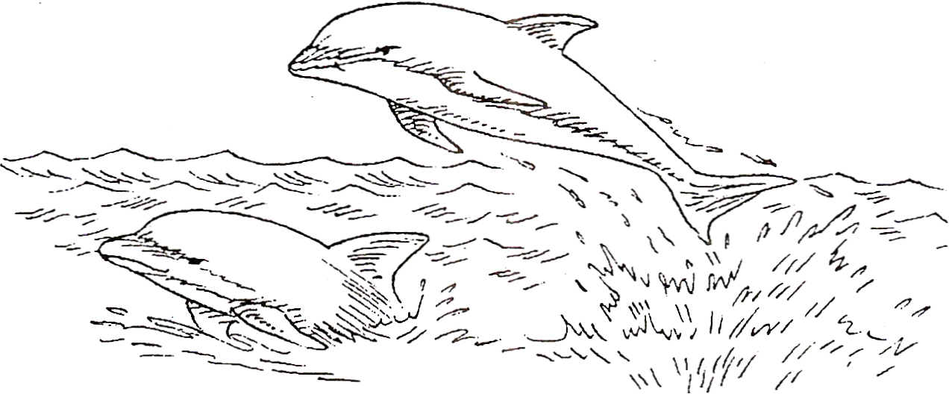

dolphins in Hongkong waters. Some estimates even put the numbers at fewer than a hundred. There is difficulty in keeping track of the number of pink dolphins in Hongkong waters due to sudden deaths. These deaths are attributed to several factors.

Firstly. the waters that the dolphins live in are becoming increasingly polluted as the years go by sewage is dumped into the harbour daily and brings along with it all kinds of bacteria and viruses that are harmful to the dolphins. The water can become so polluted that the dolphins end up absorbing all the harmful pollutants and becoming very sick.
Another factor is overfishing. This is dangerous because it takes away the food supply of the dolphins and that makes the dolphins weak. There is also the chance that they may get entangled or caught in the fishing nets. Since the Hongkong waters are so busy with many ships coming and going with great frequency. dolphins may get knocked about quite seriously. Although, dolphins have a way of sensing that a ship is near, this ability may be weakened by the pollution in the waters.
Dolphins hardly ever leave the waters that they are familiar with, even if these waters become increasingly polluted and dangerous. Thus, these dolphins, may eventually die out, especially if we do not do anything to help them.
Choose the most suitable answer and cross its number in the brackets provided
- What is the difference between a young pink dolphin and a mature one? (1) A mature dolphin's skin is darker than a young dolphin's.
(2) The young dolphin's skin is white in colour, while the mature dolphin's skin is pink.
(3) The young dolphin has dark skin but the mature dolphin has pink or white skin.
(4) There is no difference between the young and mature dolphin at all.

2. At present, 'it is estimated .. .' (paragraph 1). What does this tell us about the number of dolphins?
(1) It tells us that experts believe that these numbers are wrong. (2) It tells us that experts agree on these numbers.
(3) It tells us that the numbers ore very definite.
(4) It tells us that these are only approximate numbers.

3. How many factors are mentioned in the passage that result in the sudden deaths of the pink dolphins?
(1) Six
(2) Two
(3) Three
(4) Four

- Which word in the fourth paragraph means 'to get caught in something'? (1) Sensing
(2) Entangled
(3) Weakened
(4) Frequency

- How can the dolphins save themselves from dying in polluted waters?
(1) They should leave the area and find cleaner waters.
(2) They should not drink the water.
(3) They should eat more so that they do not become weak.
(4) They should try and sense the ships coming towards them.

Appendix 1b

INSTRUMENT OF RESEARCH

Nama : ..........................
Kelas : Elementary
Institution : Kurnia Excellent Course, Demak
Hari / Tanggal : 20 ONovember 2010.
Waktu : 90 menutes

- PRONOUNS TEST

DIRECTION:

Choose the most suitable answer and cross (X) its letter a, b, c, or d provided.

For example :
First choosing a b c d answer a wrong replaced c
Last choosing a b c d

Choose the most suitable answer and cross (X) its letter a, b, c, or d provided
- Agus: "What is on the desk?"
Rina: " "
  - It's a cup c. This is a cup
  - There is a cup d. They're cups

2. Anna: "Are there any eggs in the refrigerator?"
Hadi: "Yes, in it."
a. they aren't any c. they are some
b. there aren't d. there are some

3. Dina: "Which is your book of these two?"
July: "This one is my book and that is "
a. her c. her' s
b. she's d. hers

4. John: " car is that?"
Budi: "It's Salim's car."
a. Who c. what
b. Which d. whose

5. Rita: "How do they study without a teacher?"
Amri: "They help do the exercises."
a. theirself c. themself
b. theirselves d. themselves

6. Rina: "An apple has a sweet taste, isn't it?"
Pita: "Right. But ..... apple I ate yesterday was sour."
a. a c. the
b. an d. any

7. Tino: "Our class is dirty and dusty."
Dany: "The teacher will ask ..... to clean it."
a. they c. them
b. their d. theirs
8. Tery: "Did anyone help you do this program?"
Hans: " helped me do it. I did it by myself"
a. Someone c. every one
b. Anyone d. no one

9. Budi: "there are ten students in the class has a text book."
Paul: "Good. The lesson will run well then."
a. some c. each
b. every d. many

10. Bona: " do you need?"
Sani: "Nothing else. That's all."
a. What else c. Where else
b. Who else d. Which else

11. Lina: "Is this a kind of bag you saw at Sarinah?"
Rini: "No. this bag is made of rubber but I saw was made of pure leather."
a. The present c. the next
b. The ones d. the one

12. Gani: "If you're still thirsty, you can have ..... "
Fred: "Thanks for the offer."
a. Any glass c. some glass
b. Another glass d. the another glass
13. Tina: " bad will happen to us one day."
Sari: "We must be well prepared."
a. Something c. anything
b. Everything d. nothing

- Gito: "Do those toys belong to the children?"
Mira: "Yes, ..... :"
a. They're them c. they’re they
b. They're theirs d. they’re their
- Paul: "This is my glass. Which is …. ?
Eric: "It's the one which is half empty."
a. Yours c. you're
b. Your d. yourself
- Dean: "I'm going to have my holiday to Bali."
Rony: "Great! Please ..... "
a. enjoy it c. enjoy itself
b. enjoy you d. enjoy yourself

17. Bima : "Excuse me. Is this Mr. Sam's office?"
Udin :" "
a. yes, this is c. yes, there is
b. yes, it is d. yes, he is

- Fred : "What time is it please?"
Boby : " ten twenty five."
a. Its c. that's
b. He's d. it's

19. Mary : "This is not siut-case."
Anne : "But it's the only one left."
a. mme c. me
b. my d. I'm

20. Rudy: "Those tools are not theirs. They're "
Fres : "Sure, you're right."
- us c. we’re
- ours d. our

Appendix 1c

INSTRUMENT OF RESEARCH

Nama : ..........................
Kelas : Elementary
Institution : Kurnia Excellent Course, Demak
Hari / Tanggal : 20 ONovember 2010.
Waktu : 90 menutes

- TENSES TEST

DIRECTION:

Choose the most suitable answer and cross (x) its letter a, b, c, or d provided.

For example :
First choosing a b c d answer a wrong replaced c
Last choosing a b c d

Choose the most suitable answer and cross (x) its letter a, b, c, or d provided.

1. John: " your brother an employee?"
Hadi: "Yes, he works in private company."
a. Does c. Do
b. Is d. Are

2. Dany: "What time does Inf. danu go to work every morning?"
Gino: "He to work at 7 a.m."
a. goes c. IS gomg
b. go d. is gone

3. Tony: "Where .... ?"
Bona: "He lives at jalan tambang 25"
a. does your uncle live c. is your uncle live
b. do you uncle live d. are you uncle live
4. Nani: "Ted, what are you doing now?
Tedy: " a newspaper
a. I read c. I do
b. I'm reading d. I'm doing

5. Jack: "What will peter do next weekend?"
Sari: "He will His holiday in bali."
a. to take c. taking
b. takes d. take

6. Asep: "Those students are very curious."
Anna: "Indeed. They in the class."
a. ask often questions c. ask question often
b. often ask questions d. questions often ask

7. Mira: "When can we ..... again to talk about trip?"
Jimmy: "What about next Saturday?"
a. meet c. call
b. see d. speak

8. Gani: "What did those boys do this afternoon?"
Roby: "They Football at senayan."
a. play c. to play
b. playing d. played

9. Rima: "I called you up but there was no answer."
John: "I home when you called me up yesterday."
a. wasn't stay c. am not staying
b. didn't stay d. don't stay

10. Rudy: " You see the last episode of mac giver?"
Elsa: "Yes, I enjoyed it very much,"
a. Did C. Are
b. Do D. Were

11. Sena: "What time did you get up this morning?"
Sita: "I up at about 7 a.m."
a. Get c. have gotten
b. Am getting d. got

12. Vera: "We have our homework. What about you?"
Mina: "We haven't yet."
a. do c. did
b. done d. doing

13. Dina: " he already returned the book to the library?
Lita: "Yes, he has. He returned it this morning."
a. Has c. have
b. Did d. does

14. Joko: "Where are the children?"
Hadi: "They arrived yet."
a. don't c. aren't
b. did't d. haven't

15. Arnir: "Has she sent the parcel to mr. William?"
Edna: "Yes, she ... ... it since yesterday."
a. Sent c. will send
b. Has sent d. sends

16. Iwan: "Where is ali? Any idea?"
Rudy: "He At the moment."
a. Swims c. will swim
b. Is swimming d. swimming

- Paul: "How much your new shirt?"
Rudy: "I bought it Rp 15.000,-."
a. did you buy c. do you buy
b. you bought d. you buy

- July: "How old is Santi?"
Olga: "Now she is seventeen. She born in 1985."
a. Is c. be
b. Were d. was

- Paul: "Who this book? Can you tell meT'
Roby: "Mr. Taufik did."
a. Write c. writing
b. Wrote d. writes

- Pita: "Why don't you water the grass?"
Arnir: "I needn't do it. It "
a. will rain tomorrow c. often rains here
b. Is going to rain soon d. ls raining at the moment

