**APPENDIX**

**Teachers' Questionnaire**

This questionnaire considers, as an important tool for collecting data. I will really appreciate if you could take time and energy to share your experiences and ideas by answering the following questions.

1. How long have you been teaching English?

…………………………………………………………………………

2. Have you noticed that students do not use phrasal verbs in their writing?

Yes No

3. If yes, have you tried to ask why?

………………………………………………………………………………………

4. Have you ever mentioned the importance of phrasal verbs in everyday usage?

Yes No

5. If yes, how often do you do that?

Always Sometimes Rarely

6. What will your comments be in seeing your students' essay made up of phrasal verbs?

………………………………………………………………………………………

7. Do you think that authentic materials as a device in teaching phrasal verbs tool considers as an effective tool

Yes No

Why?.....................................................................................................................

8. Do you think that the difficulties students face in learning phrasal verbs are due to:

Their Multiple Meaning Their Grammar

Their Style They do not have Counterpart in L 1

9. Do you think that phrasal verbs are the obstacles of decreasing students' reading motivation?

Yes No

10. Do you think that the use of phrasal verbs reflects a good mastery of English?

Yes No

Explain?......................................................................................................................

.

***Thank you***

**Students' Questionnaire**

In English language there are many idiomatic expressions one of them is phrasal verbs which are combination of set of short verbs with a set of adverbs or prepositions, sometimes the two together create new concepts and new word category and the teachers can use authentic materials to teach phrasal verbs to the students which are considered as effective tools in teaching, learning a language because they provide a useful input of language learners and in this method the teachers can use video, cartoons, newspaper, articles, advertisements and sports reports to teach the students .

For each item, please tick the right box.

1. Do you use phrasal verbs in your writing? Explain why?

Yes No

…………………………………………………………………………….

2. If yes, do you deliberately use them? Explain why and how?

Yes No

……………………………………………………………………………………..

3. How frequently do you use phrasal verbs in your writing?

Always Often Never

4. Are you interested in learning phrasal verbs?

Yes No

Why?........................................................................................................................

5. Do you face any difficulty in using phrasal verbs?

Yes No

6. Do you read authentic materials in English?

Yes No

7. If yes, have you ever noticed that authentic English materials are full of phrasal verbs?

Yes No

8. Do you like the way teachers introduce phrasal verbs?

Yes No

Why?..........................................................................................................................

9. Do your teachers use phrasal verbs?

Yes No

10. How frequently do they use them?

………………………………………………………………………………………

11. Do you think that phrasal verbs are worthy patterns to be learned?

Yes No

Explain……………………………………………………………………………

***Thank you***

**The materials**

**Text 1:**

**Adventures Growing Up**

I was brought up in a small town in the countryside. Growing up in the countryside offered lots of advantages for young people. The only problem was that we often got into trouble as we made up stories that we acted out around town. I can remember one particular adventure in particular: One day as we were coming back from school, we came up with the brilliant idea to make out that we were pirates looking for treasure. My best friend Tom said that he made out an enemy ship in the distance. We all ran for cover and picked up a number of rocks to use for ammunition against the ship as we got ready to put together our plan of action. We were ready to set off on our attack, we slowly went along the path until we were face to face with our enemy - the postman's truck! The postman was dropping off a package at Mrs. Brown's house, so we got into his truck. At that point, we really did not have any idea about what we were going do next. The radio was playing so we turned down the volume to discuss what we would do next. Jack was all for switching on the motor and getting away with the stolen mail! Of course, we were just children, but the idea of actually making off with a truck was too much for us to believe. We all broke out in nervous laughter at the thought of us driving down the road in this stolen Postal Truck. Luckily for us, the postman came running towards us shouting, "What are you kids up to?!". Of course, we all got out of that truck as quickly as we could and took off down the road.

**Text 2:**

**Uncle Fester**

Last year, Jack Peterson found out that he had come into a small fortune after His uncle Fester had passed on. His uncle had been a heavy smoker for many years and had not been able to cut down on his smoking. Jack got on well with his uncle Fester, and often dropped in on him to see what he was up to. One summer, Uncle Fester promised to cut down on his cigarette smoking after having taken 3 months to get over an extremely bad cough. Jack had looked after him those 3 months and, a number of times, he had told Uncle Fester off. He came up with a brilliant idea to make Uncle Fester give up this nasty habit. He had the local cancer society telephone Uncle Fester. When they called, he told them to hold on and then put Uncle Fester through. They proceeded to make out that they were looking for a volunteer to take on to help look after the patients. Well, that frightened Uncle Fester, and he immediately swore to give up smoking. In fact, Uncle Fester took up jogging in order to help him feel better and he began to look down on other smokers (although he could not quite give smoking up entirely himself). One day, as he set off on his morning run, he made a stand out in the distance. It seems that a new society had turned up that day looking for people willing to bring up young puppies. Uncle Fester immediately went for a cute Dalmatian, and ended up taking on this new responsibility. Now, three years later, Jack had come into the "small fortune" which reminded him every day of his wonderful, if not wise, Uncle Fester.

**Text 3*:***

**My Daily Morning hehehhhe**

The alarm goes off at 6:15am. I wake up, lean over and turn off the alarm. I get up quickly and go downstairs. I put on the coffee. I go back upstairs and have a shower. I sing a song in the shower. I put on my clothes. When I come downstairs again, I have my first cup of coffee. Mmmmm! Then I have some toast and a second cup of coffee. I wash my cup and tidy up the kitchen. I take my bag and set off to work. It is 8:00 am. I lock up the house before I go. Sometimes I run to catch the bus. I get on the bus and go for three or four stops. Then I get off the bus. I reach to my office usually around 8:00 am.

Put the right phrasal verb in the appropriate context in the following pictures:

**Make up, acting up, picking up, fall out, come up, see through, break off, chill out, held up, get down, drop off, step on.**

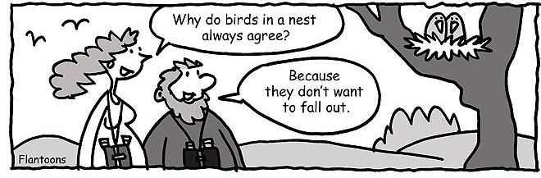











**Cartoons will be used in the third lecture:**









**Pre test**

Name: ...............................................................

Class:……………………………………………………………..

1. **Write a paragraph about your last holiday!**

………………………………………………………………………………………

………………………………………………………………………………………

………………………………………………………………………………………

………………………………………………………………………………………

………………………………………………………………………………………

………………………………………………………………………………………

………………………………………………………………………………………

………………………………………………………………………………………

………………………………………………………………………………………

………………………………………………………………………………………

………………………………………………………………………………………

………………………………………………………………………………………

………………………………………………………………………………………

………………………………………………………………………………………

………………………………………………………………………………………

………………………………………………………………………………………

………………………………………………………………………………………

………………………………………………………………………………………

………………………………………………………………………………………

………………………………………………………………………………………

1. Write sentence based on the picture below!

**Post test:**

Name:

Class:

Part I. Make a paragraph about: “Your experience in Indonesia”, **OR** “The best or the worst adventure that you have passed in your life”. 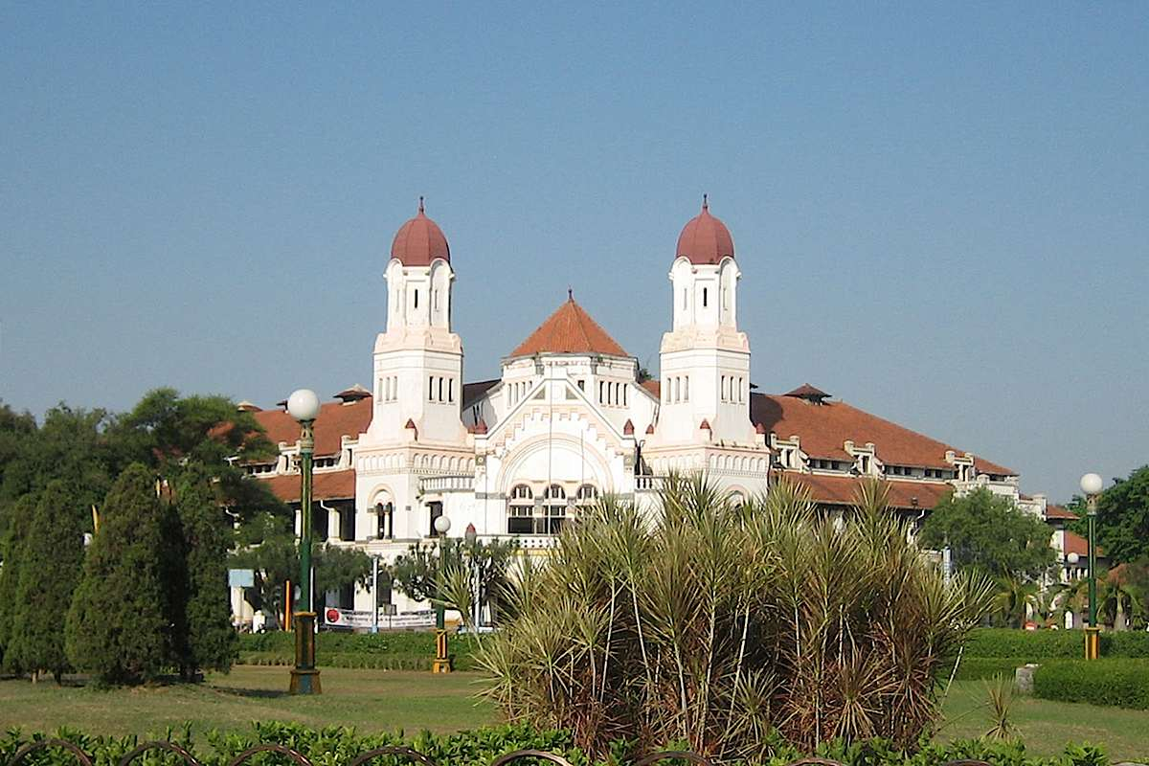

***Your experience in Indonesia***

…………………………………………………………………………………………………………………………………………………………

…………………………………………………………………………………………………………………………………………………………

…………………………………………………………………………………………………………………………………………………………

…………………………………………………………………………………………………………………………………………………………

…………………………………………………………………………………………………………………………………………………………

…………………………………………………………………………………………………………………………………………………………

…………………………………………………………………………………………………………………………………………………………

…………………………………………………………………………………………………………………………………………………………

…………………………………………………………………………………………………………………………………………………………

…………………………………………………………………………………………………………………………………………………………

…………………………………………………………………………………………………………………………………………………………

…………………………………………………………………………………………………………………………………………………………

…………………………………………………………………………………………………………………………………………………………

…………………………………………………………………………………………………………………………………………………………

…………………………………………………………………………………………………………………………………………………………

…………………………………………………………………………………………………………………………………………………………

…………………………………………………………………………………………………………………………………………………………

…………………………………………………………………………………………………………………………………………………………

…………………………………………………………………………………………………………………………………………………………

…………………………………………………………………………………………………………………………………………………………

…………………………………………………………………………………………………………………………………………………………

…………………………………………………………………………………………………………………………………………………………

…………………………………………………………………………………………………………………………………………………………

…………………………………………………………………………………………………………………………………………………………

…………………………………………………………………………………………………………………………………………………………

…………………………………………………………………………………………………………………………………………………………

…………………………………………………………………………………………………………………………………………………………

…………………………………………………………………………………………………………………………………………………………

…………………………………………………………………………………………………………………………………………………………

…………………………………………………………………………………………………………………………………………………………

…………………………………………………………………………………………………………………………………………………………

…………………………………………………………………………………………………………………………………………………………

…………………………………………………………………………………………………………………………………………………………

***The best or the worst adventure that you passed in your life***

…………………………………………………………………………………………………………………………………………………………

…………………………………………………………………………………………………………………………………………………………

…………………………………………………………………………………………………………………………………………………………

…………………………………………………………………………………………………………………………………………………………

…………………………………………………………………………………………………………………………………………………………

…………………………………………………………………………………………………………………………………………………………

…………………………………………………………………………………………………………………………………………………………

…………………………………………………………………………………………………………………………………………………………

…………………………………………………………………………………………………………………………………………………………

…………………………………………………………………………………………………………………………………………………………

…………………………………………………………………………………………………………………………………………………………

…………………………………………………………………………………………………………………………………………………………

…………………………………………………………………………………………………………………………………………………………

…………………………………………………………………………………………………………………………………………………………

…………………………………………………………………………………………………………………………………………………………

…………………………………………………………………………………………………………………………………………………………

…………………………………………………………………………………………………………………………………………………………

…………………………………………………………………………………………………………………………………………………………

…………………………………………………………………………………………………………………………………………………………

…………………………………………………………………………………………………………………………………………………………

…………………………………………………………………………………………………………………………………………………………

…………………………………………………………………………………………………………………………………………………………

**The Treatment:**

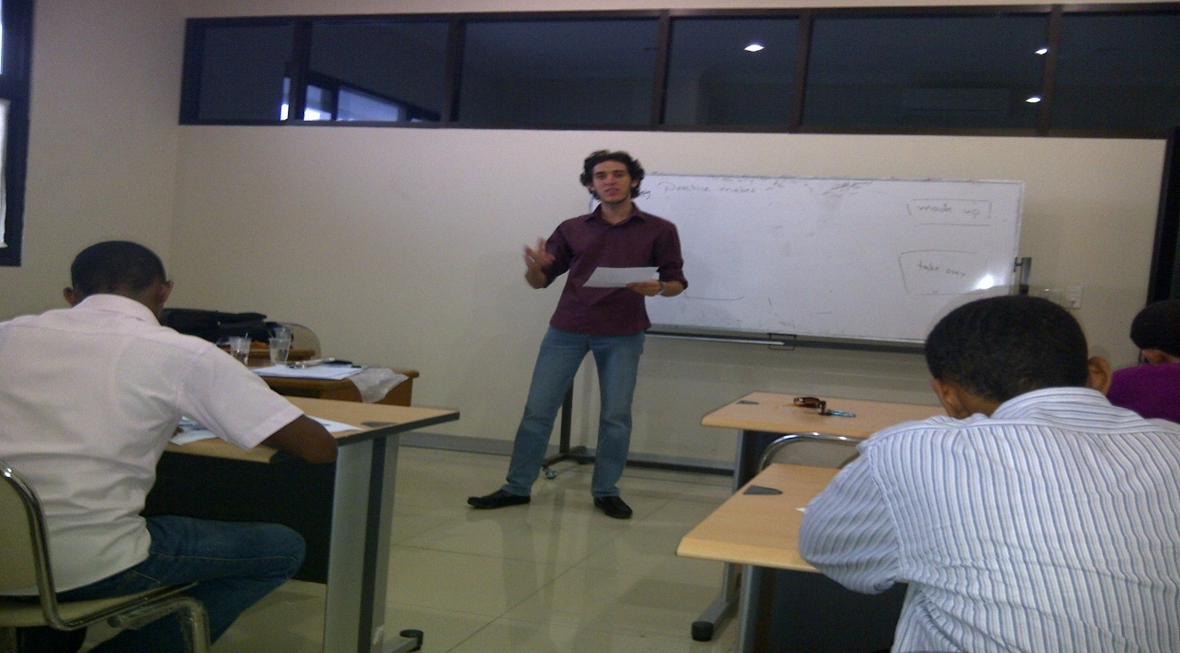

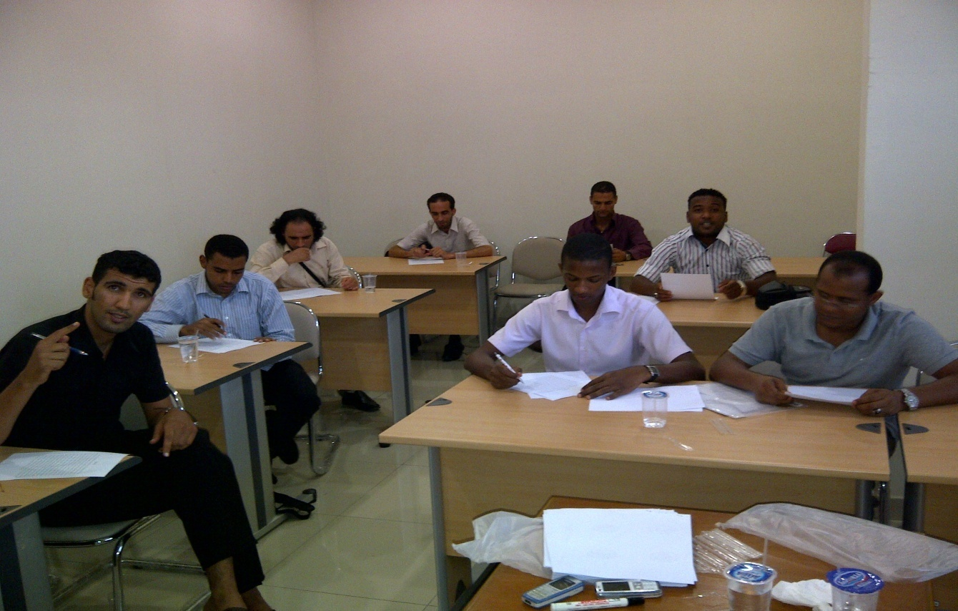

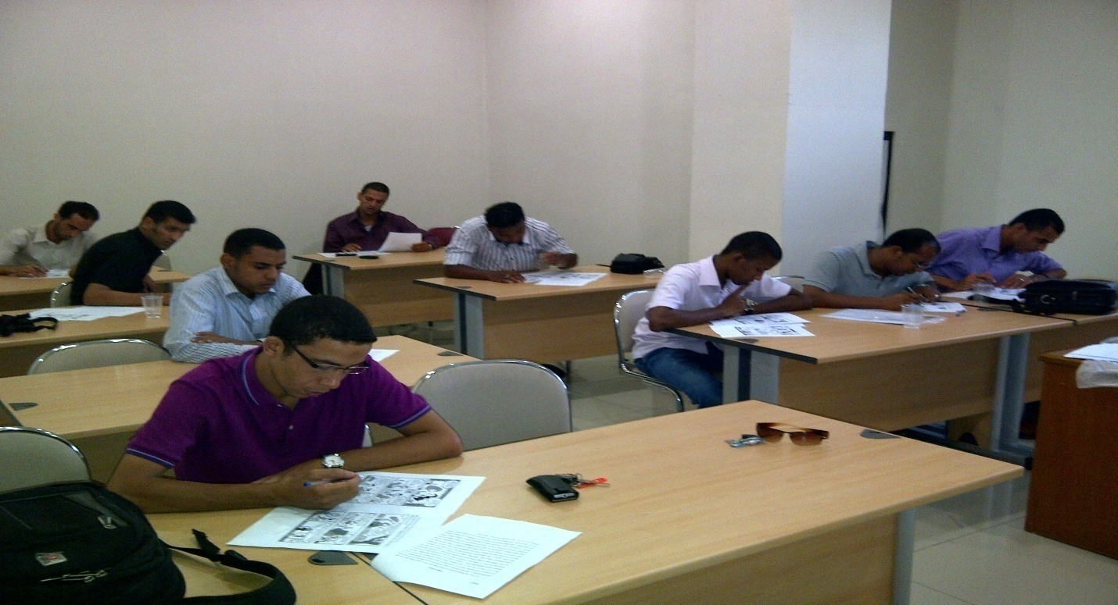

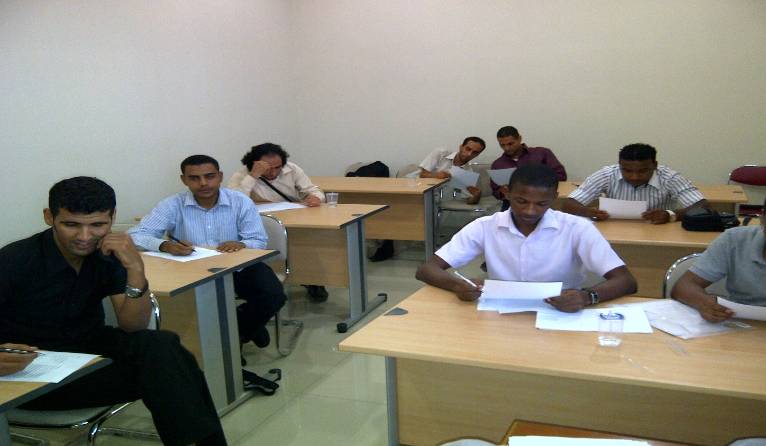

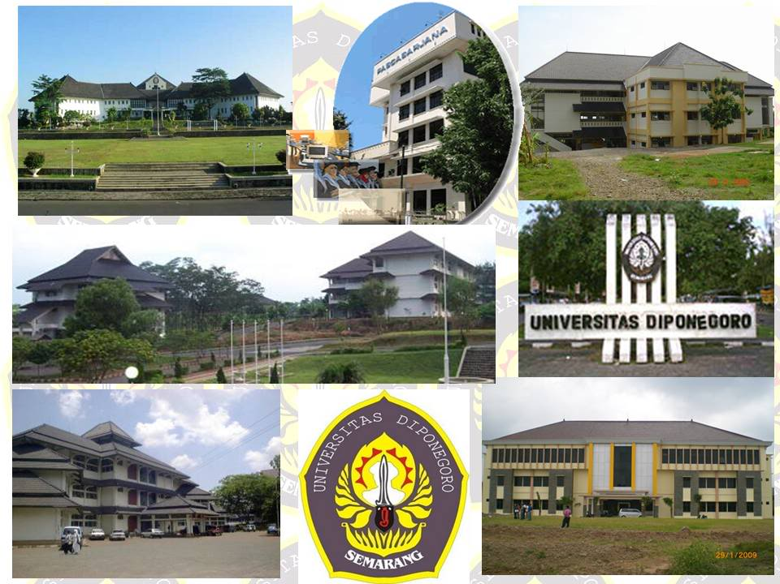

***The location of the study***

­