Appendix 1
SYLLABUS

School : SMAN I Gorontalo
Class / Semester : X / 2
Standard Competence : Expressing meaning in a short functional written text and a simple essay in forms of recount, narrative, and procedure texts in daily life context

Basic Competence | Learning Material | Learning Activities | Indicators | Assesment | Time | Resources
2.1 Expressing meaning and rhetoric steps accurately, fluently, and in acceptable manners using written language in daily life context in forms of recount, narrative, and procedure texts. | Recount Text | Writing a short recount text based on the topic given | Understand the kind of recount text  Understand the use of simple past tense  Understand the use of grammar, punctuation, and vocabulary accurately  Organize the text well  Composing a recount text based on the topic given | Written Test:  Compose a short recount text |  | Interlanguage: English for Senior High School Students X  Developing English Competencies for Senior High School Grade X  Look Ahead for Senior High School

Appendix 2

The Teacher’s Observation Sheet in the Pre-Observation

Developed from: Mozkowitz (in Alwright et al., 1991: 202-204)
The Observation Aspects | Description | Yes | No
Pre-Activities | Opening the activities by greeting and giving motivation to students | √
Deals with Feeling | Accepting, discussing, reffering, communicating, understanding feelings of students |  | √
Encouraging | Encouraging students to continue, trying to give them confidence, confirming answers are correct |  | √
Repeat students’ response | Repeat the exact words of students after they talking |  | √
Asking Questions | Ask a question about the content or procedure with the intent that a student answer | √
Giving Direction | Directions, commands, or orders to which a student is expected to comply |  | √
Correcting without rejecting | Telling students who have made a mistake the correct response without using words or intonation which communication criticism |  | √
Criticize the Students’ behaviour | Rejecting behaviour of students; trying to change the non-acceptable behaviour; communicating anger, displeasure, annoyance, dissatisfaction with what students are doing | √
Conclude the Material | At the end of teaching process, the teacher concludes the materials that have been taught. | √

Appendix 3

The Students’ Writing Result of Pre-Test

No | Name of Students | Elements of Writing |  |  |  |  | Total | Note
No | Name of Students | I | II | III | IV | V | Total | Note
1 | Andre M Djafar | 12 | 8 | 7 | 11 | 12 | 50 | Failed
2 | Andriyanto Syaputra Kasim | 11 | 10 | 11 | 10 | 11 | 53 | Failed
3 | Faldy Ambo | 10 | 11 | 8 | 12 | 10 | 51 | Failed
4 | Ilham Yasin | 11 | 12 | 10 | 9 | 11 | 53 | Failed
5 | Iqbal Alhasni | 11 | 9 | 9 | 11 | 10 | 50 | Failed
6 | Mohamad Geraldy Thaib | 12 | 11 | 11 | 12 | 10 | 56 | Failed
7 | Mohamad Syahril Bawondez | 13 | 12 | 14 | 14 | 14 | 67 | Failed
8 | Mohamad Ilyas Nusi | 12 | 10 | 10 | 11 | 12 | 55 | Failed
9 | Rahmat Ramadhani Syaus | 11 | 10 | 10 | 12 | 12 | 55 | Failed
10 | Ramdhan Tanaiyo | 11 | 11 | 8 | 11 | 12 | 53 | Failed
11 | Rifal Nugraha Uloli | 13 | 12 | 12 | 13 | 13 | 63 | Failed
12 | Rizky Septiawan Adam | 12 | 11 | 11 | 10 | 11 | 55 | Failed
13 | Zainal Abdul Aziz Hadju | 11 | 12 | 11 | 12 | 12 | 58 | Failed
14 | Atika Kaharu | 11 | 11 | 13 | 11 | 11 | 57 | Failed
15 | Dea Rizky Syukur | 13 | 12 | 13 | 11 | 13 | 62 | Failed
16 | Della Pinka Pakaya | 12 | 13 | 13 | 11 | 12 | 61 | Failed
17 | Deliana Fitri Kadir | 13 | 13 | 12 | 13 | 13 | 64 | Failed
18 | Ester G. Deasy Keintjem | 13 | 12 | 12 | 13 | 12 | 61 | Failed
19 | Farida J. Walude | 15 | 15 | 16 | 14 | 15 | 75 | Passed
20 | Indriyani Kiyai | 12 | 12 | 11 | 13 | 13 | 61 | Failed
21 | Inggrid | 13 | 12 | 13 | 11 | 12 | 61 | Failed
22 | Maryam Kasim | 12 | 11 | 11 | 12 | 13 | 59 | Failed
23 | Merlin To’engi | 12 | 12 | 13 | 12 | 12 | 61 | Failed
24 | Nurul Istihara Henok | 12 | 12 | 11 | 12 | 12 | 59 | Failed
25 | Sofya Botutihe | 11 | 12 | 11 | 12 | 12 | 58 | Failed
26 | Sri Della Ente | 13 | 13 | 12 | 12 | 12 | 62 | Failed
27 | Sri Noviani Kadir | 16 | 15 | 14 | 15 | 15 | 75 | Passed
28 | Sri Wahyuni | 16 | 15 | 14 | 15 | 15 | 75 | Passed
29 | Tresna Ayu Cahyani | 16 | 15 | 14 | 15 | 15 | 75 | Passed
30 | Widya Andria S. Ance | 13 | 12 | 11 | 12 | 12 | 60 | Failed
31 | Zein Anastasya Heriyanto | 12 | 12 | 10 | 11 | 11 | 56 | Failed

Notes:
I : Organization
II : Content
III : Grammar
IV : Mechanics
V : Style

Appendix 5

The Sample Analysis of Student’s Work in Pre-Test

Name: Tresna Ayu Cahyani
Organization | Content | Grammar | Mechanics | Style | Score
16 | 15 | 14 | 15 | 15 | 75

- Sentence 1:
Last Holiday, I and my friends went to Bolihutuo beach.
(The use of specific participants is clear and the use of simple past tense is appropriate.)
- Sentence 2:
We went to the beach on Sunday and arrived at the beach on afternoon.
(There is a repetition of the word “beach” in one sentence. She can replace the word “beach” at second place with the word “there”. So, the sentence will be “we went to the beach on Sunday and arrived there in the afternoon. But, it is not a significant mistake)
- Sentence 3:
I am so happy because my parents gave me to go to Bolihutuo.
(Wrong use of tenses, am should be was)
- Sentence 4:
I and my friends enjoyed our holiday at the beach.
(There is no significant error)

- Sentence 5:
My friends was built the sand castle but I can’t did it.
(The sentence My friends was built… is not appropriate because this sentence is passive. The sentence should be my friends built…)
- Sentence 6:
I saw many interesting fish.
(There is no significant error)
- Sentence 7:
I want to took one of them.
(I want to took one of them is wrong. The sentence should be “I wanted to take one of them)
- Sentence 8:
But, it was hard.
(There is no significant error)
- Sentence 9:
Then, we paid a boat and boarded to saw the beautiful sea.
(to saw should be to see. The use of paid is not suitable to use. The word ‘rented’ is quite suitable to use in the sentence)
- Sentence 10:
About 5 hours later, I and my friends leaved the beach.
(The word leaved is wrong. The past form of leave is left)
- Sentence 11:
The holiday was so fun and we enjoyed it much.
(There is no significant error)
- Sentence 12:
We were all very happy.
(There is no significant error)

Appendix 6

LESSON PLAN

School : SMAN I Gorontalo
Subject : English
Class / Semester : X/2
Theme : Recount Text
Aspect / Skill : Writing
Time : 6 X 45 Minutes

A. Standard Competency
Expressing meaning in a short functional written text and a simple essay in forms of recount, narrative, and procedure texts in daily life context

B. Basic Competence
Expressing meaning and rhetoric steps accurately, fluently, and in acceptable manners using written language in daily life context in forms of recount, narrative, and procedure texts.

C. Indicators
The students are expected to:
- Understand the kind of recount text
- Understand the use of simple past tense
- Understand the use of grammar, punctuation and vocabulary accurately
- Organize the text well
- Composing a recount text based on the topic given

D. Learning Material
- Writing a short recount text based on the topic given
- Grammar Review
- Simple Past Tense

E. Teaching Method
Student Teams - Achievement Divisions Method

F. The Steps in Teaching and Learning Process

1. Pre-Activity
- Greeting
- Pray
- Checking the students’ attendance
- Giving motivation
2. Activity
- The teacher explains the material about recount text
- The teacher explains the language features of recount text
- The teacher gives some examples of recount text
- The teacher explain the Simple Past Tense
- The Teacher devide the students into groups
- Ask the students to compose a recount text
- Motivate the students to be active in groups
3. Post-Activity
- The teacher conclude the material
- Ask the students’ difficulties

G. Learning Sources
- Interlanguage : English for Senior High Students X
- Developing English Competencies for Senior High School Grade 10
- Look A Head for Senior High School Students X

H. Evaluation
- Technique: Written Test
- Writing A Short Recount Text of The Students’ Experience when celebrating the Independence Day

Rubric of Assesment
No | Name | Aspects |  |  |  |  | Scores | Value
No | Name | Organization | content | Grammar | mechanics | Style | Scores | Value
1.
2.
3.
4.
5.
6.

Gorontalo, January 2011

The Headmaster The teacher

Syaiful Kadir, S.Pd, M.Pd Sunarti Niu, S.Pd
NIP. 19690122 199903 1 005 NIP.19680531 200312 2 004

Appendix 7

The Teacher’s Observation Sheet in the First Cycle

Developed from: Mozkowitz (in Alwright et al., 1991: 202-204)
The Observation Aspects | Description | Yes | No
Pre-Activities | Opening the activities by greeting and giving motivation to students | √
Deals with Feeling | Accepting, discussing, reffering, communicating, understanding feelings of students | √
Encouraging | Encouraging students to continue, trying to give them confidence, confirming answers are correct | √
Repeat students’ response | Repeat the exact words of students after they talking |  | √
Asking Questions | Ask a question about the content or procedure with the intent that a student answer | √
Giving Direction | Directions, commands, or orders to which a student is expected to comply
Correcting without rejecting | Telling students who have made a mistake the correct response without using words or intonation which communication criticism |  | √
Criticize the Students’ behaviour | Rejecting behaviour of students; trying to change the non-acceptable behaviour; communicating anger, displeasure, annoyance, dissatisfaction with what students are doing | √
Conclude the Material | At the end of teaching process, the teacher concludes the materials that have been taught. | √
Appendix 8
The Students’ Observation Result in Cycle 1
No | Name | The Observation Aspects |  |  |  | Total | % | Criteria
No | Name | I | II | III | IV | Total | % | Criteria
1 | Andre M Djafar | 0 | 0 | 0 | 0 | 0 | 0 | D
2 | Andriyanto Syaputra Kasim | 0 | 1 | 1 | 0 | 2 | 50 | C
3 | Faldy Ambo | 0 | 0 | 0 | 0 | 0 | 0 | D
4 | Ilham Yasin | 0 | 0 | 1 | 1 | 2 | 50 | C
5 | Iqbal Alhasni | 0 | 0 | 0 | 0 | 0 | 0 | D
6 | Mohamad Geraldy Thaib | 0 | 0 | 0 | 1 | 1 | 25 | D
7 | Mohamad Syahril Bawondez | 1 | 1 | 1 | 0 | 3 | 75 | B
8 | Mohamad Ilyas Nusi | 0 | 0 | 1 | 1 | 2 | 50 | C
9 | Rahmat Ramadhani Syaus | 0 | 0 | 0 | 0 | 0 | 0 | D
10 | Ramdhan Tanaiyo | 0 | 0 | 0 | 0 | 0 | 0 | D
11 | Rifal Nugraha Uloli | 1 | 1 | 0 | 1 | 3 | 75 | B
12 | Rizky Septiawan Adam | 0 | 0 | 0 | 0 | 0 | 0 | D
13 | Zainal Abdul Aziz Hadju | 0 | 0 | 0 | 1 | 1 | 25 | D
14 | Atika Kaharu | 0 | 0 | 0 | 1 | 1 | 25 | D
15 | Dea Rizky Syukur | 0 | 1 | 1 | 1 | 3 | 75 | B
16 | Della Pinka Pakaya | 1 | 0 | 1 | 0 | 2 | 50 | C
17 | Deliana Fitri Kadir | 1 | 0 | 0 | 1 | 2 | 50 | C
18 | Ester G. Deasy Keintjem | 1 | 1 | 1 | 0 | 3 | 75 | B
19 | Farida J. Walude | 1 | 1 | 1 | 0 | 3 | 75 | B
20 | Indriyani Kiyai | 1 | 0 | 1 | 1 | 3 | 75 | B
21 | Inggrid | 1 | 1 | 0 | 1 | 3 | 75 | B
22 | Maryam Kasim | 1 | 0 | 0 | 1 | 2 | 50 | C
23 | Merlin To’engi | 1 | 0 | 1 | 1 | 3 | 75 | B
24 | Nurul Istihara Henok | 0 | 0 | 0 | 1 | 1 | 25 | D
25 | Sofya Botutihe | 1 | 0 | 1 | 1 | 3 | 75 | B
26 | Sri Della Ente | 1 | 0 | 0 | 1 | 2 | 50 | C
27 | Sri Noviani Kadir | 1 | 1 | 1 | 1 | 4 | 100 | A
28 | Sri Wahyuni | 1 | 1 | 1 | 1 | 4 | 100 | A
29 | Tresna Ayu Cahyani | 1 | 1 | 1 | 1 | 4 | 100 | A
30 | Widya Andria S. Ance | 0 | 0 | 1 | 0 | 1 | 25 | D
31 | Zein Anastasya Heriyanto | 1 | 0 | 1 | 0 | 2 | 50 | C

Notes:
I : Encouraging
II : Checking for Understanding
III : Sharing Ideas and Information
IV : Correcting
The Criterion of Students’ Activeness
A | 80 – 100 | Excelent Level
B | 60 – 79 % | High Level
C | 40 – 59 % | Satisfactory Level
D | 39 % or below | Low level
Appendix 9
The Students’ Writing Result of First Test

No | Name of Students | Elements of Writing |  |  |  |  | Total | Note
No | Name of Students | I | II | III | IV | V | Total | Note
1 | Andre M Djafar | 13 | 13 | 11 | 12 | 10 | 59 | Failed
2 | Andriyanto Syaputra Kasim | 16 | 15 | 15 | 14 | 15 | 75 | Passed
3 | Faldy Ambo | 13 | 12 | 11 | 12 | 12 | 60 | Failed
4 | Ilham Yasin | 13 | 13 | 11 | 13 | 13 | 63 | Failed
5 | Iqbal Alhasni | 12 | 11 | 11 | 12 | 11 | 57 | Failed
6 | Mohamad Geraldy Thaib | 13 | 12 | 11 | 12 | 12 | 60 | Failed
7 | Mohamad Syahril Bawondez | 15 | 16 | 14 | 15 | 15 | 75 | Passed
8 | Mohamad Ilyas Nusi | 13 | 12 | 11 | 12 | 12 | 60 | Failed
9 | Rahmat Ramadhani Syaus | 13 | 13 | 11 | 11 | 12 | 60 | Failed
10 | Ramdhan Tanaiyo | 12 | 11 | 11 | 12 | 12 | 58 | Failed
11 | Rifal Nugraha Uloli | 15 | 16 | 14 | 15 | 15 | 75 | Passed
12 | Rizky Septiawan Adam | 14 | 12 | 11 | 11 | 12 | 60 | Failed
13 | Zainal Abdul Aziz Hadju | 14 | 12 | 11 | 11 | 12 | 60 | Failed
14 | Atika Kaharu | 15 | 14 | 13 | 14 | 14 | 70 | Failed
15 | Dea Rizky Syukur | 15 | 15 | 15 | 16 | 15 | 76 | Passed
16 | Della Pinka Pakaya | 16 | 15 | 14 | 16 | 15 | 76 | Passed
17 | Deliana Fitri Kadir | 14 | 15 | 13 | 14 | 14 | 70 | Failed
18 | Ester G. Deasy Keintjem | 16 | 15 | 14 | 16 | 15 | 76 | Passed
19 | Farida J. Walude | 17 | 16 | 15 | 16 | 16 | 80 | Passed
20 | Indriyani Kiyai | 16 | 15 | 14 | 15 | 15 | 75 | Passed
21 | Inggrid | 16 | 16 | 13 | 15 | 15 | 75 | Passed
22 | Maryam Kasim | 14 | 14 | 13 | 14 | 13 | 68 | Failed
23 | Merlin To’engi | 16 | 15 | 14 | 16 | 15 | 76 | Passed
24 | Nurul Istihara Henok | 15 | 16 | 14 | 15 | 15 | 75 | Passed
25 | Sofya Botutihe | 15 | 14 | 13 | 15 | 14 | 65 | Failed
26 | Sri Della Ente | 16 | 16 | 14 | 15 | 16 | 77 | Passed
27 | Sri Noviani Kadir | 17 | 16 | 16 | 15 | 15 | 79 | Passed
28 | Sri Wahyuni | 17 | 17 | 15 | 15 | 16 | 80 | Passed
29 | Tresna Ayu Cahyani | 18 | 18 | 17 | 17 | 18 | 88 | Passed
30 | Widya Andria S. Ance | 16 | 15 | 14 | 15 | 15 | 75 | Passed
31 | Zein Anastasya Heriyanto | 16 | 15 | 14 | 14 | 15 | 74 | Failed

Notes:
I : Organization
II : Content
III : Grammar
IV : Mechanics
V : Style

Appendix 11

The Sample Analysis of Student’s Work in First Test

Name: Tresna Ayu Cahyani
Organization | Content | Grammar | Mechanics | Style | Score
18 | 18 | 17 | 17 | 18 | 88

- Sentence 1:
In celebrating the Independence Day, I followed the competition in school.
(The use of ‘followed’ in the sentence is not suitable. The word ‘joined’ is suitable to use)
- Sentence 2:
I was the vice student who represented my class to follow writing competition.
(There is no significant error)
- Sentence 3:
The competition was held on 18th August, 2010.
(There is no significant error)
- Sentence 4:
There were many themes of writing competition and I choosed the theme I Love Indonesia
(the word choosed is wrong, the verb 2 of choose is chose)
- Sentence 5:
According to me, the theme was interesting.
(There is no significant error)

- Sentence 6:
My teacher and my friends gave me support.
(There is no significant error)
- Sentence 7:
Eventhough many people gave me support, I was nervous.
(There is no significant error)
- Sentence 8:
Eventhough I only ranking four, I was very happy because I got gift from school.
(The use of Eventhough for many times has to be avoided. The sentence I only ranking four is not appropriate. The sentence should be I only got ranking four…)
- Sentence 9:
I was happy also because the competition created a spirit of nasionalism in myself.
(There is no significant error)
- Sentence 10 :
It made me proud.
(There is no significant error)
- Sentence 11:
My teacher and my friends also were proud of me.
(There is no significant error)
- Sentence 12:
I was so happy.
(There is no significant error)

Appendix 12

The Pictures of Method Implementation in Cycle 1
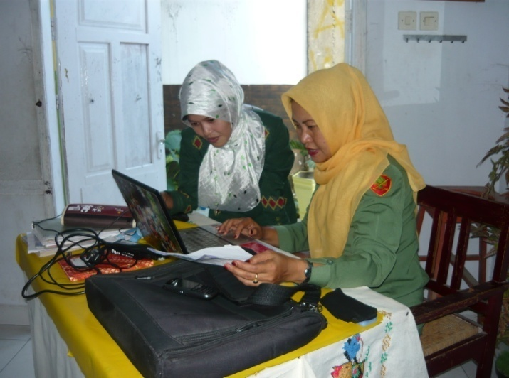
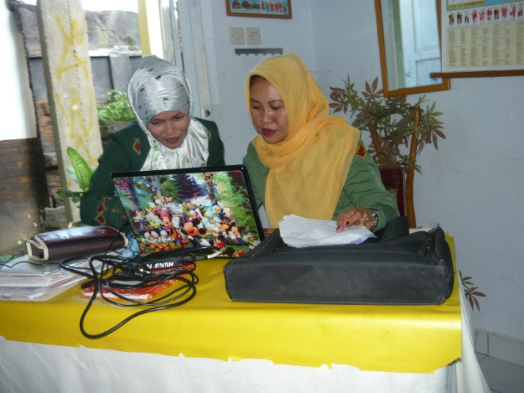
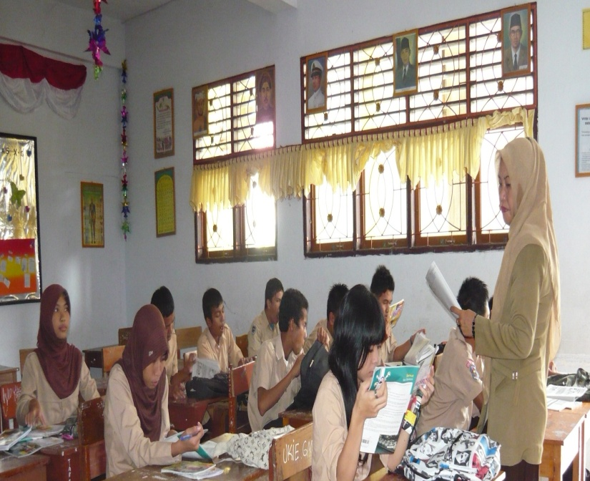
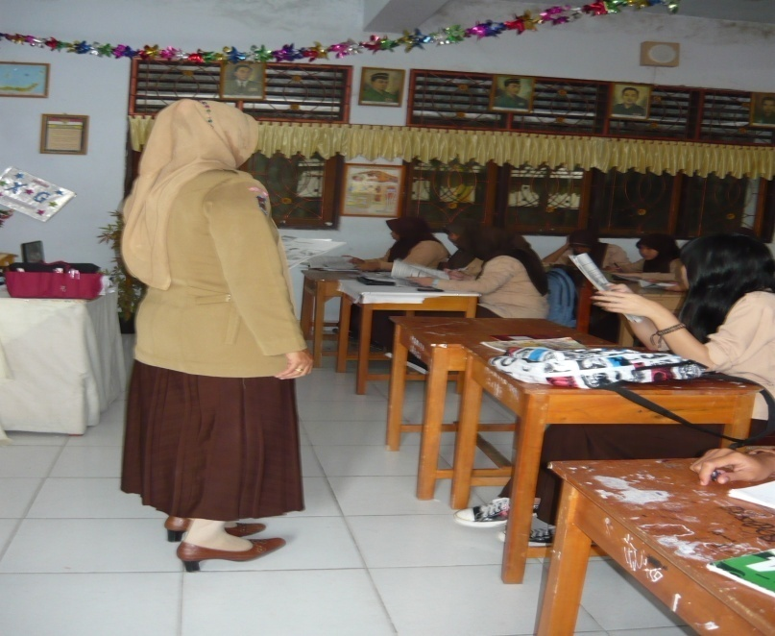
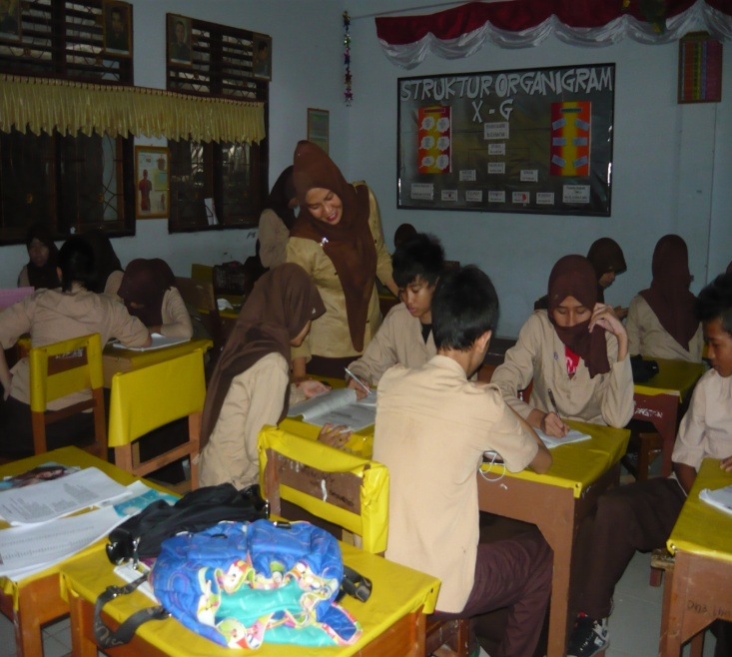
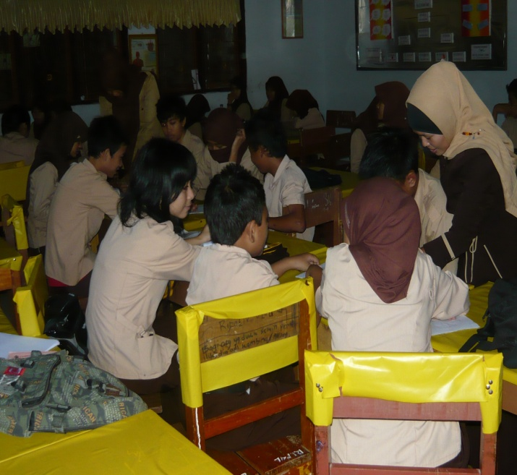

Appendix 13

LESSON PLAN

School : SMAN I Gorontalo
Subject : English
Class / Semester : X/2
Theme : Recount Text
Aspect / Skill : Writing
Time : 6 X 45 Minutes

A. Standard Competency
Expressing meaning in a short functional written text and a simple essay in forms of recount, narrative, and procedure texts in daily life context

B. Basic Competence
Expressing meaning and rhetoric steps accurately, fluently, and in acceptable manners using written language in daily life context in forms of recount, narrative, and procedure texts.

C. Indicators
The students are expected to:
- Understand the kind of recount text
- Understand the use of simple past tense
- Understand the use of grammar, punctuation and vocabulary accurately
- Organize the text well
- Composing a recount text based on the topic given

D. Learning Material
- Writing a short recount text based on the topic given
- Simple Past Tense
- Vocabulary
- Punctuation

E. Teaching Method
Student Teams - Achievement Divisions Method

F. The Steps in Teaching and Learning Process

1. Pre-Activity
- Greeting
- Pray
- Checking the students’ attendance
- Giving motivation
2. Activity
- The teacher explains the material Simple Past Tense
- The teacher explains the use of punctuation
- The teacher provides vocabulary to students related to the material learned
- The teacher devide the students into groups
- Ask the students to compose a recount text based on the topic given
3. Post-Activity
- The teacher conclude the material
- Ask the students’ difficulties

G. Learning Resources
- Interlanguage : English for Senior High Students X
- Developing English Competencies for Senior High School Grade 10
- Look A Head for Senior High School Students X

H. Evaluation
- Technique: Written Test
- Writing A Short Recount Text of The Students’ Bad Memorable Experience

I. Rubric of Assesment
No | Name | Aspects |  |  |  |  | Scores | Value
No | Name | Organization | Content | Grammar | mechanics | Style | Scores | Value
1.
2.
3.
4.
5.
6.

Gorontalo, March 2011
The Headmaster The teacher

Syaiful Kadir, S.Pd, M.Pd Sunarti Niu, S.Pd
NIP. 19690122 199903 1 005 NIP.19680531 200312 2 004

Appendix 14

The Teacher Observation Sheet in the Second Cycle

Developed from: Mozkowitz (in Alwright et al., 1991: 202-204)
The Observation Aspects | Description | Yes | No
Pre-Activities | Opening the activities by greeting and giving motivation to students | √
Deals with Feeling | Accepting, discussing, reffering, communicating, understanding feelings of students | √
Encouraging | Encouraging students to continue, trying to give them confidence, confirming answers are correct | √
Repeat students’ response | Repeat the exact words of students after they talking | √
Asking Questions | Ask a question about the content or procedure with the intent that a student answer | √
Giving Direction | Directions, commands, or orders to which a student is expected to comply | √
Correcting without rejecting | Telling students who have made a mistake the correct response without using words or intonation which communication criticism | √
Criticize the Students’ behaviour | Rejecting behaviour of students; trying to change the non-acceptable behaviour; communicating anger, displeasure, annoyance, dissatisfaction with what students are doing | √
Conclude the Material | At the end of teaching process, the teacher concludes the materials that have been taught. | √
Appendix 15
The Students’ Observation Result in Cycle 2
No | Name | The Observation Aspects |  |  |  | Total | % | Criteria
No | Name | I | II | III | IV | Total | % | Criteria
1 | Andre M Djafar | 1 | 1 | 1 | 1 | 4 | 100 | A
2 | Andriyanto Syaputra Kasim | 1 | 1 | 1 | 1 | 4 | 100 | A
3 | Faldy Ambo | 1 | 1 | 0 | 1 | 3 | 75 | B
4 | Ilham Yasin | 1 | 0 | 1 | 1 | 2 | 50 | C
5 | Iqbal Alhasni | 0 | 0 | 1 | 1 | 2 | 50 | C
6 | Mohamad Geraldy Thaib | 1 | 1 | 1 | 1 | 4 | 100 | A
7 | Mohamad Syahril Bawondez | 1 | 1 | 1 | 1 | 4 | 100 | A
8 | Mohamad Ilyas Nusi | 1 | 1 | 1 | 1 | 4 | 100 | A
9 | Rahmat Ramadhani Syaus | 1 | 1 | 1 | 0 | 3 | 75 | B
10 | Ramdhan Tanaiyo | 1 | 0 | 0 | 1 | 2 | 50 | C
11 | Rifal Nugraha Uloli | 1 | 1 | 1 | 1 | 4 | 100 | A
12 | Rizky Septiawan Adam | 1 | 1 | 1 | 0 | 3 | 75 | B
13 | Zainal Abdul Aziz Hadju | 1 | 1 | 1 | 0 | 3 | 75 | B
14 | Atika Kaharu | 1 | 1 | 1 | 1 | 4 | 100 | A
15 | Dea Rizky Syukur | 1 | 1 | 1 | 1 | 4 | 100 | A
16 | Della Pinka Pakaya | 1 | 1 | 1 | 1 | 4 | 100 | A
17 | Deliana Fitri Kadir | 1 | 1 | 1 | 1 | 4 | 100 | A
18 | Ester G. Deasy Keintjem | 1 | 1 | 1 | 1 | 4 | 100 | A
19 | Farida J. Walude | 1 | 1 | 1 | 1 | 4 | 100 | A
20 | Indriyani Kiyai | 1 | 1 | 1 | 1 | 4 | 100 | A
21 | Inggrid | 1 | 1 | 1 | 1 | 4 | 100 | A
22 | Maryam Kasim | 1 | 1 | 1 | 1 | 4 | 100 | A
23 | Merlin To’engi | 1 | 1 | 1 | 1 | 4 | 100 | A
24 | Nurul Istihara Henok | 1 | 1 | 1 | 0 | 3 | 75 | B
25 | Sofya Botutihe | 1 | 1 | 1 | 1 | 4 | 75 | B
26 | Sri Della Ente | 1 | 1 | 1 | 1 | 4 | 75 | B
27 | Sri Noviani Kadir | 1 | 1 | 1 | 1 | 4 | 75 | B
28 | Sri Wahyuni | 1 | 1 | 1 | 1 | 4 | 100 | A
29 | Tresna Ayu Cahyani | 1 | 1 | 1 | 1 | 4 | 100 | A
30 | Widya Andria S. Ance | 1 | 1 | 1 | 1 | 4 | 100 | A
31 | Zein Anastasya Heriyanto | 1 | 1 | 1 | 1 | 4 | 100 | A

Notes:
I : Encouraging
II : Checking for Understanding
III : Sharing Ideas and Information
IV : Correcting
The Criterion of Students’ Activeness
A | 80 – 100 | Excelent Level
B | 60 – 79 % | High Level
C | 40 – 59 % | Satisfactory Level
D | 39 % or below | Low level
Appendix 16

The Students’ Writing Result of Second Test

No | Name of Students | Elements of Writing |  |  |  |  | Total | Note
No | Name of Students | I | II | III | IV | V | Total | Note
1 | Andre M Djafar | 14 | 13 | 13 | 12 | 12 | 64 | Failed
2 | Andriyanto Syaputra Kasim | 16 | 15 | 14 | 15 | 15 | 75 | Passed
3 | Faldy Ambo | 17 | 15 | 14 | 14 | 15 | 75 | Passed
4 | Ilham Yasin | 16 | 15 | 15 | 14 | 15 | 75 | Passed
5 | Iqbal Alhasni | 13 | 13 | 11 | 11 | 12 | 60 | Failed
6 | Mohamad Geraldy Thaib | 17 | 16 | 15 | 15 | 16 | 79 | Passed
7 | Mohamad Syahril Bawondez | 17 | 17 | 15 | 16 | 16 | 81 | Passed
8 | Mohamad Ilyas Nusi | 16 | 15 | 14 | 15 | 15 | 75 | Passed
9 | Rahmat Ramadhani Syaus | 15 | 14 | 13 | 14 | 14 | 70 | Failed
10 | Ramdhan Tanaiyo | 15 | 14 | 13 | 15 | 14 | 65 | Failed
11 | Rifal Nugraha Uloli | 17 | 16 | 15 | 16 | 16 | 80 | Passed
12 | Rizky Septiawan Adam | 16 | 16 | 14 | 15 | 15 | 76 | Passed
13 | Zainal Abdul Aziz Hadju | 16 | 15 | 14 | 15 | 15 | 75 | Passed
14 | Atika Kaharu | 17 | 16 | 16 | 15 | 15 | 79 | Passed
15 | Dea Rizky Syukur | 18 | 17 | 16 | 16 | 16 | 83 | Passed
16 | Della Pinka Pakaya | 17 | 16 | 15 | 16 | 16 | 80 | Passed
17 | Deliana Fitri Kadir | 17 | 16 | 15 | 16 | 15 | 79 | Passed
18 | Ester G. Deasy Keintjem | 17 | 16 | 15 | 16 | 16 | 80 | Passed
19 | Farida J. Walude | 19 | 18 | 17 | 17 | 18 | 89 | Passed
20 | Indriyani Kiyai | 17 | 16 | 15 | 15 | 16 | 79 | Passed
21 | Inggrid | 17 | 17 | 15 | 15 | 16 | 80 | Passed
22 | Maryam Kasim | 16 | 16 | 14 | 15 | 16 | 77 | Passed
23 | Merlin To’engi | 17 | 16 | 14 | 15 | 16 | 78 | Passed
24 | Nurul Istihara Henok | 17 | 16 | 15 | 16 | 16 | 80 | Passed
25 | Sofya Botutihe | 17 | 16 | 16 | 15 | 15 | 79 | Passed
26 | Sri Della Ente | 17 | 16 | 16 | 16 | 17 | 82 | Passed
27 | Sri Noviani Kadir | 19 | 18 | 16 | 17 | 17 | 90 | Passed
28 | Sri Wahyuni | 19 | 18 | 17 | 17 | 17 | 90 | Passed
29 | Tresna Ayu Cahyani | 19 | 18 | 19 | 18 | 18 | 92 | Passed
30 | Widya Andria S. Ance | 17 | 17 | 15 | 15 | 16 | 80 | Passed
31 | Zein Anastasya Heriyanto | 17 | 16 | 15 | 16 | 16 | 80 | Passed

Notes:
I : Organization
II : Content
III : Grammar
IV : Mechanics
V : Style

Appendix 18

The Sample Analysis of Students’ Work in Second Test

Name: Tresna Ayu Cahyani
Organization | Content | Grammar | Mechanics | Style | Score
19 | 18 | 19 | 18 | 18 | 92

- Sentence 1:
I had a bad experience in a trip to Manado last year.
(There is no significant error)
- Sentence 2:
I intended to visit my family there
(There is no significant error)
- Sentence 3:
I was very happy because I could meet my aunt, my uncle, and my cousins
(There is no significant error )
- Sentence 4:
In half of our journey, the car crashed the fence and I was very shocked
(There is no significant error)
- Sentence 5:
I cried because I was very afraid
(There is no significant error)
- Sentence 6
But, there was no one hurt in the accident
(There is no significant error)

- Sentence 7:
I thanked to god because I and my parents were all safe.
(The word God should be written in capital letter and ‘to’ should be ommited).
- Sentence 8:
It was a trauma and I hope I will not meet an incident like that.
(The sentence can be ‘it was a trauma and I hope I will not meet such an incident like that’).

Appendix 19

The Pictures of Method Implementation in Cycle 2

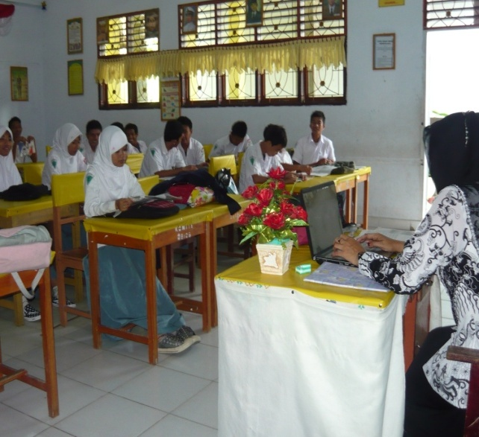
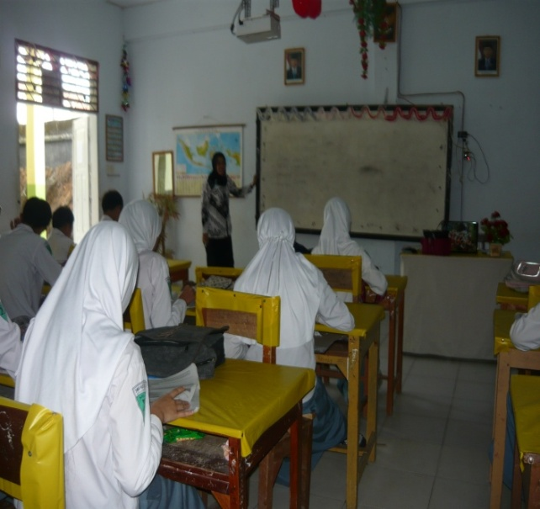

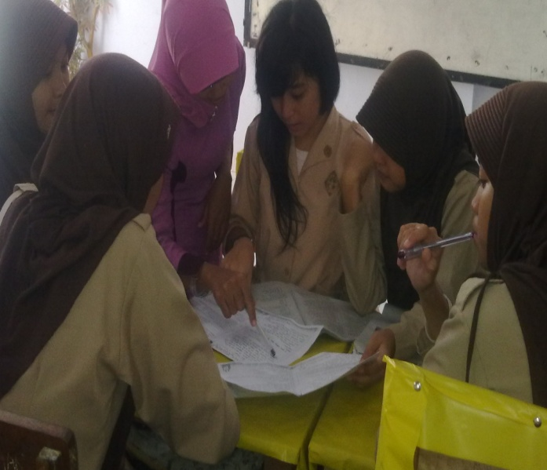
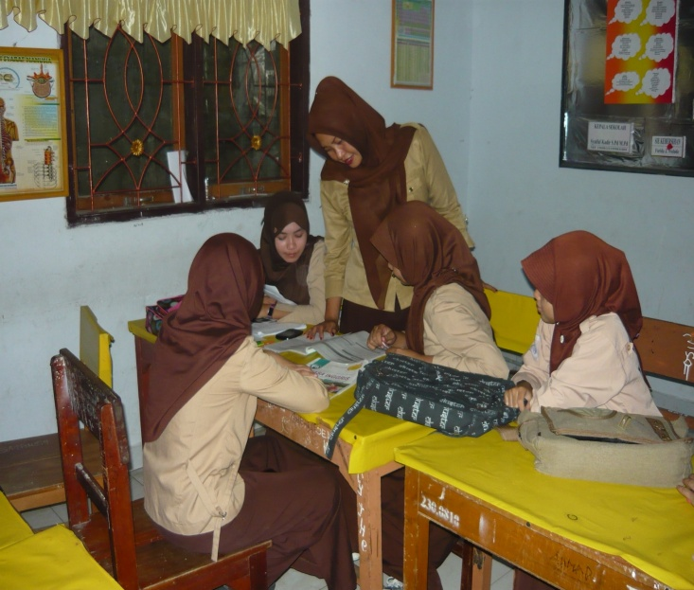

A P P E N D I C E S

