CHAPTER I
I N T R O D U C T I O N

In this introductory chapter, the general perspective and the substantial parts of this study will be described, which consists of background of the Study, the objectives of the study, the significance of the study, the scope of study, and the previous studies. Finally, the organization of this study will be outlined.

  - Background of the Study

All over the world, there are many students from all ages who learn to speak English, but the reasons of learning English greatly differ from one to another, because they learn English based on their needs. It is supported by Harmer (2007:11) who states
Some people need English for Specific Purpose (ESP). Such students of ESP (sometimes also called English for Specific Purposes) may need to learn the legal language, or the language of tourism, banking or nursing, for example, an extremely popular strand of ESP is the teaching of Business English, where students learn about how to operate English in the business world.

Students in the Elementary level of vocational high school are the students of ESP, because they learn how to use language in business world. In order to learn English better, the students of vocational high school have to master speaking ability that is relevant to future job. It is also described in the curriculum. The curriculum, especially for the Business and Management of Office Administration Program in the elementary level, describes students must be able to express various feelings. One of them is expressing opinions. In order to meet the standard of the curriculum, the students of the elementary level, in this case the students of Office Administration, must be able to express their opinions related to the office jobs. However, when students want to learn speaking skill, they feel that learning speaking is a difficult thing, not only because of their limited vocabulary items, but also their fear of making mistakes when they have to speak. It might happen, as a result of students’ thought that they have to organize words into good sentences.
From the interview with the English teacher, the writer found the fact that speaking became a problem that should be solved in the eleventh grade of Office Administration 1 Class. She said
The standard of learning achievement in this school is 70, but in this class, their learning achievement is around 78. Even their learning achievement was high, it does not mean that they could speak English fluently, because from 36 students in one class, it was just about one or two students who could speak English fluently.

From the explanation, it was difficult for the teacher to apply the right method or strategy to improve students’ speaking ability and students’ participation in the class, even when the teacher implemented some methods in teaching speaking, the result of the students’ ability in speaking was still low. The teacher also said
To improve their speaking ability, actually, I have used several techniques, like working in pairs, practicing dialogue, and role-play technique. I used Role Play to improve the students’ speaking ability. For the other students, who were joined extra course. Through the course, they could practice their English more and more, because in our school, we have an extra class in the afternoon.

Based on the pre-observation result, it was found that the teaching-learning process in eleventh grade of Office Administration 1, SMK Negeri 1 Gorontalo was still teacher oriented. Meanwhile, most of the students were not engaged in meaningful conversation and they did not participate in learning activities. They are considered written expressive students. It was difficult for them to speak in front of other people because they did not have self-confidence in doing so. Besides, the result of pre-test showed that the students usually started grammatical pattern in a wrong way and change their direction. Their accent is Indonesian accent, and most of them were not able to express their opinion fluently.
To overcome the students’ problems in speaking and classroom participation, the writer conducts a classroom action research by using cooperative learning approach, because the students are assumed to get involve and participate in classroom interaction and they can motivate each other to achieve a good result of their learning. Richard and Rodgers (2003:192) state as follow:
Cooperative language learning is a part of some general instructional approaches which also known as the collaborative learning. Cooperative learning is an approach to teach that makes maximum use of cooperative activities involving pairs and small groups of learners in the classroom.

From the definition above, it can be concluded that cooperative learning is a teaching approach that uses pair activities and small groups learning. Think-Pair-Share is a teaching strategy, can be used as a part of cooperative learning, in which the students will think by themselves, and sit in pairs to discuss and exchange their thinking in a small group and after that they will share and interact with the whole class. McKnight (2010:158) expresses
The implementation of Think-Pair-Share is pair the students and have each student recall that entire he or she may already know about an assigned topic. As the students share information, encourage them to ask questions and ask for additional details. Students enjoy being able to share ideas and information as they are learning.

The writer conducts a Classroom Action Research using Think-Pair-Share strategy to overcome problem stated above. It is attempted to improve the students’ speaking ability in expressing opinions. The writer assumes that Think-Pair-Share strategy can facilitate students to use the language. It also gives the opportunity for the students to engage in meaningful conversations with other students, so they can improve their speaking ability.
So, it can be said that Think-Pair-Share is a strategy which can give an opportunity to the students, to participate and practice their speaking ability in English, to encourage them to ask questions and to ask for additional details and to motivate the learning of others. Because of that, the writer is interested in conducting an action research with the title: “Improving Students’ Speaking Ability through Think-Pair-Share Strategy, : A Collaborative Action Research on the Eleventh Grade Students of Office Administration 1 of SMK Negeri 1 Gorontalo in 2010/2011 Academic Year”, because the writer assumes that Think-Pair-Share strategy can improve the students’ speaking ability.
Based on the description above, the writer formulates the problem statements as follows:
    - What problems do the eleventh grade students of Office Administration 1 of SMK Negeri 1 Gorontalo in 2010/2011 academic year face in speaking English?
    - How can Think-Pair-Share strategy be applied to solve the problems of speaking of the eleventh grade students of office administration 1 of SMK Negeri 1 Gorontalo in 2010/2011 academic year?
    - To what extent can Think-Pair-Share strategy improve the students’ speaking ability for eleventh grade students of office administration 1 (AP1) of SMK Negeri I Gorontalo in 2010/2011 Academic Year?

  - The Objectives of the Study

There are some objectives of this study. The objectives of this study are as follows:
Generally, the objective of this study is to improve students’ speaking ability in the eleventh grade students of Office Administration (AP1) of SMK Negeri I Gorontalo in 2010/2011 Academic Year.
Specifically, the objectives of this study are: a) to identify the problems arose when the students of the eleventh grade students of office administration 1 (AP1), SMK Negeri I Gorontalo, in 2010/2011 Academic Years should speak English, b) to get the description of Think-Pair-Share strategy applied to solve the problems of speaking in the eleventh grade students of office administration 1 of SMK Negeri 1 Gorontalo, in 2010/2011 academic year, c) to measure the students’ speaking ability through Think-Pair-Share strategy of the eleventh grade students of Office Administration 1 (AP1) of SMK Negeri I Gorontalo, in 2010/2011 academic year.

1.3. The Significance of the Study

The writer hopes that the result of this study will be useful and give a little contribution:
    - Theoretically, this study will give benefits to the students, as follows: a) to improve the students’ participation in learning activities, and b) to improve the students’ speaking ability, which can be seen that almost all students express their understanding of the content and their perspectives or ideas. Most or almost all students will use the language of the subject matter. (Bishop, 2009:43).
    - Practically, this study will give benefits. As follows: 1) giving contribution to become more creative and innovative in teaching learning process, and 2) giving contribution to the teacher to solve the students’ problems in speaking.
    - Pedagogically, the writer will get some benefits. They are: 1) developing the writers’ understanding about the Collaborative Action Research, 2) developing the understanding of teaching models, especially to improve the students’ speaking ability, and 3) improving the writers’ ability in composing classroom action research.

1.4. Scope of the Study

This study is done to improve the students’ speaking ability in Communicating English Level Elementary, in Expressing Various Feelings. In order to focus the study, the writer makes a limitation of her study in “Expressing Opinions”.

1.5. Previous Studies

There are some previous studies related to this study. The first was research conducted by Wafi (2011) entitled “Using the Think-Pair-Share Strategy to Increase Students’ Active Involvement and to Improve Students’ Speaking Ability at Islamic the University of Malang.” Wafi’s subject was the university students. The process in his study discussed the answer in pairs and shared the result of the discussions when they sat in pairs. The result of his study showed that the students’ achievement in speaking improved. The findings of his study indicated that the Think-Pair-Share strategy was sucsessful to increase the students’ active involvement and improve the students’ speaking ability. The students’ active involvement increased and speaking ability improved.
Another study was a research conducted by Gunawan (2010) entitled “Improving Students’ Speaking Ability in Conveying Interpersonal and Transactional Speech using Think-Pair-Share for the Fifth Year of SD Muh. 16 Karangase Surakarta”. Gunawan focused on improving the students’ speaking ability in conveying interpersonal and transactional speech. The subject of his study was the fifth year of the SD MUH. 16 Karangasem, Surakarta. His study is to get the description of the implementation of Think-Pair-Share strategy, the result of teaching speaking, and the students’ response taught by using Think-Pairs-Share. Gunawan’s study showed that the students’ speaking ability improved by using Think-Pair-Share strategy.
Based on those studies, the writer thinks she needs to do further research relate to the students’ speaking ability and the students’ participation in classroom interaction among the students and the teacher. She finds it is necessary to conduct a study entitles “Improving Students’ Speaking Ability through Think-Pair-Share Strategy: A Collaborative Action Research on the Eleventh Grade Students of Office Administration 1 of SMK Negeri 1 Gorontalo in 2010/2011 Academic Year”. It discusses the implementation of Think-Pair-Share strategy in expressing opinion, the students’ participation in classroom interaction occure between the students and the teacher and the students’ achievement in speaking ability. Besides, this study is to find out the problems occure when the students had to speak English. The writer thinks by finding out the problems was an important thing, because if the teacher knew the students’ weakness when they had to speak, s/he would know which part of the students’ speaking ability needed to improve.

1.6. The Organization of Writing

This study consists of five chapters. Chapter I Introduction, it includes background of the study, the objectives of the Study, the significance of study, the scope of study, previous studies and the organization of writing.
Chapter II deals with the Literary Review. The literary review describes about language teaching and learning, the nature of speaking, which consists of the definitions of speaking and the position of speaking in teaching learning English, the importance of speaking. Cooperative Learning Approach, which consists of cooperative learning, goal of using cooperative learning, learning advantages in cooperative learning classroom. The most important is Think-Pair-Share, it includes the definition of Think Pair-Share, Think-Pair-Share in action, the advantages and the disadvantages of Think-Pair-Share, and the way to create pairs, and the last is opinions.
Chapter III is research method. This chapter consists of research design, research setting, which describes research place and research time, research subject, research procedures, data collection and data analysis.

Chapter IV deals with research findings and discussion. Research findings consist of teaching learning activities before the implementation of Think-Pair-Share strategy, results in first cycle, second cycle and third cycle and discussion of the results of study.
The last is Chapter V. Chapter V draws the conclusions of the study and suggestions.

CHAPTER II
LITERARY REVIEW

In this chapter, the writer deals with the literatures of the study in improving students’ speaking ability through Think-Pair-Share strategy. This study is underpinne by some related theories concerning improving speaking ability through Think-Pair-Share strategy. The theories include the Language teaching and learning, the nature of speaking, Cooperative learning approach, Think-Pair-Share and Opinion.

  - Language Teaching and Learning

One skill that should be mastered by the students of the vocational high school is speaking. It is very important for them because they are the students who are prepared to face the business world after they graduate. There are some problems occuring in mastering speaking skill, especially in the teaching-learning process of speaking.
Teaching and learning activity is an activity of transfering knowledge in order to make the students understand, master and apply their knowledge. During teaching learning process, there is an interaction between the teacher and the students. Students learn a language through interacting with the teacher and others. Bishop, et al (2009:33) state
We learn language through interaction with others who have more skills than ourselves. In the classroom, the more skilled language user is you, teacher. Teachers are models of language when they make announcements, give directions, teach lesson, respond to questions, work with small groups, and engage in conversation with individuals.

Bishop’s statement means that the teacher’s role is very important in learning a language. Not only the teacher, but also the students as the language learners have an important role in learning a language. Bishop, et al (2009:37) add
Students themselves are a source of language. When the students listen each other in the classroom, opportunities for language learning are increased-particularly when the students have different background, experience and interest.

Harmer (2005:28) also supports the statement. He states
Shortage of opportunities for practice is identified as an important contribution factor to speaking failure. And by practicing it meant that not practice grammar and vocabulary, but practice of interactive speaking itself. The combined effect of these deficiencies is a lack of confidence and often an acute sense of anxiety when it comes to speaking.

Based on some explanations above, interaction in the classroom to master a language is very important. By interacting with others, students will have more opportunities to learn a language, to speak fluently and to improve their participation in classroom interaction.
The students at the elementary level in vocational high school have already achieved competencies in novice level, so they have a basic speaking competence to be involved and participated in an interaction in the classroom. Harmer (2007:17) expresses
“Elementary students are no longer beginners and are able to communicate in a basic way. They can string some sentences together, construct a simple story, or take part in simple spoken interaction”

It means that a teacher as an educator in the classroom has to give opportunities to the students in the elementary level to do meaningful conversation, to participate and to improve their speaking ability. In fact, most of the students do not get the opportunity in doing so.
Bishop et al. (2009:41) explain further about the interaction in the classroom. It is shown by stating
Research shows that teachers do most of the talking in classrooms and the students’ opportunities to talk are quite limited (National Center for Education Statistics 2003). When the teacher do invite talk, they most typically engage in what has been identified as an I-R-E interchange. The teacher initiates (I) talk by asking a question, one student responds (R), and the teacher evaluates (E) the response (Cazden 1986). The I-R-E interchange is limited and limiting.

Besides the interaction in the classroom, another problem affects the students’ ability to speak. The problem is their knowledge mastery, vocabulary and grammar of the foreign language. Harmer (2005:28) further states it by saying
Problems affect the students’ ability to speak is their knowledge of the foreign language, including its vocabulary and grammar, is rarely extensive or established as their knowledge of their first language. They are like the students who say, “I can’t find the words, I always use the same sentences.

Based on the description above, most of the problems to master speaking come from the teaching-learning process, the students’ lack of vocabularies, their grammar problems which affect their confidence, and their acute sense of anxiety when it comes to speak.
If an English teacher wants to improve the students’ speaking ability, s/he should apply the proper strategy, which facilitates the students to use the language and to give opportunity to the students to engage in meaningful conversations and to participate in classroom interaction.

  - The Nature of Speaking

Speaking is very important for the students in vocational high school, especially in a business field. The teacher should choose the right strategy to improve the students’ participation and speaking ability, so the students can interact and communicate with their friends.

2.2.1. Speaking
Speaking is one of the basic skills in English. Brown (2004:140) expresses “Speaking is a productive skill that can be directly and empirically observed.” Speaking is a productive skill. It means that speaking is a skill that produces the language from the mouth when someone speaks. Besides, Harmer (2006:269) argues “The ability to speak fluently presuppose not only the knowledge of language features, but also the ability to process information and language “on the spot.”
It means that speaking is a productive skill in which the speaker will produce the language from the mouth to process the information.

2.2.2. The Position of Speaking in Teaching Learning English

There are four skills that should be mastered in learning English. They are reading, listening, writing and speaking, which grouped into two major categories, Receptive Skills and Productive Skills. Harmer (2003:199) states “Receptive skills are the ways in which people extract meaning from the discourse they see or hear. Reading and Listening is belonged to the receptive skills”. While, Harmer (2003:246) adds that the productive skills are writing and speaking. Speaking is the productive skill in the oral mode. So when someone speaks, s/he produce the language from the mouth. It meant speaking as a productive skill when s/he produce the language from the mouth.

2.2.3. The Characteristics of Spoken Language
There are some characteristics of Spoken language. Davison and Jane (2003:92) explain
“Depending upon where, when, why and to whom they are talking, speakers will probably alter some of the following:
- Their register (eg. From tormal to informal);
- Their Grammar (eg. From clauses embedded in complex sentences to linked simple sentences peppered withgap-filters, false starts and changes of directions);
- Their dialect (e.g) from standard English to regional);
- Their accent (eg. From a regional accent to received pronunciation);
- The prosodic features of their speech (e.g. tone, speed and rhythm)”

It means someone speak, s/he could alter some of the characteristics of spoken language.

2.2.4. The Importance of Speaking
Generally, speaking is really important for the students because when they have a good skill in speaking, they will not only have a great chance to get a good job, but also they will have a great chance of further education, finding job, and gaining promotion in the future after they graduate.
Brown and Yule (in Richards, 2008:21), state that there are numerous functions of speaking related to the human interaction. They make a useful distinction between the interactional functions of speaking, in which it serves to establish and maintain social relations, and the transactional functions, which focus on the exchange of information.
So speaking is an important skill and it has some important functions. Speaking also is very important for the students in vocational high school, especially in a business field. It is supported by Baker and Westrup (2003:5) who express
Speaking English well can help the students access up-to-date information in the field, including science, technology and health. Good English speakers will be in strong position to help their country’s economic, social and politic development. So that, by learning to speak English well, students gain a valuable skill that can be useful in their lives and contribute to their community and country.

There are some ways that the teacher can encourage the students to speak in the classroom. Bishop et. al. (2009:42) express that first, teachers have to create a safe atmosphere for students to express themselves. Students need to feel confident and comfortable in speaking with the teacher and peers. So they will not be ridiculed if they misuse or mispronounce a word. The teacher has a responsibility to build a classroom community in which the students respect and sincerely listen one another. Second, the teacher has to create an environment that facilitates conversation. Third, teacher has to give students time to talk. Fourth, teacher needs to provide students the reasons to talk. S/he has to stimulate students’ interest, encourage them to ask, and provide them with experiences that are highly engaging and arising their curiosity. By giving strong reason to communicate, students will talk.
Based on the reasons above, the teacher should choose the right approach and strategy to improve the students’ participation and speaking ability, so the students can interact and communicate with their friends. One of the approaches that can be applied is Cooperative Learning Approach.

2.3. Cooperative Learning Approach

Cooperative learning approach could be said as a learning approach, which can give the opportunity for the students to participate and to work together with their friend, and hopefully it can improve their participation in classroom interaction and their ability to master speaking skill. Cooperative learning (CL) is an approach that is involved students’ participation in pair or small group activity. Richard and Rodgers (2003:192) explain

Cooperative language learning is a part of some general instructional approaches which also known as the collaborative learning. Cooperative learning is an approach to teach that makes maximum use of cooperative activities involving pairs and small groups of learners in the classroom.

Cooperative Learning Approach offers a way to organize group work to enhance learning and increase academic achievement. Olsen and Kagan (in Kessler, 1992:1) explain
Cooperative Learning (CL) is a body of literature and research that has examined the effects of cooperation in education. It offers ways to organize group wok to enhance learning and increase academic achievement. CL is not general, free discussion; nor are all types of group work need cooperative learning. It is carefully structured-organized, so that each learner interacts with others, and all learners are motivated to increase each other’s learning.

Cooperative learning not only assumes could increase the students’ learning achievement but also could facilitate the students to learn. It is based on Joyce, et. al. (2000:15) who express
Cooperative Learning procedures facilitate learning across all curriculum areas and ages, improving self-esteem, social skill and solidarity, and academic learning goals ranging from the acquisition of information and skill through the modes of inquiry of the academic disciplines.

From the explanation above, the writer concludes that cooperative learning is an approach, which can motivate and improve the students’ ability to learn. Besides, Cooperative learning is also assumed could improve the students’ participation in classroom interaction.
When the teacher wants to use one approach in teaching English, the teacher needs to know the goal. Cooperative learning as a teaching approach also has some goals. Richards and Rogers (2003:193) express the goals of using Cooperative Language Learning as follows:
- to provide opportunities for naturalistic second language acquisition through the use of interactive pair and group activities;
- to provide teachers with a methodology to enable them to achieve this goal and one that can be applied in a variety of curriculum settings (e.g., content-based, foreign language classroom, mainstreaming)
- to enable focused attention to particular lexical items, language structures, and communicative function through the use of interaction tasks.
- to provide opportunities for learners to develop successful learning and communication strategies.
- to enhance learner motivation and reduce learner stress ad to create a positive affective classroom climate.

McGroarty (in Richard and Rogers, 2001:195) offers six learning advantages for ESL students in Cooperative Learning classroom. They are:
a. Increased frequency and variety of second language practice through different of interaction;
b. Possibility for development or use of language in ways that support cognitive development and increase language skills;
c. Opportunities to integrated language with content-based instruction;
d. Opportunities to include a greater variety of curricular materials to stimulate language as well as concept learning;
f. Freedom for teachers to master new professional skills, particularly those emphasizing communication; and
g. Opportunities for students to act as resources for each other, thus assuming a more active role in their learning.

It means Cooperative Learning Approach not only offers a way to organize group work to enhance learning and increase academic achievement but also has some goals and offers some advantages.

2.4. Think-Pair-Share

One strategy as a part of cooperative learning approach that is assumed can increase the students’ participation to interact with others and to encourage them to speak is Think-Pair-Share strategy.

2.4.1. The Definition of Think-Pair-Share
Slavin (1995:132) says “Think-Pair-Share is a simple, but a very useful method developed by Frank Lyman of the University of Maryland”.
Lyman (in Bishop, et al, 2009:44) further explains
Think-Pair-Share, a strategy that may be used in any content, facilitates the students’ use of language, as they first consider a question that the teacher has posed, briefly discuss their responses with partners, and then share their answer with then entire class.

It means that Think-Pair-Share is a simple strategy developed by Frank Lyman which can facilitate the students to use the language and participate in a meaningful conversation.

2.4.2. Think-Pair-Share in Action
Generally, there are some steps in Think-Pair-Share strategy. Olsen and Kagan (in Richard and Rodgers, 2001: 198) express the steps of Think-Pair-Share strategy. They are: 1) the teacher poses a question, 2) students think of a response, 3) students discuss their responses with their partners, and 4) the students share their partner’s responses with the class.
McKnight (2010:158) expresses that the implementation of Think-Pair-Share strategy can be done by pairing the students and having each student recalls entire knowledge, asking the students to share information, encouraging them to ask questions and additional details, and making students enjoy to share ideas and informations as they are learning.
As stated above, it can be described that the action of Think-Pair-Share strategy in the classroom can be done by making the students paired up and taking on the destinations “Student A and student B”. Then, the teacher explains about the steps in Think-Pair-Share strategy. The teacher poses the question to the students based on the topic. The students think of the response without discussing with their friends. After that, the teacher asks them to sit in pairs discussing and changing the response. Next, the pairs come in front of the class to share their partners’ response. While they share their response, the teacher can encourage the other students to ask the pairs. It will create a meaningful interaction happened in teaching learning process.

2.4.3. The Advantages and Disadvantages of Think-Pair-Share
There are some advantages and disadvantages of using Think-Pair-Share strategy. Education Technology Clearinghouse (2009) explains the advantages of Think-Pair-Share as follows: “1) Total involvement; 2) generates a lot of ideas quickly; and 3) small groups can have quality discussions”. While, the disadvantages of using Think-Pair-Share are: “1) can be very noisy; and 2) Puts time pressure on some.”
Budd (in Kessler, 1992:21) adds
An advantage to TPS is that students have increased wait time, the opportunity to think about their answers before thinking about who they will share with. Low-consensus information, unfamiliat topics, or “higher-order” analysis, synthesis, or evaluation applications may require more thinking time than high-consensus information.

Based on the description above, it can be concluded that Think-Pair-Share strategy could be a good strategy with some advantages which gives the opportunity for the students to think and to interact with the other students, so they will get a change to practice using the language. Despite the disadvantage of Think-Pair-Share strategy could make the classroom very noisy.

2.4.4. The Way to Create Pairs
When implementing Think-Pair-Share strategy, the teacher groups the students in pairs. Harmer (2001:120) expresses that there are some ways to put individual students into pairs. They are:
a) Friendship. It is a key consideration when putting students in pairs or groups is to make sure that we put friends with friends, rather than risking the possibility of people working with other whom they find difficult or unpleasant,
b) Streaming. The pairs should mix of weaker and stronger students,
c) Chancing. The teacher pairs the students by ‘chance’ – that is, so far, no special reasons of friendship, ability, or level of the participant.
In implementing Think-Pair-Share strategy, the teacher and the writer chose friendship to put the individual students into pairs. Hopefully, by putting the students into pairs based on friendship, they will be more comfortable and can help each other to practice use the language and change the information.

2.5. Opinions

All of the people have their own opinions. Expressing opinion is very important. By expressing the opinion, other people will understand about what we think, feel, and what our perspective. Moddy (2005:61) expresses “Opinions represent judgements, evaluations, feelings, emotions, or personal reactions, and are different for different people.”
Widyantoro (2008:143) explains that there are some expressions usually used in giving opinions. They are: “in my opinion, I think, I (really) feel that, The way I see things, If you ask me…I tend to think that.”

CHAPTER III
RESEARCH METHOD

This chapter provides and describes overview of research design, research setting which describes research place and time, research subject, and research procedures. Besides, this chapter focuses on data collection and analysis.

3.1. Research Design

This study is a Collaborative Classroom Action Research, in which the writer and the English teacher worked together to improve the students’ speaking ability and participation in classroom interaction. Burns (2003:30) states
Classroom action research is the application of fact finding to practical problem solving in a social situation with a view to improve the quality of action within it, involving the collaboration, and co-operation of researchers, practitioners, and laymen.

Kemmis and McTaggart (in Cohen, et. al,. 2007:297-298) argue “To do action research is to plan, act, observe, and reflect more carefully, more systematically, and more rigorously than one usually does in everyday life”.
Kemmis and McTaggart (in Burns, 2010:9) show the research design as follows: Planning, Acting, Observing, Reflecting. It can be described in details as follows:
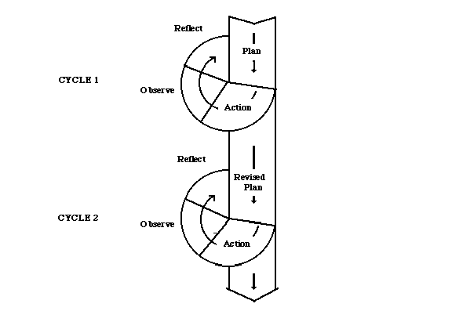
Picture 1. Research Design of Classroom Action Research

Practically, classroom action research includes planning, acting, observating and reflecting in each cycle. The phases stop after a positive improvement achieved.
This study is composed in classroom action research because through classroom action research, the problems in teaching learning process can be studied, improved and solved, so the teaching learning process will be more innovative and the students’ learning achievement will be better. However, through this study, the writer hopes that she and the English teacher can solve not only the students’ speaking problem to express the opinion, but also to improve the quality of teaching learning process itself, in which the students will be participated in teaching learning process and classroom interaction more.

3.2. Research Setting

This research was conducted at SMK Negeri 1 Gorontalo in three months.

    - Research Place

The research was conducted at SMK Negeri I Gorontalo. It is located on Jl. Ternate, Kelurahan Tapa, Kota Gorontalo, at the centre of the town. The telephone/fax number is (0435) 822772 - 822313. SMK Negeri I Gorontalo is located in a strategic place, and easy to reach. SMK Negeri I Gorontalo is a favorite Vocational High School in Gorontalo. This school has a good reputation in Gorontalo province, because SMK Negeri I Gorontalo is a vocational high school which has ISO Certification 9001-2000 with the international standard, and it is supported by some facilities, such as multimedia, internet and language laboratory room, photocopy services and many more.

    - Research Time

This study was conducted at SMK Negeri 1 Gorontalo, in three months, from January to April 2011.

  - Research Subjects

The subjects of this study were the eleventh grade students of the Office Administration 1 of SMK Negeri 1 Gorontalo in 2010/2011 Academic Year. There were 34 girls and 2 boys as the subject of this study. The problem which was going to be solved in this study was “Expressing Opinion” for the students of the Elementary level.
The writer chose the students of eleventh grade students of Office Administration 1 (AP1) because they are the students of English for Specific Puspose who are prepared to be able to communicate in English and could participate in teaching learning activity. In fact, most of the students of Office Administration 1 (AP1) SMK Negeri 1 Gorontalo did not participate in classroom activities, and their speaking ability was still low. Therefore, it means that the teacher needs a good strategy to improve the students’ speaking ability and their participation in the classroom interaction.

  - Research Procedures

There were some steps of procedures that the writer had to follow. These steps began from finding the fact until revising the plan.
For the research procedures in action research, Kemmis and McTaggart (in Cohen et al, 2007:305) express that in doing Practice, the process begins with a general idea The general idea prompts a ‘reconnaissance’ of the circumstances of the field, and fact-finding about them. The writer decided a general plan of action. Breaking the general plan into achievable steps, the writer settled on the first action step. Primary to the first step the writer became more circumspect, and devised a way of monitoring the effects of the first action step. As the step implemented, new data started to come in and the effect of the action could be described and evaluated. The general plan was then revised in the light of the new information about the field of action and the second step could be planned along with appropriate monitoring procedures. The second step was implemented, monitored and evaluated; and the spiral cycle went on to the next steps.
Primary to the research, the writer observed the teacher’s performance in explaining and introducing the expressions in expressing opinion, and the students’ participation in teaching learning process. This observation was done in order to know not only the students’ participation in classrom interaction, but also the teacher’s way in teaching the lesson and the interaction of the teacher and the students in classroom activity. After that, a pre-test was given to the students to measure the students’ speaking ability in expressing the opinion. After the observation done, it was found that the students’ participation in classroom interaction was still limited and their speaking ability to express their opinion still limited. Maybe it was caused by the teaching strategy used by the teacher. So the writer and the teacher tried to look for the solution to improve the students’ speaking ability and their participation in classroom interaction by using the Think-Pair-Share strategy. The writer in collaboration with the English teacher tried to build the same perception about the study that was going to be done. The writer and the teacher planned and designed the study that was going to be done. The procedures used in this study consisted of some steps. Each cycle began with planning the action until revising the plan.

3.5 Instruments of Data Collection

The data were collected in two ways. They are quantitative data and qualitative data. Generally, research instrument used in this study were gathered from the following instruments: Test, Observation Checklist, Interviews, Questionairre, and Field notes.
    - Quantitative Data
Quantitative data were collected based on the students’ participation and speaking improvement which were taken from checklist observation result and score of pre-test, first post-test, second post-test and third-post test through recording. The students' speaking ability was scored by using the instrument of speaking assessment, which was used to know the students’ speaking ability, including grammar, vocabulary, fluency, comprehension, Pronunciation and Task.
- Observation
In assesing the students’ participation, or in this case was the students’ participation in cooperative learning interaction, the writer conducted an observation to collect the information.
Observation was conducted before the implementation of the strategy and during the implementation of Think-Pair-Share strategy in learning process from the the first, second and third cycle.
There are some kinds of observation forms, and one of those is checklist. Checklist is a simple form used to observe the situation in the classroom during the teaching learning process. Checklist was not only used to observe the teacher’s interaction with the students, but also to observe the students’participation, especially on the students’ participation in cooperative learning interaction. McDonell (in Kessler, 1992:167) expresses “Systemic observations focus the teacher’s observations. Often the teacher prepares checklist in order to identify esential skills for cooperative interaction”.

Table 1. The Observation Form of the Students’ Participation
Date : ________________
Cycle : ________________

Paying attention to the teacher | Checking for understanding by Individual Thinking | Discussing / Exchanging the Opinions in Pairs | Encouraging to share opinions with the other | Able to Speak Naturally | Participating in Asking and Answering Questions
Developed from J. Clarke (in Kessler. 1992: 172)

To categorize the students’ as the participant students, the writer used grades on a scale of 100 and distributed into:
Table 2. Grading Scale of Students’ participation
Grading Scale
A | 90 – 100% | Excellent level of participation
B | 80 – 89% | High level of participation
C | 70 – 79% | Satisfactory level of participation
D | 69% or below | Low level of participation
Ohio University grading scale (2011) and Airasian (2008:279).
The result of the observation is very important. It is expressed by McDonell (in Kessler, 1992:167). She says
When we listen and observe, we find out the learner interests, strength, needs, and feelings. We find out what the learner brings to or takes from the learning exprience. We discove that what learners’ surprises or questions are and how they are solving problems. We are able to assess what second language learner know about language and culture. We are given opportunity to assess group interaction and to monitor how learners are practicing social skills. Finally, observing groups at works gives us the basic to reflec on our own teaching and learning practices. It gives us reason for supportive intervention.

So observation checklist could give an important contribution to observe the students’ participation in cooperative interaction in the classroom.
- Test
A test was used to measure the students’ speaking ability in expressing opinion after implementing the Think-Pair-Share strategy. Cohen et. al. (2007:418) explain
The purpose of the test are several, for example to diagnose a student’s strengths, weakness and difficulties, to measure achievement, to measure aptitude and potential, to identify readiness for a programme.

The type of test used to evaluate the students’ speaking ability in expressing their opinions was “Picture cued elicitation of responses and description.” The writer chose this test because it was strengthened by Brown, (2004:155), who explains “The test asks test-takers not only to identify certain information, but also to elaborate their own opinions, to accomplish a persuasive function, and to describe preferences in paintings”.
The tests used in this study pre-test and three post tests. Pre-test was used to gather information about the students’ previous ability to speak before they were given Think-Pair-Share strategy. Meanwhile, the post-tests were used to measure the students’ ability to speak, especially in expressing opinion after the implementation of Think-Pair-Share strategy.

    - Qualitative Data

The qualitative data were taken from interview, questionnaire and field notes based on the activities and the situation happening during the teaching learning process.
- Interviews
Interviews were done with the English teachers and some students to find out the problems occuring in the classroom, especially related to the problems which happening in teaching learning process and the students’ speaking ability.
- Questionnaire
There are several kinds of questionairre, and one of them is dichotomous questionnaire. To find out the students’ problems in learning speaking, the writer gave them a questionnaire in dichotomous questions. Cohen et al., (2007:322) express
The dichotomous question is useful, for it compels respondents to come off the fence on an issue. It provides a clear, unequivocal response. Further, it is possible to code response quickly, there being only two categories of response.

Therefore, it helps the students to fill the questionnaire of their speaking problems.
- Field Notes
The field notes were use to add more value to the observation result, in which the writer had freedom to record her own observation with her own words. Field note was used to record the event happenned in the classroom while the teaching learning process happenned.

3.6 Data Analysis

The writer analyzed both the students and the teacher’s interaction as the data of the research. Each of the analysis was done in a different way, in which the teacher was focused on the interaction occurred when she implementing Think-Pair-Share strategy and the analysis of the students’ was focused on their ability in speaking, especially in expressing the opinion and the students’ participation in clasroom interaction. The data that collected by the writer were analyzed. They are:
a. Observation report
b. The students’ speaking score: pre-test, first, second and third post test.
c. Field notes
d. Questionnaire
e. Photograph, Recorder and Video Tape Recorder of teaching and learning process.
The quantitative data that were going to be analyzed were: The first was the students’ participation during the implementation of Think-Pair-Share strategy. In observing the students’ participation, the writer used Checklist form, and categorized it into grading scale of participation. Meanwhile, the improvement of the students’ speaking ability was got from the pre-test, first post-test, second post-test and third post-test. The scoring system used to analyze the students’ speaking ability was by using the oral proficiency scoring categories to know the students’ ability grammar, vocabulary, comprehension, fluency, pronunciation and the task of speaking abilities. It could be seen in the table below:
Table 3. The Scoring Rubric of Speaking Assessment
(Brown, 2004:172-173)

 | Grammar | Vocabulary | Comprehension | Fluency | Pronunciation | Task
I | Errors in grammar are frequent, but speaker can be understood by a native speaker used to dealing with foreigners attempting to speak his language. | Speaking vocabulary inadequate to express anything but the most elementary needs. | Within the scope of his very limited language experience, can understand simple questions and statements if delivery with slowed speech, repetition or phrase | (No specific fluency description. Refer to other four language areas for implied level of fluency) | Error in pronunciation are frequent but can be understood by a native speaker used to dealing with foreigners attempting to speak his language. | Can ask and answer questions on topics very familiar to him. Able to satisfy routine travel needs and minimum courtesy requirements. (Should be able to order a simple meal, ask for shelter or lodging, ask and give simple direction, and tell time.)
II | Can usually handle elementary construction quite accurately but does not have thorough of confident control of the grammar. | Has speaking vocabulary sufficient to express himself simply with some circumlocutions. | Can get the gist of most conversations of non-technical subjects (i.e. topics that require no specialized knowledge) | Can handle with confidence but not with facility most social situations, including introductions and casual conversations about current events, as well as work, family an autobiographical information | Accent is intelligible though often quite faulty. | Able to satisfy routine social demands and work equipments; needs help in handling any complication or difficulties.

III | Control of grammar is good. Able to speak the language with sufficient structural accuracy to participate effectively in most formal and informal conversations on practical, social and professional topics. | Able to speak the language with sufficient vocabulary to participate effectively in most formal and informal conversation on practical, social and professional topic. Vocabulary is broad enough that he rarely has to grope for a word. | Comprehension is quite complete at a normal rate or speech. | Can discuss particular interests of competence with reasonable ease. Rarely has to grope for words. | Errors never interfere with understanding and rarely disturb the native speaker. Accent may be obviously foreign. | Can participate effectively in most formal and informal conversations on practical, social on professional topics.
IV | Able to use the language accurately on all levels normally pertinent to professional needs. Errors in grammar are quietly rare. | Can understand and participate in any conversation within the range of his experience with a high degree of precision of vocabulary | Can understand any conversation within the range of his experience. | Able to use the language fluently on all levels normally pertinent to professional needs. Can participate in any conversation within the range of this experience with a high degree of fluency. | Errors in pronunciation are quite rare. | Would rarely be taken for a native speaker but can but can respond appropriately even in unfamiliar situations. Can handle informal interpreting from and into language.
V | Equivalent to that of an educated native speaker. | Speech on all levels is fully accepted by educated native speakers in all its features including breadth of vocabulary and idioms, colloquialism, and pertinent cultural references. | Equivalent to that of an educated native speaker. | Has complete fluency in the language such that his speech is fully accepted by educated native speakers. | Equivalent to and fully accepted by educated native speakers. | Speaking proficiency equivalent to that of an educated native speaker.

From the oral proficiency scoring categories, the subcategories of oral proficiency scores were:

Table 4. The Sub-Categories of Oral Proficiency Scores
(Brown, 2004:174)

Level | Description
0  0+  1  1+  2  2+  3  3+  4  4+  5 | Unable to function in spoken language  Able to satisfy immediate needs using rehearsed utterances  Able to satisfy minimum courtesy requirements and maintain very simple face-to-face conversations on familiar topics  Can initiate and maintain predictable face-to-face conversations and satisfy limited social demands.  Able to satisfy routine social demand and limited work requirements  Able to satisfy most work requirements with language usage that is often, but not always, acceptable and effective.  Able to speak the language with sufficient structural accuracy and vocabulary to participate effectively in most formal and informal conversations on practical, social and professional topics.  Often able to use the language to satisfy professional needs in a wide range of sophisticated and demanding tasks.  Able to use the language fluently and accurately on all levels normally pertinent to professional needs.  Speaking proficiency is regularly superior in all respect, usually equivalent to that of a well-educated, highly articulate native speaker.  Speaking proficiency is functionally equivalent to that of a highly articulate, well educated native speaker and reflects the cultural standards of the country where the language is spoken.

In analyzing the students’ speaking ability to express the opinion was done by using some steps as follows:
- Doing analysis of the students’ recording of speaking test, from pre-test, first post-test, second post-test and third post-test. The teacher as an expert in speaking and in teaching learning process, and the writer in collaboration assessed the students’ speaking ability by using Brown’s analytic scale. It was done to obtain the objectivity in scoring the result of the test.
- Analysing the content of the students’ answer and giving scores on each of the result, then categorized them into sub categories of oral proficiency scores by Brown.
- Analyzing the observation result in teaching learning process.
- Describing the result of the students’ speaking scores and the interaction occurred among the teacher and the students, also the students’ participation in classroom interaction.
Besides, Qualitative data were got from interview transcript, field note, and review of the photographs from the activities of teaching learning process.

CHAPTER IV
FINDINGS AND DISCUSSION

In this chapter, the writer is concerned with presenting and discussing the research findings to answer the research questions. It consists of two sections, findings and discussion. The findings descibe the results of teaching learning process before the implementation of Think-Pair-Share strategy, the application of Think-Pair-Share strategy and the students’ participation in classroom interaction in all cycles and the results of the tests. The discussion section tries to elaborate the findings to answer the reseach questions.

4.1 Findings

After analyzing the data which was taken from the test and observation of classroom interaction in teaching learning process, the writer described the result of teaching learning process not only before the implementation of Think-Pair-Share strategy. It also describes the implementation of Think-Pair-Share strategy, the problems arose when the students had to speak, the interaction occurred in the classroom in all cycles and the results of the tests.

4.1.1 Teaching Learning Activities before the Implementation of Think-
Pair-Share strategy

Before the implementation of Think-Pair-Share strategy, the writer tried to get the description of the teaching learning activites including the teacher and the students’ interaction, and the students’ speaking ability.
From the observation held on February 2nd, 2011, it was found that the students’ vocabulary items were limited. They were difficult to speak in front of the other people. Most of the students were the written expressive students, in which they liked to organize their thinking on the paper, and read it. The students’ accent was still Indonesian accent. Students felt that they had no self-confidence, they felt shy and afraid to speak in front of their friends. Most of them did not participate in learning activities. They were likely to answer the questions given by the teacher in chorus, so their participation needed to be improved. It was supported by the interview with some students. From the interview, it was found that the students felt that their vocabularies were limited, they were not able to pronounce the words, they felt difficult to arrange the words into good order when they had to speak. They were shy and afraid to speak in front of other people, and they were not able to express their opinions to others.
The English teacher also found it difficult to choose the right method or strategy to teach and improve the students’ speaking ability. She became the centre of the teaching learning process and dominated the process. Pimary to the treatment, the English teacher used a direct method to teach the students. She explained the topics to the students and gave them task. So it might influence the students, in which the students didn’t involve and participated in classroom activities.
From the interview with the English teacher, it was found that she tried to apply some methods such as working in pairs, practicing dialogue and role-play to improve the students’ speaking ability, but it was not improved yet. She said that only one or two students who could speak English.
The teacher’s interaction in the classroom before the implementation of Think-Pair-Share strategy was still limited to greeting and giving apperception. The interaction was also repeating the exact words of the students after they participated, asking questions to which an answer was anticipated, and concluding all the material learnt in the end of teaching learning process.
From the questionnaire given, it was found that most of the students felt that they believed that speaking was a difficult skill to learn, they did not have self-confidence to speak, they felt difficult to pronounce the words and to arrange the sentences into good order, they were also afraid of making mistakes. Their vocabularies were not sufficient to express their opinion. They were not able to speak in front of other people. Besides, most of them believed that they were not able to answer directly the questions from the teacher.
Primary to the treatment, the writer and the English teacher gave pre-test to the students to measure the students’ speaking ability. It was held on February 5th, 2011. The result showed that speaking was the problem that Eleventh grade students of Office Administration 1 of SMK Negeri 1 Gorontalo face. It can be seen in the result of the pre-test below:

Table 5: The Result of Pre-Test
Passing Grade | F | Percentage (%) | Note
70 | 0 | 0 | Passed
70 | 36 | 100 | Not Passed
∑ | 36 | 100

Table 5 displays the result of pre-test. It was found that the students’ speaking ability was still low. It showed that none of them could pass the minimum passing grade, 70. The result of the pre-test showed that the students usually started grammatical patterns in a wrong way and change their direction. Their accent was Indonesian accent, and most of them were not able to express their opinions fluently, even just to identify the specific informations in the pictures given in the test.
Based on the findings above, it was found that the teaching-learning process in Office Administration 1 of SMK Negeri 1 Gorontalo was still teacher oriented. Most of the students were not engaged in meaningful conversation and participated in learning activities, and speaking became a problem that should be solve.
To solve these problems and to improve the students’ speaking ability, the writer in collaboration with the English teacher tried to build the same perception about the research by using Think-Pair-Share strategy, which was assumed to improve the students’ speaking ability and students’ participation in classroom interaction. The writer and the English teacher made a schedule, prepared the lesson plan, chose an interesting topic, and prepared all instruments use for the first cycle.

4.1.2 First Cycle

The teacher used the lesson plan to teach the eleventh grade students of Office Administration 1 of SMK Negeri 1 Gorontalo, by using Think-Pair-Share strategy to improve the students’ speaking ability and the students’ participation in classroom interaction. When the teacher was applying Think-Pair-Share strategy in the first cycle, there were some problems arose when the students had to speak, but through Think-Pair-Share strategy, the students’ participation and speaking ability could improve.

4.1.2.1. The Application of Think-Pair-Share Strategy to Solve speaking Problems in Cycle 1

The teacher used the lesson plan to teach the eleventh grade students of Office Administration 1 of SMK Negeri 1 Gorontalo in 2010/2011 academic year, by using Think-Pair-Share strategy. In the first meeting held on February 7th, 2011, the English teacher not only reviewed the use of present continuous tense to identify the specific information in the picture, but also taught the expressions to express the opinions, the simple present tense and preference to the students. In the second meeting held on February 14th, 2011, the teacher gave them vocabulary items related to the topic and implemented Think-Pair-Share strategy. In the third meeting held on February 16th, 2011, the writer and the English teacher gave test to the students to measure their ability to express their opinion.
In observing the activity and interaction in the classroom, the writer observed the teacher and the students’ activity using the observation sheet, meanwhile the teacher observed the students’ weeknesses when they share their opinion in front of the class. The interaction occurred in the classroom was the teacher greeted the students. She accepted, discussed, reffered or communicated the students’ feelings. She also encouraged them to continue, tried to give them self-confidence, and confirmed answer to correct. She repeated the exact words of students after they participated, asked, gave information, facts, own opinions or ideas, gave statement which the students were expected to repeat (substitution drills). The last step was she concluded all the materials learnt in the end of teaching learning process.
The students also participated in classroom interaction. They focused more when the teacher posed the question and they had to pay attention to the teacher. Most of them started to think by themselves and focused on task on their hand. They sat in pairs and discussed their opinion with their partner and be brave to come in front of the class to share their partner’s opinion. Students’ encouragement to share in front of the class, their ability to express their partner’s opinion with their own words, and their participation in asking and answering question were still limited.
In the first cycle, the teacher gave a topic “Secretary’s Skills: Typing, handling the Telephone and Taking Note Using Stenography”, then the teacher posed a question to the teacher asked them to choose one of the skills and think about the skill they had been chosen.
When the teacher posed the question, all the students had to pay attention to the teacher, because when the teacher posed the question, the students had to think by themselves to find the answer to the questions. When the students were thinking by themselves, most of the students started to think by themselves because they had limited time to think, around 10 minutes to think. It might happen because their choice could be different for others. The students also participated more when they had to sit in pairs. Each student had a responsibility with their pairs to explain and make their partners understood of what their pairs explained about. For the example, in a pair, student “A” chose “Typing”, and student “B” chose “Handling the Telephone”. It meant that student “A” had to explain what s/he thought about Typing, and student “B” did the same think in explaining “Handling the telephone”. In pairs, the students got a change to practice their speaking ability with their partner in a small group, and it could encourage them to speak before they had to share to the whole class. In pairs, the students had to be focused on what their friend expressed, because when they had to come to front of the class, they had to express their friend’s opinion and not their own opinion. They had 15 minutes to sat in pairs. In pairs, it looked like that the students did not have enough time to think of the answer and to change their opinion with their partner. When the students had to share their partner’s opinion in front of the class, most of them still read the paper, because it might difficult for them to express their partner’s opinion with their own words. Meanwhile, in asking and answering interaction, most of them did not involve on it, because they were still afraid to do that. It showed that throught Think-Pair-Share strategy, the students’ participation in classroom interaction could developed, because every student had their own responsibility, though their ability to express the opinion with their own words and their participation in asking and answering questions were still limited. The result of the students’ participation in classroom interaction could be seen in the table below:
Table 6.
The Result of Students’ Participation in Cycle 1

Category | F | Percentage
Participated | 17 | 47.22
Not Participated | 19 | 52.78
Total | 36 | 100

Table 6 shows the result of students’ participation in cycle 1. Based on the students’ interaction in the classroom, there were 17 students (47.22%) who participated in classroom interaction during the implementation of Think-Pair-Share strategy. There were 19 students (52.78%) who still did not participate in the classroom. The findings indicate that most of the students started to participate in classroom interaction.
When the teacher was applying Think-Pair-Share strategy, there were some problems arose when the students had to speak in front of the class and in answered the test given. In the first cycle, the problem arose when the students had to speak in which most of the students were the written expressive students. They were likely to organize their thinking on the paper, even when they had to sit in pairs and understand their friend’s opinion. When they had to share their friend’s opinion in front of the class, most of them just read what they had written before. They were not able to tell their partner’s opinion with their own words.
The second problem was that they did not want to participate in asking questions, because they were afraid if their friend would do the same thing to them. Meanwhile, if the pairs got any questions, they became passive when they had to speak and they were not able to answer the questions.
The third problem was some of the students felt that they had no self-confidence. Because of that, some students still did not come in front of the class to share their friend’s opinion because they had lack of self-confidence. It was very difficult to ask them to come in front of the class and share with the other students.
The fourth problem was the result of the test showed that the vocabulary items used were not enough to express the students’ opinion. When they expressed the opinion, they did not use the correct expression to express the opinion and the students’ accent was Indonesian accent.
The findings in the first cycle indicated that there were some problems occurred when the students had to speak English. It might happen because of their lack of vocabularies and grammar, which affected to their self-confidence, and their ability to express their opinion orally.

4.1.2.2. The Students’ Speaking Score in Cycle 1
In the third meeting, the writer and the English teacher gave the first post-test to measure the students’ speaking ability, analized, identified and gave score for the test result. The test held on Wednesday, February 16th, 2011, at 07.5-08.45 am. The result of the test can be seen in the table below:
Table 7. The Result of First Post-Test
Passing Grade | F | Percentage (%) | Note
70 | 15 | 41.67 | Passed
70 | 21 | 58.33 | Not Passed
∑ | 36 | 100

Table 7 shows the result of first post-test. The result of the test in the first cycle showed that there were 21 students who got under 69, 1 student got of 70, 3 students got 73, 8 students who got 77, 2 students got 80, and 1 student got 83. It meant that the percentage of the students who could pass the minimum score of passing grade was 15 students (41.67%) out of 36 students. The average or the mean of the students’ speaking score was 59.81.
It also meant that there were 21 students (58.33%) who couldn’t pass the minimum passing grade 70. The minimum students who could pass the minimum score is 80% (around 29 students) in the classroom. The findings indicated that the numbers of the students who could pass the minimum passing grade increased. It meant that the use of Think-Pair-Share strategy gave positive improvement to the students’ speaking ability, especially in expressing opinion. Because of the standard of the minimum students who could pass the minimum score was 80% (or around 29 students) in the class, so the writer and the teacher decided to continue the process to the second cycle.

4.1.3. Second Cycle

The writer and the English teacher planned the next lesson plan to overcome the weeknesses in the first cycle. The teacher used a new lesson plan to teach the students by using Think-Pair-Share strategy. In the first meeting held on February 23rd, 2011, the teacher reviewed the expressions of expressing opinion and simple present tense, then she taught the use of Auxiliary verbs to express opinions, she gave the students time to practice composing a good sentence to express their opinions. The teacher gave the students some vocabulary items, asked them to find other vocabulary items related to the topic and the teacher along with the students pronunced the words. In the second meeting held on February 26th, 2011, the English teacher implemented Think-Pair-Share strategy. She gave time for the students to think around 15 minutes and sit in pairs to change their opinions with their partners around 20 minutes. When the teacher was applying Think-Pair-Share strategy in the second cycle, there were some problems arose in the first cycle when the students had to speak could be solve, but there were some other problems faced in the second cycle still arose, but the students’ speaking score and participation in classroom interaction showed improvement.

4.1.3.1. The Application of Think-Pair-Share Strategy to Solve Speaking Problems in Cycle 2

In the second cycle, the teacher used a new lesson plan to teach the students by using Think-Pair-Share strategy. In the first meeting held on February 23rd, 2011, the teacher reviewed the expressions of expressing opinion and simple present tense, the she taught the use of Auxiliary verbs to express opinion. She gave the students time to practice composing a good sentence to express their opinions. The teacher gave the students some vocabulary items, asked them to find other vocabulary items related to the topic and the teacher along the students pronunced the words. In the second meeting held on February 26th, 2011, the English teacher implemented Think-Pair-Share strategy. When the teacher was implementing Think-Pair-Share strategy, the writer observed the students’ participation in classroom interaction using their observation sheet and the teacher’s interaction with the students. The teacher also observed the students’ weeknesses when they shared their opinion in front of the class. In classroom interaction, the students and the teacher’s interaction improved. In the second cycle, the teacher not only encouraged and motivated the students but also told and criticized the students’ responses and behaviour. The students started to participate by sharing their opinions in front of the class. The students’ encouragement to share in front of the class, their ability to express their partner’s opinion with their own words and their participation in asking and answering questions improved, though they sometimes used Bahasa Indonesia in doing so, and the pairs sometimes were not able to answer the questions well.
The students participated in classroom interaction. Students’ encouragement to share in front of the class, their ability to express their partner’s opinion with their own words, and their participation in asking and answering question were started to improved.
The findings indicated that most of the students participated in classroom interaction. In the second cycle, the teacher gave a topic “The Secretary’s Job Activities: Handling the Guest, Presenting and Composing Business Letter”, then the teacher posed a question to the students and asked them to choose one of the activity they like most and think about the activity they had chosen around 15 minutes.
The students also participated more when they had to sit in pairs. The English teacher gave and added the time for the students to think and sit in pairs to change their opinions with their partners around 20 minutes. Each student had a responsibility with their pairs to explain and make their partner understand about what their pairs explained. They did the same thing as in the first cycle. In pairs, the students had to be focused on what their friend expressed about, because when they had to come in front of the class, they had to express their friend’s opinion and not their own opinion. When the students had to share their partner’s opinion in front of the class, they started to participate in expressing opinion by using their own words. Meanwhile, in asking and answering interaction, the students started to be brave to ask and answer the question. In the second cycle, the students’ participation in classroom interaction improved so through Think-Pair-Share strategy, the students’ participation in classroom interaction could be developed, because every student had their own responsibility. The improvement of the students’ participation in classroon interaction in the second cycle could be seen in the table below:

Table 8.
The Result of Students’ Participation in Cycle 2

Category | F | Percentage
Participated | 26 | 72.22
Not Participated | 10 | 27.78
Total | 36 | 100

Table 8 displays the result of students’ participation in cycle 2. Based on the table above, there were 72.22% students who participated in classroom interaction by using the implementation of Think-Pair-Share strategy. There were 27.78% students who still did not participate in the classroom.
When the teacher was implementing Think-Pair-Share strategy, there were some problems arose when the students had to share and answered the test given. In the second cycle, the problem arose when the students had to speak, in which most of the students avoided to using Auxiliary verbs when they had to share their partner’s opinion in front of the class. The auxiliary verbs used in expressing opinion are “should, have to and must”, in which the students should be able to express their opinion by using the auxiliary verbs. The use of should not only to suggest something, but it also expresses opinion, on person’s point of view, the same with the use of have to. Meanwhile, the use of must is to express a stronger point of view. The modal auxiliary must is use to express the opinion, one person’s point of view. In this case, when the students have to share their ideas in front of the class, most of them did not use auxiliary verbs to express their opinion or their point of view, about their partner’s thinking. Besides, when they got a question in which they have to use the auxiliary verbs to express their opinion or their point of view, they usually avoided the use of auxiliary verbs. Second problem was that they started to participate in asking and aswering interaction, but they sometimes used Bahasa Indonesia in doing so, and the pairs sometimes were not able to answer the question well. The third problem was that the result of the test showed that the students’ weakness in expressing their opinions was that they were not able to use the auxiliary verbs.
The findings in the Second cycle indicated that the most problems occurring when the students had to speak English was still about grammar, in which they were not able to use the auxiliary verbs and their lack of vocabulary items, that could be seen from the students’ interaction, in which they still used Bahasa Indonesia in asking and answering questions.

4.1.3.2. The Students’ Speaking Score in Cycle 2
In the third meeting, the writer in collaboration with the English teacher gave the second post-test to the students to measure the students’ speaking ability in expressing opinion. The writer and the teacher also identified and gave score for the test result. The resulf of the test in the second cycle could be seen in the table below:

Table 9. The Result of Second Post-Test
Passing Grade | F | Percentage (%) | Note
70 | 23 | 63.89 | Passed
70 | 13 | 36.11 | Not Passed
∑ | 36 | 100

Table 9 displays the result of second post-test. The result of the test in the second cycle showed that there were 2 students who got 33, 2 students got 40,1 student got 57, 2 students got 60, 1 student got 63, 3 students got 67, 1 student got 70, 2 students got 77, 6 students got 80, 4 students got 87, and 1 student got 90. The average of the students’ speaking score was 70.25. It meant that the percentage of the students who could pass the minimum score of passing grade was 23 students (63.89%) out of 36 students. It did not meet the minimum indicators of success.
The findings indicated that the numbers of the students who could pass the minimum passing grade increased. It meant that the using of Think-Pair-Share strategy gave positive improvement in the second cycle to the students’ speaking ability, especially in expressing opinion. Since the students’ speaking score did not meet the minimum percentage of passing grade about 80% (around 29 students) and to overcome the weeknessess occurred in the second cycle, the writer and the English teacher decided to continue the process to the third cycle.

4.1.4. Third Cycle

To overcome the weaknesses in the second cycle, the writer and the English teacher planned the third lesson plan. In the third cycle, the students’ problems when they had to speak in the first and second cycle could be solved, and the application of Think-Pair-Share strategy could improve the students’ speaking ability and the students’ participation in classroom interaction met the positive improvement.

4.1.4.1. The Application of Think-Pair-Share Strategy to Solve Speaking Problems in Cycle 3

To improve the students’ participation in classroom interaction, the writer and the English teacher only gave a topic to the students, so they will focus more in pairs to share, ask and answer the same topic. The third cycle focused on expressing opinon of using the auxiliary verbs to overcome the students’ weaknesses in using the auxiliary verbs in expressing the opinion. The teacher used a new lesson plan to teach the students by using Think-Pair-Share strategy. In the first meeting held on March 2nd, 2011, the teacher used power point slides to explain the usage of Auxiliary Verbs to attract the students’ interest. She gave the students time to practice to compose a good sentence in expressing opinion. The teacher gave the students vocabulary items, asked them to find other vocabulary items related to the topic. In pronuncing the words, the teacher used speaker so the students had more self-confidence to speak after they pronuncing the words briefly. In the second meeting held on March 7th, 2011 and in the third meeting held on March 12th, 2011, the teacher implemented Think-Pair-Share strategy. In classroom interaction, the students and the teacher’s interaction improved. In the third cycle, the teaching learning process in office admininstration 1 of SMK Negeri 1 Gorontalo was not teacher oriented anymore. She motivated and facilitated the students. The students also participated in clasroom interaction. They had self-confidence, they were not the written expressive students anymore. Their encouragement to share in front of the class, their ability to express their partner’s opinion with their own words, and their participation in asking and aswering question improved.
In order to encourage the students more focus in expressing the opinion and in asking and answering questions, so the writer together with the English teacher chose one topic only in the third cycle. The teacher gave a topic “Update and Upgrade Secretary”, then the teaher posed a question to the teacher and asked them “Why the secretary should update and upgrade?” Because the English teacher only gave a topic to the students, so the students not only focus in a topic in pairs to share dan discuss, but also ask and answer the same topic. In classroom interaction, most of the students were able to express their opinion with their own words and participated more in asking and answering questions. In the second meeting, most of the students were participate not only in sharing but also in asking and answering questions, so the time to share was not enough and the other students did not had a chance to share in front of the class. Because of that, the English teacher continued to the third meeting held on March 9th, 2011, for the other students who did not had a chance to share their opinion in front of the class to participate and share their opinion.
Based on the observation, the students’ participation improved in the third cycle. The improvement in the third cycle could be seen in the table below:
Table 10.
The Result of Students’ Participation in Cycle 3

Category | F | Percentage
Participated | 34 | 94.44
Not Participated | 2 | 5.56
Total | 36 | 100

Table 10 displays the result of students’ participation in cycle 3. The students’ interaction in the classrom showed that there were 34 students (94,44%) students who participated in classroom interaction by using the implementation of Think-Pair-Share strategy. There were 2 students (5.56%) of the students) who still did not participate in the classroom. The findings indicated that the using of Think-Pair-Share strategy could improve the students’ participation in classroom interaction. It could encourage the students to share in front of the class and use English more.
When the students had to speak in the third cycle, the problem arose when the students had to speak could be solved. They were able to use the auxiliary verbs to express their opinion. The findings in the third cycle indicate the most problems occurred in the first and in the second cycle could be solved, but when they had to share their partner’s opinion in front of the class, some students sometimes forgot and tried to remember the words used to express their friend’s opinion.

4.1.4.2. The Students’ Speaking Score in Cycle 3
In the fouth meeting held on March 12th, 2011, the writer in collaboration with the English teacher gave the third post-test to the students to measure the students’ speaking ability, especially in expressing opinion and evaluated the students’ speaking ability by giving score to the students’ test. The result of the test in cycle 3 could be seen in the table below:
Table 11. The Result of Third Post-Test
Passing Grade | F | Percentage (%) | Note
70 | 33 | 91.67 | Passed
70 | 3 | 8.33 | Not Passed
∑ | 36 | 100
Table 11 displays the result of third post-test. The result of the test in the third cycle showed that there were 3 students got score of 67, 15 students got 77, 1 student got 80, 5 students got 83, 5 student got 87, 4 students got 90, 2 students got 93, and 1 student got 97. It meant that there were 33 students (91.67%) and more than 80% (29 students) who could pass the minimum passing grade 70. So the phases stopped because a positive improvement achieved.
The improvement of the students’ speaking ability in each cycle is described on the figure below:

Figure 1. The Percentage of the Students who Passed
the Passing Grades in Each Cycle

From the figure above, it can be concluded that students’ ability in speaking especially in expressing opinion is improve in each cycle, which means they get better in expressing the opinion, but they need to practice to use the language more.
The students also participated in classroom interaction. The students who participated in classroom interaction by using the implementation of Think-Pair-Share strategy improved. The improvement of students’ participation in classroom interaction described on the picture below:

Figure 2. The Percentage of the Students’ Participation
in Classroom interaction

While, the improvement of the students’ interaction for each aspect observed is described on the picture below:

Figure 3. The Percentage of the Students’ Participation
for Each Interaction Observed

The result showed the differences of the students’ participation in classroom interaction after the implementation of Think-Pair-Share strategy. The students gave more attention when the teacher posed the question and participated in each activity.
It was proved that the usage of Think-Pair-Share strategy could improve the students’ speaking ability and their participation in classroom interaction, especially for the Eleventh Grade students of Office Administration 1 Gorontalo of SMK Negeri 1 Gorontalo in 2010/2011 academic year. The use of Think-Pair-Share strategy was successful in teaching speaking, especially in expressing opinion.

4.2. Discussion

The discussion section tried to elaborate the findings to answer the reseach questions.
In the first cycle, the teacher gave a topic to the students about “Secretary’s Skills: Typing, Handling the telephone, and Taking Note using Stenography.” The interaction occurred in the classroom improved. The teacher greeted the students, accepted, discussed, reffered and communicated students’ feelings. She also encouraged them, repeated their words after they participated, asked questions, gave information, gave statement (substitution drills) and concluded all the materials learnt. The students’ participation improved. There were 17 students (47.22%) participated in classroom interaction. In the second cycle, the teacher gave a topic to the students about “The Secretary’s Job Activities: Handling the Guest, Presenting and Compposing business letter”. In this cycle, the teacher started to criticize the students’ responses and behaviours. The students’ participation improved. There were 26 students (72.22%) participate in classroom interaction. In the third cycle, the teacher gave a topic to the students about “Update and Upgrade Secretary”. She greeted the students, gave apperception, encouraged them, repeated their responses, askedd questions, gave direction, criticized their responses and behaviour, and concluded the materials learnt. The students’ participation improved into 34 students (94.44% of the students) who participated in classroom interaction.
Based on that, a good way to overcome and to participate in classroom interaction is through Think-Pair-Share strategy. This finding resembled the idea by Lyman (in Bishop, et al, 2009: 44) who expresses
Think-Pair-Share strategy is a strategy that may be used in any content, facilitates the students’ use of language, as they first consider a question that the teacher has posed, briefly discuss their responses with partners, and then share their answer with then entire class.

In Think-Pair-Share strategy, the students have more change to use English and communicate with their friend. They can practice how to express their ideas and opinion, appreciate the other’s opinion and help each other. Think-Pair-Share strategy can effect the students to participating in learning process and improve the students’ participation in classroom interaction individually
The students’ and the teacher’s participation improved, and the improvement could affect the students’ speaking ability. To overcome the problems arose when the students had to speak, the teacher could observe their weeknesses when they participated in classroom interaction, so the students could learn from her and were encouraged to speak.
During the implementation of Think-Pair-Share strategy, the teacher and the students’ interaction improved. This study was tried to observe the teacher’s involvement in teaching learning process, since this study is a collaborative action research, in which the teacher’s involvement is important in practice.
The first finding only limited at finding out the implementation of Think-Pair-Share strategy to solve the students’ problems, the students and the teacher’s participation in classroom interaction. During the implementation of Think-Pair-share strategy, most of the students did not participate in sharing their opinions in front of the class, expressing their opinions with their own words and expressing in asking and answering the questions. It might happen because the students were afraid to speak and they were also afraid to make mistakes.
After implementing Think-Pair-Share strategy, there were some problems arose when the students had to speak in English. In the first cycle, the problem was that the students still organized their thinking on paper. It showed that they were less in mastering vocabulary. Most of them were also afraid to participate in asking and answering questions, besides their accent was still Indonesian accent. In the second cycle, the students participate in asking and answering questions, and when they had to ask or answer questions, some of them still used Bahasa Indonesia. In the third cycle, the students’ problems in the first and the second cycle could be solved, although some of the students still tried to find the appropriate words to use when they had to speak.
Based on the explanation above, the problems arose when the Eleventh Grade students of Office Administration 1 (AP1) of SMK Negeri 1 Gorontalo had to speak English because they have lack of vocabulary items and grammar, which affected their self-confidence. It made them nervous, afraid and shy to speak in front of other people. The students’ problems in vocabulary items and grammar relevant with Harmer (2005:28) who further states it by saying
Problems affect the students’ ability to speak is their knowledge of the foreign language, including its vocabulary and grammar, is rarely extensive or established as their knowledge of their first language. They are like the students who say, “I can’t find the words, I always use the same sentences.

Based on the description above, most of the problems to master speaking skill come from the teaching-learning process, the students’ lack of vocabularies, their grammar problems which affect their confidence, and their acute sense of anxiety when it comes to speaking.
To solve the problems above, the writer in collaboration with the English teacher tried to solve it by using Think-Pair-Share strategy.
This study tried to find out the problems occurred when the students had to speak. The writer believed that by finding out the problems was an important thing, because if teachers knew the students’ weakness when they had to speak, s/he would know which part of the students’ speaking ability needed to be improved.
In this study, the second finding was only limited to finding out the students’problems when they had to speak in English. The result of this study showed that most of the problems arose when the students had to speak in English because of their limited vocabulary items and grammar. It might happen because the teacher did not give any vocabularies related to the topic and the students did not get a chance to arrange the words into a correct grammatical, which could affect their ability to speak.
The finding of this research showed that Think-Pair-Share as a strategy of Cooperative Learning Approach could improve the students’ speaking ability in “Expressing Opinion”. It is relevant with Olsen and Kagan (in Kesler, 1992:1) who explained:
Cooperative Learning (CL) is a body of literature and research that has examined the effects of cooperation in education. It offers ways to organize group wok to enhance learning and increase academic achievement. CL is not general, free discussion; nor are all types of group work need cooperative learning. It is carefully structured-organized, so that each learner interacts with others, and all learners are motivated to increase each other’s learning.

In the first cycle, the result of the test showed that there were only 15 students (41.67%) who met the minimum grade, 70. In the second cycle, there were 23 students (63.89%) who met the minimum grade. In the third cycle, there were 33 students (91.67%) who passed the minimum passing grade, but there were 3 students (8.33%) who did not meet the minimum grade. It meant that in the third cycle, there were 33 students (91.67%) and more than 80% (29 students) who could pass the minimum passing grade 70. So the phases stopped because a positive improvement achieved.
Based on the explanation above, it was proved that the usage of Think-Pair-Share strategy could improve the students’ speaking ability, especially for the Eleventh Grade Students of Office Administration 1 Gorontalo in 2010/2011 academic year. The use of Think-Pair-Share strategy was succesful in teaching speaking, especially in epxressing opinion. The improvement of the students’ speaking ability could be seen from the improvement of their ability to master the grammar rule, pronunciation, vocabulary mastery, comprehention, fluency and in doing task.
Therefore, the writer assumes that Think-Pair-Share strategy improves the students’ speaking ability in any content. Based on all description above, it can be concluded that the students’ ability to speak can be improved by implementing Think-Pair-Share strategy, in which the students need to improve their vocabulary mastery and focus on grammar.

CHAPTER V
CONCLUSIONS AND SUGGESTIONS

From the discussions, the writer formulates the conclusions and suggestions as follows:

5.1 Conclusions

Based on the analysis, the result of this study can be concluded as follows:
5.1.1. Some problems arise when the students have to speak, most of the students are the written expressive students, they like to organize their thinking on the paper and read that. They become passive when they have to speak. Students feel that they have no self confidence. Their expressions are not grammatical, especially in using the auxiliary verbs to express their opinion. The students make mistakes in pronouncing the words, and the vocabulary items are limited.
5.1.2. Primary to the treatment, the teaching-learning process still focuses on the teacher, but then the teacher become the facilitator and motivator to make the students involved in all the activities, and the students’ participation improve in every cycle by using Think-Pair-Share strategy.
5.1.3 The implementation of Think-Pair-Share can improve the students’ participation and speaking ability to express opinion. Based on the test given to the eleventh grade students of office administration 1, SMK Negeri I Gorontalo, in 2010/2011 academic years, it is found that in the first cycle, there are 15 students who pass the passing grade, or about 41.67% students. In the second cycle it increases into 23 students or about 63.89% and in the third cycle it becomes 33 students or about 91.67% who pass the passing grade.

5.2 Suggestions

Considering the result of this study, there are some suggestions that can be addressed. They are:
5.2.1. For the English Teacher
a. Teachers need to give a chance to the students to think, and work in teams, so all the students will be involved in all the learning activities.
b. English teachers should act as the facilitator who interacts, supports and motivates the students, and as the creator, who is able to find a good strategy to teach, to make the students feel interested.
c. English teachers can apply Think-Pair-Share strategy to improve the students’ speaking ability and their participation in classroom interaction.

5.2.2 For the Students
a. It is important for the students to participate in the classroom activities, during the teaching-learning process to gain the optimal competence.
b. The students should have self-confidence to speak in English, in asking and answering questions and they should be not afraid to make mistakes, and always practice their speaking ability.

REFERENCES
Airasian, Peter W. 2008. Classroom Assesment: Concept and Application. New York: McGraw-Hill Higher Education.
Allwright, Dick and Kathleen M. Bailey. 1991. Focus on the Language Classroom, an Introduction to Classroom Research for Language Teacher. New York: Cambridge University Press.
Anwar, Munasaf F. 2006. English in Progress, business & Management Elementary Level. Jakarta: Yudhistira
Baker, Joanna and Heather Westrup. 2003. Essential Speaking Skills. London: VSO.
Best, John W. 1981. Research in Education. New Jersey: Prentice-Hall, INC.
Bishop, Ashley, Ruth Helen Yopp and Hallie Kay Yopp. 2009. Vocabulary Instruction for Academic Success. USA: Shell Education.
Brown, H. Douglas. 2000. Principles of Language Learning and Teaching. New York: Longman
----------. 2001. Teaching by Principles: An Interactive Approach to Language Pedagogy. New York: Longman
----------. 2004. Language Assessment: Principles and Classroom Practice. San Francisco: Longman
Brown, James Dean, 2005. Testing in Language Program, a Comprehensive Guide to English Language Assessment. Singapore: McGraw-Hill ESL/ELT
Burns, Anne. 2003. Collaborative Action Research for English Language Teachers. United Kingdom: Cambridge University Press.
----------. 2010. Doing Action Research in English Language Teaching. New York: Taylor and Francis.
Cohen, Louis, Lawrence Manion, and Keith Marrison. 2007. Research Methods in Education. Great Britain: MGP Books Ltd.

Davison, Jon and Jane Dowson. 2003. “Learning to Teach English in the Secondary School”.
Retrieved on September 10, 2011.
http://books.google.co.id

Depdiknas. 2008. Penilaian Hasil Belajar Sekolah Menengah Kejuruan. Jakarta: Direktorat Pembinaan Sekolah Menengan Kejuruan.

Education Technology Clearinghouse. 2009. “Think Pair Share”.
Retrieved on November 23, 2011.
http://etc.usf.edu

Gunawan, Beni. 2010. “Improving Students’ Speaking Ability in Conveying Interpersonal and Transactional Speech Using Think-Pair-Share for the Fifth Year of SD Muh. 16 Karangasem Surakarta”.
Retrieved on August 9, 2011
http://etd.eprints.ums.ac.id/ 8034/1/A320050281.PDF

Harmer, Jeremy. 2001. The Practice of English Language Teaching. Malaysia: Longman Pearson

----------. 2007. How to Teach English. China: Longman
Joyce, Bruce, Marsha Weil and Emily Calhoun. 2000. Models of Teaching. United States of America: Allyn and Bacon
Kessler, Carolyn. 1992. Cooperative Language Learning. United States of America: Prentice Hall.
McKnight, Katherine S. 2010. The Teacher’s Big Book of Graphic Organizer. United States of America: Jonsey

Moody, Daniel L. 2005. “CAHSEE English-Language Arts (REA)”.
Retrieved on August 21, 2011
http:// books.google.co.id.

Ohio University. 2011. “Grading Scale for Participation Grade”.
Retrieved on August 9, 2011
http://www.ohio.edu /people/ sathe/participationscale.htm.

Richard, Jack C and Theodore S. Rodgers. 2001. Approaches and Methods in Language Teaching. United States of America: Cambridge University.
Slavin, Robert E. 1995. Cooperative Learning: Theory, Research and Practice. United States of America: Allyn and Bacon
Setiyadi, Bambang. 2006. Teaching English as a Foreign Language. Yogyakarta: Graha Ilmu
SMK NEGERI I GORONTALO. 2010. Kurikulum SMK Negeri I Gorontalo Kompetensi Administrasi Perkantoran, tahun pelajaran 2010-2011. Gorontalo: Dinas Pendidikan SMK Negeri I Gorontalo.
Thornbury, Scott. 2005. How to Teach Speaking. England: Longman
Wafi, Abdul. 2011. “Using Think-Pair-Share Strategy to Increase Students’ Involvement and to Improve Students’ Speaking Ability at Islamic the University of Malang (Thesis)”.
Retrieved on August 9, 2011
http://karyailmiah.um.ac.id/ index.php /disertasi/article/view/13986.

Widyantoro, Agus. et al. 2008. Effective Communication, an Integrated Course of English for Vocational High School, Elementary Level. Jakarta: Pusat Perbukuan Departemen Pendidikan Nasional

Appendix 1. Syllabus
Syllabus

TYPES OF VOCATIONAL HIGH SCHOOL : SMK BUSSINESS MANAGEMENT
PROGRAM / STUDY PROGRAM : OFFICE ADMINISTRATION / SECRETARY
STANDARD COMPETENCE : COMMUNICATE IN ENGLISH LEVEL ELEMENTARY
CLASS/ SEMESTER : XI / 2

BASIC COMPETENCES | LEARNING MATERIAL | LEARNING ACTIVITIES | INDICATORS | ASSESSING | TIME ALOCATION |  |  | LEARNING SOURCES
 |  |  |  |  | TM | PS | PI | LEARNING SOURCES
2.5 Expressing Various Feelings (Bargaining, Necessity and Obligation, Certainty, opinion, Complements) | Expressing Opinions | Speaking:  - Expressing opinions related to the situations given | - Understand the use of preference  - Use simple present tense and auxiliary verbs in expressing opinion  - Identify specific information will express  - Expressing opinion based on the situation given related to the job | Oral test  - Picture-cued elicitation of responses and description |  |  |  | - Effective communication  - English in Progress  - Understanding and using English Grammar

Appendix 2. Result of the Interview with the English Teacher

The Name of the English Teacher : Yulin Mudi, S.Pd
Date of Interview : January 24th, 2010
The writer : How long have you been teaching in this class?
The teacher : 7 months
The writer : How many students in the eleventh grade of Office Administration 1 of SMK Negeri 1 Gorontalo?
The teacher : There are 36 students, 2 boys and 34 girls.
The writer : Would you please describe the situation of the eleventh grade students of office administration 1 SMK Negeri 1 Gorontalo.
83
The teacher : Well, The standard of learning achievement in this school is 70, but in this class, their learning achievement is around 78. Even their learning achievement was high, it does not mean that they could speak English fluently, because from 36 students in one class, it was just about one or two students who could speak English fluently.
The writer : Did you find any difficulties in teaching learning process?
The teacher : Yes, I did. I found some difficulties in teaching English. When I explained the material to the students in English, the students screamed and said that they did not understand what I have explained. Besides, we have limited facilities in this school, there are about 66 classes but the language laboratory just one, so it has been the most problem for us here.
The writer : Did the students find any difficulties in learning English?
The teacher : Yes, they did. The students always find some difficulties in learning English, because they have very limited vocabulary, because of the limitation of their vocabulary so it is difficult for the students to speak more in English. Besides, when I teach English in the class, I cannot use English all the time, I must mix in Indonesia, because English is difficult for the students to understand the material I’ve explained. The students were afraid to speak English because of their dialogue or their pronunciation still the same when they still in Junior High School.
The writer : Would you please explain the students’ speaking ability?
The teacher : Ok, speak about the students’ speaking ability, in my opinion, actually the students always try to speak English, but back to their limited of vocabulary items, they were difficult for pronuncing the words, and the mastering of tenses, so it’s difficult for them to speak more in English.

The writer : Did they join any activities to improve their speaking ability?
The teacher : To improve their speaking ability, actually, I have used several techniques, like working in pairs, practicing dialogue, and role-play technique. I used Role Play to improve the students’ speaking ability. For the other students, who joined extra course. Through the course, they could practice their English more, because in our school, we have an extra class in the afternoon.
The writer : Thank you
The teacher : You’re welcome

Appendix 3. The Instruments of Students’ Interview

Name :

- How long have you been learning English?

- Please describe, what you like and what you do not like when you learn English?

- Do you like practicing your speaking skill?

- Do you think, it is important for you to improve your speaking ability?

- Have you done some activities to improve your speaking ability? Tell me about the activity.

- Did you find any difficulties when you have to speak English?

Result of the Interview
Q | Silvie Luciana M. | Tirta Yunus | Herni Noho | Friska D. Djafar | ArmilaLadiku
1 | She learned English for 9 years | She learned English for 9 years | She learned English for 9 years | She learned English for 9 years | She learned English for 9 years
2 | She liked to learn personal pronouns, but she did not like to learn tenses, such as simple present tense, progressive tense, and past tense. | She liked to learn English but she did not like to learn English if there was something that she did not understand, especially if the English teacher only gave them task. | She liked to discuss with her friends. | She learned English because English is an international language, and she did not like learning English if what the English teacher explained to her was difficult to understand, and she also did not understand what the English teacher said. | She liked to learn English but she felt that her vocabulary items were not enough.
3 | She liked to practice her speaking ability. | She likes to practice her speaking ability. | She did not get a chance to practice her speaking ability. | She liked to practice her speaking ability through practicing dialogue with friend | She liked to practice her speaking ability through telling story and practicing a simple dialogue.
3 | She thought that learning English is very important. | She thought that learning English is important to help her in finding out a good job after she graduate from the vocational high school. | She thought that learning English is an important thing. | She felt that learning English is important because she can interact with the other and learning English can support her to find a good job for her future. | She thought that English is important to learn because she can communicate with the other people.
5 | She has done some activities to improve her speaking ability, such as join the extra course in the school. | She has done some activities to improve her speaking ability, such as practice her speaking ability by trying to chat with her friends, and asking to the other who know English well. | She has done some activities to improve her speaking ability, such as try to read English books. | She has done some activities to improve her speaking ability, such as chat with other and practice her speaking ability without paying attention to the using of grammar. | She has done some activities to improve her speaking ability.
6 | She found some difficulties when she has to speak English orally, because of the limited vocabulary items, afraid of making mistakes when she has to speak and she felt nervous when she has to speak in front of the other people. | She found some difficulties when she has to speak English, because she felt that it was difficult for her to use the tenses, and it was hard to express her thinking in a good grammatical pattern. Besides, her friends would laugh at her if she made mistakes when she has to speak English orally. | She was difficult to pronunce the words when she has to speak English, and afraid of making mistakes when she has to speak, because her friends would laugh at her. | It was difficult for her to speak orally in English, because she felt that her vocabulary items were not enough and it was very difficult for her to understand what the English teacher said. | She found that it was difficult to pronunce the words.

Appendix 4. Questionnaire
- Preface
Dear students,
I ask you to take part in thesis research, which focuses on improving speaking ability by completing this questionnaire. Speaking ability as one ability that you should master in vocational high school. This questionnaire is seeking to identify your feelings about learning English, your difficulties that you face related to the speaking ability, and other aspects which are assumed can improve your speaking ability.
The questionnaire will take around twenty minutes to complete. It consists of the dichotomous form, ask Yes/No answer related to the questions given. You do not need to write your name, and you will not be able to identify or traced. It would be greatly appreciated if you would be involved in this process by completing the sheets attached, and returning them to me. Please be as truthful as possible in completing the questionnaire.
I really hope that you will feel able to participate and take part in this questionnaire. I thank you, in advance, for your valuable cooperation.

Thank you,

Nur Endah Hawayanti.

- The Instructions
- This questionnaire is just for academic need, please answer honestly.
- Please read and answer all of the questions.
- Give symbol (√) to the answer based on your own feelings.

- Respondent
Sex : [ ] Boy [ ] Girl
No | The Questions | Yes | No
1  2  3  4  5  6  7  8  9  10  11  12  13  14  15  16  17 | Do you think, English is an important language to learn?  Do you enjoy learning English?  Do you enjoy learning speaking?  Do you believe that it is important to improve your speaking ability?  Do you think Speaking easy to master?  Do you have a self-confidence to speak English?  Have you ever practice your speaking skill with your friend?  Do you feel that it is easy for you to pronounce the English words?  Is it easy for you to arrange the words into a good sentence, when you have to speak orally?  Do you feel make mistake when you speak in English is usual?  Do you feel that your vocabulary is enough to express your opinion orally?  Do you able, to speak in a long duration when you speak in English?  Can you express the information, ideas and your feelings orally, in English?  Can you express the information, ideas and your feelings orally to the public?  Can you directly answer the questions in English orally, when the teacher asks you something?  Do you prefer to think more in finding the answer of the questions, than answer the questions directly?  Do you enjoy discussing with your friend in pairs?

Result of the Questionnaire
Number of Respondents | Item Number
Number of Respondents | 1 | 2 | 3 | 4 | 5 | 6 | 7 | 8 | 9 | 10 | 11 | 12 | 13 | 14 | 15 | 16 | 17
1 | 1 | 1 | 1 | 1 | 1 | 1 | 1 | 1 | 0 | 1 | 0 | 1 | 1 | 1 | 1 | 1 | 1
2 | 1 | 0 | 1 | 0 | 0 | 0 | 0 | 0 | 0 | 1 | 0 | 0 | 0 | 0 | 0 | 0 | 1
3 | 1 | 1 | 1 | 1 | 0 | 0 | 1 | 0 | 0 | 1 | 0 | 0 | 0 | 0 | 0 | 1 | 1
4 | 1 | 1 | 0 | 1 | 0 | 0 | 0 | 0 | 1 | 0 | 1 | 0 | 0 | 0 | 0 | 1 | 0
5 | 1 | 1 | 0 | 1 | 0 | 0 | 1 | 0 | 0 | 1 | 0 | 0 | 0 | 0 | 0 | 1 | 1
6 | 1 | 1 | 1 | 1 | 0 | 0 | 1 | 0 | 0 | 0 | 0 | 0 | 0 | 0 | 1 | 1 | 1
7 | 1 | 1 | 0 | 1 | 0 | 0 | 1 | 0 | 0 | 1 | 0 | 0 | 0 | 0 | 0 | 1 | 1
8 | 1 | 1 | 0 | 1 | 0 | 0 | 1 | 0 | 0 | 1 | 0 | 0 | 0 | 0 | 0 | 1 | 1
9 | 1 | 1 | 1 | 1 | 0 | 1 | 1 | 0 | 0 | 0 | 1 | 0 | 0 | 0 | 0 | 1 | 1
10 | 1 | 1 | 1 | 1 | 1 | 0 | 1 | 0 | 0 | 1 | 0 | 0 | 1 | 1 | 1 | 1 | 1
11 | 1 | 1 | 1 | 1 | 1 | 1 | 1 | 0 | 0 | 1 | 0 | 1 | 0 | 0 | 0 | 1 | 1
12 | 1 | 1 | 1 | 1 | 0 | 0 | 1 | 0 | 0 | 1 | 0 | 0 | 0 | 0 | 0 | 1 | 1
13 | 1 | 1 | 1 | 1 | 0 | 0 | 1 | 0 | 0 | 1 | 0 | 0 | 0 | 0 | 0 | 1 | 1
14 | 1 | 1 | 1 | 1 | 0 | 0 | 1 | 0 | 0 | 0 | 0 | 0 | 0 | 0 | 0 | 1 | 1
15 | 1 | 1 | 1 | 1 | 0 | 0 | 1 | 0 | 0 | 1 | 1 | 0 | 1 | 0 | 1 | 1 | 1
16 | 1 | 1 | 1 | 1 | 0 | 0 | 0 | 0 | 0 | 1 | 1 | 0 | 0 | 0 | 0 | 1 | 1
17 | 1 | 1 | 1 | 1 | 0 | 0 | 1 | 0 | 0 | 1 | 0 | 0 | 0 | 0 | 0 | 1 | 1
18 | 1 | 1 | 1 | 1 | 0 | 0 | 0 | 0 | 0 | 1 | 1 | 0 | 0 | 0 | 0 | 1 | 1
19 | 1 | 1 | 1 | 1 | 0 | 1 | 1 | 0 | 0 | 1 | 0 | 0 | 0 | 0 | 0 | 1 | 1
20 | 1 | 1 | 1 | 1 | 0 | 1 | 1 | 0 | 0 | 1 | 0 | 0 | 0 | 0 | 0 | 1 | 1
21 | 1 | 1 | 1 | 1 | 0 | 0 | 0 | 0 | 0 | 1 | 0 | 0 | 0 | 0 | 0 | 1 | 1
22 | 1 | 1 | 1 | 1 | 0 | 0 | 0 | 0 | 0 | 1 | 0 | 0 | 0 | 0 | 0 | 1 | 1
23 | 1 | 1 | 1 | 1 | 0 | 0 | 1 | 0 | 0 | 1 | 0 | 0 | 0 | 0 | 0 | 1 | 1
24 | 1 | 1 | 1 | 1 | 0 | 0 | 1 | 0 | 0 | 1 | 0 | 0 | 0 | 0 | 0 | 1 | 1
25 | 1 | 1 | 1 | 1 | 0 | 0 | 1 | 0 | 0 | 1 | 0 | 0 | 0 | 0 | 0 | 1 | 1
26 | 1 | 1 | 1 | 1 | 0 | 0 | 1 | 0 | 0 | 1 | 0 | 0 | 0 | 0 | 0 | 1 | 1
27 | 1 | 1 | 1 | 1 | 0 | 0 | 1 | 0 | 0 | 1 | 0 | 0 | 0 | 0 | 0 | 1 | 1
28 | 1 | 1 | 1 | 1 | 0 | 0 | 1 | 0 | 0 | 1 | 0 | 0 | 0 | 0 | 0 | 1 | 1
29 | 1 | 1 | 1 | 1 | 0 | 0 | 1 | 0 | 0 | 1 | 0 | 0 | 0 | 0 | 0 | 1 | 1
30 | 1 | 1 | 0 | 1 | 0 | 0 | 1 | 0 | 0 | 1 | 0 | 0 | 0 | 0 | 0 | 1 | 1
31 | 1 | 1 | 0 | 1 | 0 | 0 | 0 | 0 | 0 | 1 | 0 | 0 | 0 | 0 | 0 | 1 | 1
32 | 1 | 1 | 0 | 1 | 0 | 0 | 1 | 0 | 0 | 1 | 0 | 0 | 0 | 0 | 0 | 1 | 1
33 | 1 | 1 | 1 | 1 | 0 | 0 | 0 | 0 | 0 | 1 | 0 | 0 | 0 | 0 | 0 | 1 | 1
34 | 1 | 1 | 1 | 1 | 1 | 0 | 1 | 0 | 0 | 1 | 0 | 0 | 1 | 0 | 1 | 1 | 1
35 | 1 | 1 | 1 | 1 | 0 | 0 | 1 | 0 | 0 | 0 | 0 | 0 | 0 | 0 | 0 | 1 | 1
36 | 1 | 1 | 1 | 0 | 0 | 0 | 0 | 0 | 0 | 0 | 0 | 0 | 0 | 0 | 0 | 1 | 1
Sum | 36 | 35 | 29 | 34 | 4 | 5 | 27 | 1 | 1 | 30 | 5 | 2 | 4 | 2 | 5 | 35 | 35

Appendix 5. The Documentation of Pre-Observation
Date : February 2nd, 2011
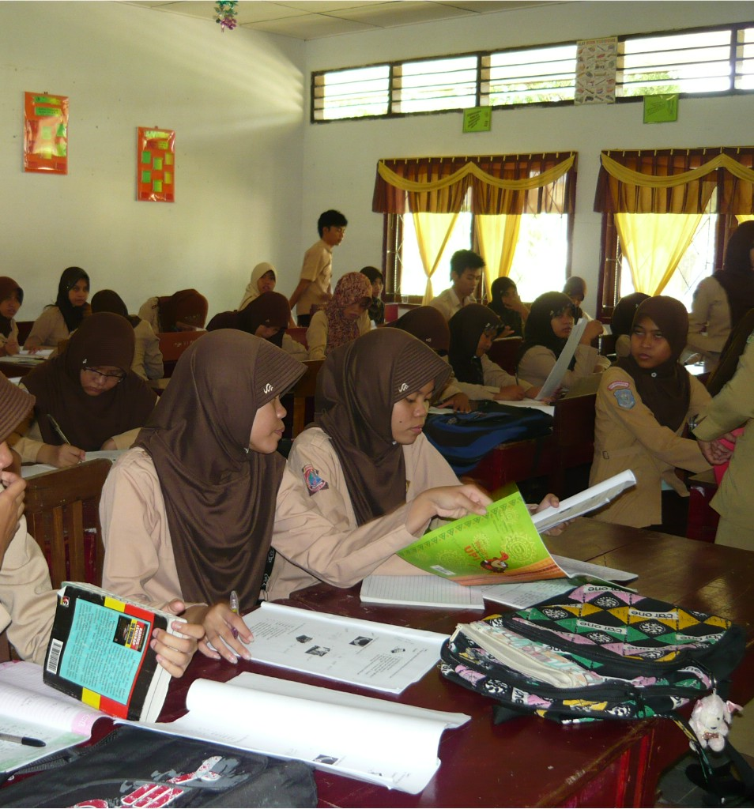
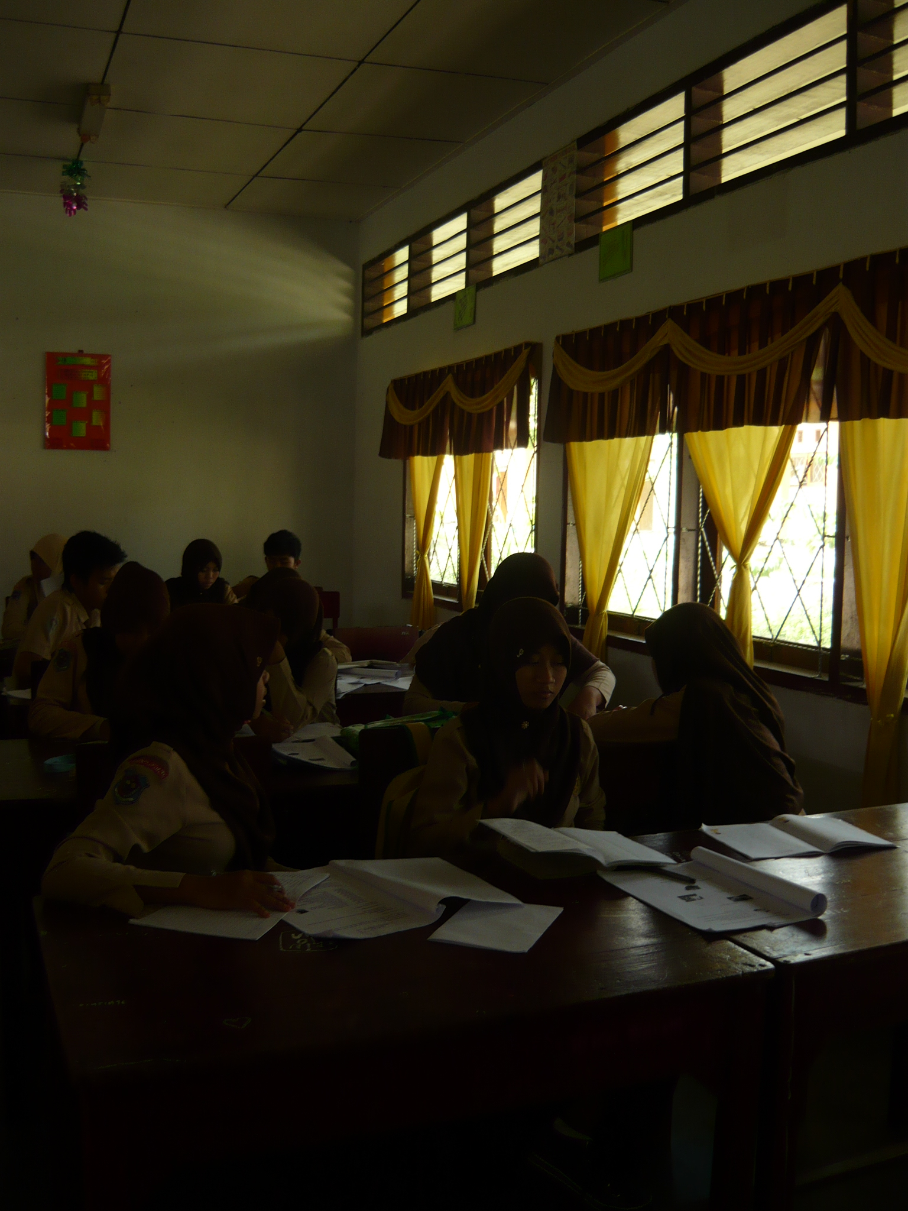

The Students work together
The English teacher asked the students to came and speak in front of the class.
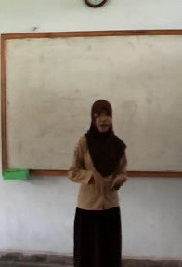
Some Students who did not understand the teacher’s explanation came to the English teacher and asked in Indonesian
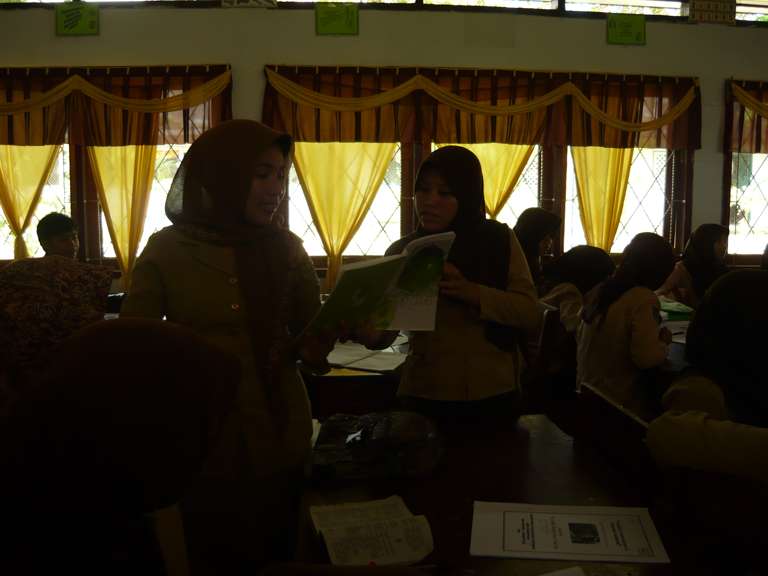
The Students’ Identify the Pictures Given.
They were not focused, asked each other and only answered the question in a word, based on the picture

Appendix 6. The Teacher’s Observation Sheet
Pre-Observation : February 2nd, 2011
Developed from : Mozkowitz (in Alwright et al., 1991: 204)
The Aspects Observe | Description | Yes (√) | No (√)
Pre-Activities | Opening activities by greeting and giving motivation | √
Deals With Feelings | Accepting, discussing, referring to, or communicating understanding feelings of students |  | √
Encourages | Encouraging students to continue, trying to give them confidence, confirming answers are correct |  | √
Uses Ideas of Students | Claryfing, using, interpreting, summarizing the ideas of students. the ideas must be rephrased by the teacher but still recognized as being student contribution. |  | √
Repeats Students’ response | Repeating the exact words of students after they participate. | √
Ask questions | Asking questions to which an answer is anticipated. | √
Gives information | Giving information, facts, own opinion or ideas, lecturing, or asking rhetorical questions. |  | √
Correct without rejection | Telling students who have made a mistake the correct response without using words or intonations which communicate criticsm. |  | √
Gives directions | Giving direction, requests, or commands which students are expected to follow.  Giving statements which students are expected to repeat exactly, to make substitution (substitution drills), or to change from one form to another (transformation drills) |  | √
Criticizes the students’ behaviour | Rejecting the behaviour of students; trying to change the non-acceptable behaviour; communicating anger, displeasure, annoyance, dissatisfactory with what students are doing. |  | √
Criticizes student response | Telling the student his response is not correct or acceptable and communicating by words or intonation criticism, displeasure, annoyance, rejection |  | √
Conclude the material | Conclude all the material learns at the end of teaching learning process. | √

Appendix 7. The Pre-Test Form
Task Type | Item Type | Focus
Intensive  Test-Takers see:  Test-Takers hear:  - (Point to the left picture) Who are they?  What are they doing?  - (Point to the right picture) who are they?  What are they doing?  - (Point to the both picture) After you graduate from Vocational High School, which one do you like the most? Do you want to continue your study or do you want to get a job? Why?  - What do you have to do, to prepare for that?  - (Point to the Right picture) If you work, what kind of job do you want to get? Why?  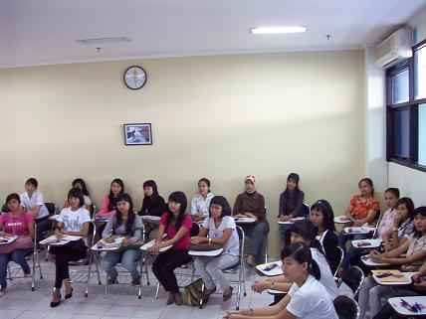 | Picture-cued elicitation of responses and description | Identify specific information, elaborate opinion and to describe preferences in painting.



Appendix 8. The oral Proficiency Score for Pre-Test
Date : February 5th, 2011

No | N A M E | Elements in Speaking |  |  |  |  |  | Score | Level | Learning Achievement
No | N A M E | I | II | III | IV | V | VI | Score | Level | Learning Achievement
1 | Zaenuddin | 1 | 1 | 0 | 1 | 1 | 0 | 4 | 0+ | 13
2 | Zulfiady M. | 1 | 1 | 2 | 2 | 4 | 1 | 11 | 1+ | 37
3 | Almi S. Harun | 1 | 1 | 1 | 1 | 1 | 1 | 6 | 1 | 20
4 | Arina A. Kasim | 1 | 1 | 1 | 1 | 1 | 1 | 6 | 1 | 20
5 | Astrid Blongkod | 1 | 1 | 2 | 2 | 2 | 2 | 11 | 1+ | 33
6 | Israyanti Tamuu | 0 | 1 | 1 | 1 | 1 | 1 | 5 | 0+ | 17
7 | Elmi S. Harun | 2 | 1 | 1 | 2 | 2 | 1 | 9 | 1+ | 30
8 | Fahriani Halidu | 1 | 1 | 1 | 1 | 1 | 1 | 6 | 1 | 20
9 | Faradila Pou | 0 | 0 | 0 | 1 | 0 | 0 | 1 | 0+ | 3
10 | Febrianty Moha | 1 | 1 | 1 | 2 | 1 | 1 | 7 | 1+ | 23
11 | Feronika Ridwan | 1 | 2 | 2 | 2 | 2 | 2 | 11 | 1+ | 37
12 | Fitri Yusuf | 1 | 2 | 2 | 2 | 2 | 2 | 11 | 1+ | 37
13 | Friska D. Djafar | 3 | 3 | 4 | 4 | 3 | 3 | 20 | 3 | 67
14 | Herny Noho | 2 | 2 | 2 | 2 | 2 | 2 | 12 | 2 | 40
15 | Hesti Isa | 0 | 1 | 1 | 1 | 1 | 0 | 4 | 0+ | 13
16 | Israwaty Rauf | 0 | 0 | 0 | 0 | 0 | 0 | 0 | 0 | 0
17 | Masita F. Yasin | 2 | 2 | 2 | 2 | 2 | 2 | 12 | 2 | 40
18 | Nahrisa L. | 1 | 1 | 1 | 1 | 1 | 1 | 6 | 1 | 20
19 | Nitawati Djasri | 1 | 2 | 2 | 2 | 2 | 2 | 11 | 1+ | 37
20 | Nurain Abudi | 0 | 1 | 0 | 0 | 0 | 0 | 1 | 0+ | 3
21 | Oliviya O. Taha | 2 | 3 | 3 | 3 | 3 | 2 | 16 | 2+ | 53
22 | PuspitaSari Hayati | 2 | 1 | 1 | 2 | 2 | 1 | 9 | 1+ | 30
23 | Ria S. Ishak | 0 | 0 | 0 | 1 | 1 | 0 | 2 | 0+ | 6.7
24 | Rizka Limonu | 0 | 1 | 0 | 1 | 0 | 0 | 2 | 0+ | 6.7
24 | Silvie L.Mohamad | 3 | 3 | 3 | 3 | 3 | 3 | 3 | 3 | 60
26 | Sintiya D.Djunubi | 1 | 1 | 1 | 2 | 2 | 1 | 8 | 1+ | 27
27 | Siska Mohamad | 2 | 3 | 2 | 2 | 2 | 2 | 13 | 2+ | 43
28 | Sri A. Ladiku | 1 | 1 | 1 | 1 | 2 | 1 | 7 | 1+ | 23
29 | Srinovanti b. M. | 1 | 2 | 2 | 2 | 3 | 2 | 12 | 2 | 40
30 | Sunarty Djaini | 1 | 1 | 1 | 1 | 1 | 1 | 6 | 1 | 20
31 | Susan T. Sako | 1 | 2 | 2 | 2 | 2 | 1 | 10 | 1+ | 33
32 | Tirta Yunus | 2 | 3 | 3 | 3 | 3 | 3 | 17 | 2+ | 57
33 | Irmawaty Husain | 2 | 2 | 2 | 3 | 4 | 2 | 15 | 2+ | 50

No | N A M E | Elements in Speaking |  |  |  |  |  | Score | Level | Learning Achievement
No | N A M E | I | II | III | IV | V | VI | Score | Level | Learning Achievement
34 | Yayu R. Ngiu | 0 | 0 | 0 | 1 | 1 | 0 | 2 | 0+ | 6.7
35 | Yuliyanti Idrus | 1 | 1 | 1 | 2 | 2 | 1 | 7 | 1+ | 27
36 | Yunita Mahajani | 0 | 0 | 0 | 1 | 0 | 0 | 1 | 0+ | 3
Sum |  | 39 | 50 | 48 | 60 | 60 | 43 | 285
Average |  | 1.083 | 1.389 | 1.333 | 1.667 | 1.667 | 1.194 |  | 27.78
Note:
I | Grammar
II | Vocabulary
III | Comprehension
IV | Fluency
V | Pronunciation
VI | Task
The students’ Achievement = $\frac{The Students^{'}Total Score}{Maximum Score}X100\%=$

Number | Speaking Evaluation’s Aspects | Maximum Score
1 | Grammar | 5
2 | Vocabulary | 5
3 | Comprehension | 5
4 | Fluency | 5
5 | Pronunciation | 5
6 | Task | 5

Gorontalo, February 2011
The Writer The English Teacher

Nur Endah Hawayanti Yulin Mudi, S.Pd
NIP. 19760108 200501 2 019

Appendix 9. The Example of Pre-Test Anaysis
Name : FRISKA DEVITA DJAFAR
Grammar | Vocab. | Comp. | Fluency | Pronunciation | Task | Total Score | Level | Achievement
3 | 3 | 4 | 4 | 3 | 3 | 20 | 3+ | 67

- (Point to the left picture) Who are they?
The Content Analysis : THE ANSWER IS RELEVANT
Her answer : “ They are student “
Her pronunciation : [ ∂əI ǝ:’ stʌdən ]
The right pronunciation : [∂əI ǝ:’/̛stju:dnt/ /stu:-]

What are they doing?
Her answer : “hmm #.1 looking something, they are looking something. They are just looking something, eh, no no no, but e #.1 sit down, dis:: discuss “

- (Point to the right picture) who are they?
THE RELEVANCY BETWEEN THE QUESTION AND THE ANSWER: Relevant
Her answer : “ official “
Her pronunciation : [o'fIʃIal]
The right pronunciation : [ɘ'fIʃl ]

What are they doing?
THE RELEVANCY BETWEEN THE QUESTION AND THE ANSWER: Relevant

Her answer : “mmm #.1 They are watching laptop for a #.1 searching #.1 a searching an information “
Her pronunciation : [fɔr] [sʌrtʃi:ŋ] [Infɘr'maʃIən]
The right pronunciation : [fɔ:] [sɜ:rtʃi:ŋ] [Infɘ'meʃn ]

- (Point to the both picture) After you graduate from Vocational High School, which one do you like most? Do you want to continue your study or do you want to get a job? Why?
The Content Analysis : The answer is relevant
Her answer : “ #.2 Study”
Her pronunciation : #.2 [ 'stʌdi ]
The right pronunciation : [ 'stʌdi ]

Why?
Her answer : “ because eh because #.1 because #.2 I #.2 saya masih ingin menambah ilmu begitu “
Her pronunciation : [bIkaʊs] eh [bIkʌz] [bI'kʌz] #.2 [ai] #.2 saya masih ingin menambah ilmu begitu mam.
The right pronunciation : [ bI'kɒz]

- What do you have to do, to prepare for that?
The Content Analysis : THE ANSWER IS RELEVANT
Her answer : “ I want to be a lawyer\ #.3 mental #.1 and #.2 all about e #.1 the subject #.1 all about #.2 yang berkaitan with my #.1 jurusan“.
Her pronunciation : [ 'lʌwjǝr] [mentʌl] [ʌl ʌboʊt] [ʌl ʌboʊt]
The right pronunciation : [ 'lɔ:jǝ’] ['mentl] [ɔ:l ǝbaʊt] [ɔ:l ǝbaʊt]

- (point to the Right picture) if you work, what kind of job do you want to get?
The Content Analysis : THE ANSWER IS RELEVANT
Her answer : “Civil servant”
Her pronunciation : ['sIvIl 'sərvənt ]
The right pronunciation : ['sIvl 'sɜ:vənt ]
Why?
Her answer : “ because I like e my hobby is #.2 writing and I like e #.17
bisa mo ralat mam… maksudnya di situ depe cita-cita… I want to be lawyer because I like all about of the law #.1 the law“
Her pronunciation : [wraItiŋ] [bI’kʌʊz] [ʌl ʌbaʊt] ['lʌʊ]
The right pronunciation : [raItiŋ] [bI’kǝz] [ɔ:l ǝbaʊt] ['lɔ: ]

Appendix 10. The Lesson Plan in the First Cycle
LESSON PLAN

Subject : English
Grade /Semester : XI/4
Time Allocation : 6 x 45 minutes
Standard Competence : Communicating in English
Level Elementary
Basic Competence : Expressing various Feelings
Topic : Expressing opinion related to the Secretary’s skills

1. The Learning Aim
The students are expected to be able to:
- Understand the preferences
- Use the simple present tense form and Auxiliary Verbs
- Identify the object will express
- Express the opinion based on the situation given related to the job.

2. Learning Material
Expressing Opinions: Expression opinions related to the secretary’ skills
3. Learning Method
Cooperative Language Learning: Think-Pair-Share strategy
- Steps of Learning
First Meeting
a. Pre-activities (around 10 minutes)
- Greet the students
- Check students’ presence (Write down the name of the students who are absent)
- Give apperception and Motivation (asking the students about what they are going to do when they have an opinion, Etc, and giving clues to them about the topic they are going to learn.)

b. Activities (around 70 minutes)
- Ask the students about the type of questions used in asking questions.
- Explain Wh-Questions to the students.
- Explain the expression use in expressing opinions.
- Explain grammar review: Preferences and Simple Present Tense to express their opinion.
c. Post-activities (5 minutes)
- Ask whether or not the students have difficulties
- Conclude the material.

Second Meeting
a. Pre-activities (around 10 minutes)
- Greet the students
- Check students’ presence (Write down the students who are absent)
- Give apperception and Motivation
- Activities (75 minutes)
- Give some vocabularies related to the topic “Secretary’s skills”.
- Teach the students how to pronounce the words.
- Explain the procedures of Think-Pair-Share.
- Pose a topic to discuss. The topic is about “The Secretary’s Skills”. The topic is divided into three sub-topics. They are: handling the telephone, Taking Note Using Stenography, and Typing.
- Ask the students to choose one sub-topic they like, and think about the sub topic they choose. The teacher asks them to think about their thinking about the skill they have chosen.
- Ask the students to sit in pairs to discuss and exchange their opinions with their friends in pairs.
- Student A ask about student B’s opinion, and student B, also does the same thing to the student A. They should know their partner’s opinion.
- Ask the students to come in front of the class in pairs, and ask them to share their friend’s opinion.
- Call the students randomly to come in front of the class.
- Encourage the other students to ask question and motivate their pairs to ask the question when the pairs stand in front of the class and share the opinion.
- In asking and giving questions, the students can learn from each other.
c. Post-activities
- Ask whether or not the students have difficulties.
- Conclude the matter.

The Third Meeting
Give test to the students and evaluate their speaking ability in expressing opinion.

5. Resources, Instruments, Media
Resources : Effective Communication, English in Progress.
Instruments: Pictures, Recorder.
Media : Pictures
6. Evaluation
Technique : Oral Test
Form : Picture-Cued Elicitation of Responses and Description

Task Type | Item Type | Focus
Intensive  Test-Taker see:  Test-Taker hear:  - (Point to the left picture) Who is she?  What is she doing?  - (point to the right picture) Who is she?  What is she doing?  - (Point to the both pictures) Which one do you like the most. Why?  - Which one is more challenging? Why?  - (Point to the left picture) Do you think, typing is a difficult skill to master? Why? | Picture-cued elicitation of responses and description | Identify specific information, elaborate opinion and to describe preferences in painting.



http://img825.imageshack.us/img825/1637/82763953.jpg

The technique of evaluation as follows as:
    - The score for every aspect in speaking is from 1 to 5 based on the criteria before.
    - The total score get from the sum of all the score from all aspects that the students achieve.
    - The students’ achievement get from the formula:
$$Learning Achievement=\frac{The Student^{'}s Total Score}{Maximum Score} x 100\%=$$

Gorontalo, February 2011
Under the supervision of
The principle, The Teacher

Drs. Rustam Umalu, M.Si Yulin Mudi, S.Pd
NIP. 19670321 199703 1 005 NIP. 19760108 200501 2 019
Appendix 11. The Documentation in the First Cycle
The pairs Share their opinion in front of the class, but many of them still read the opinions
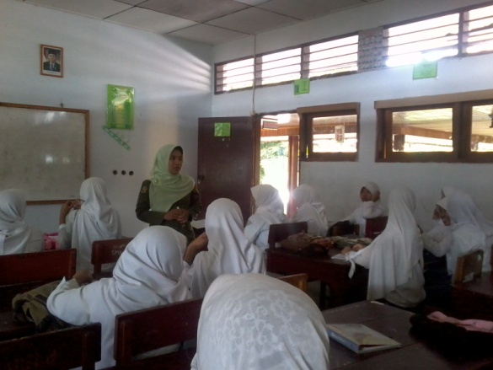
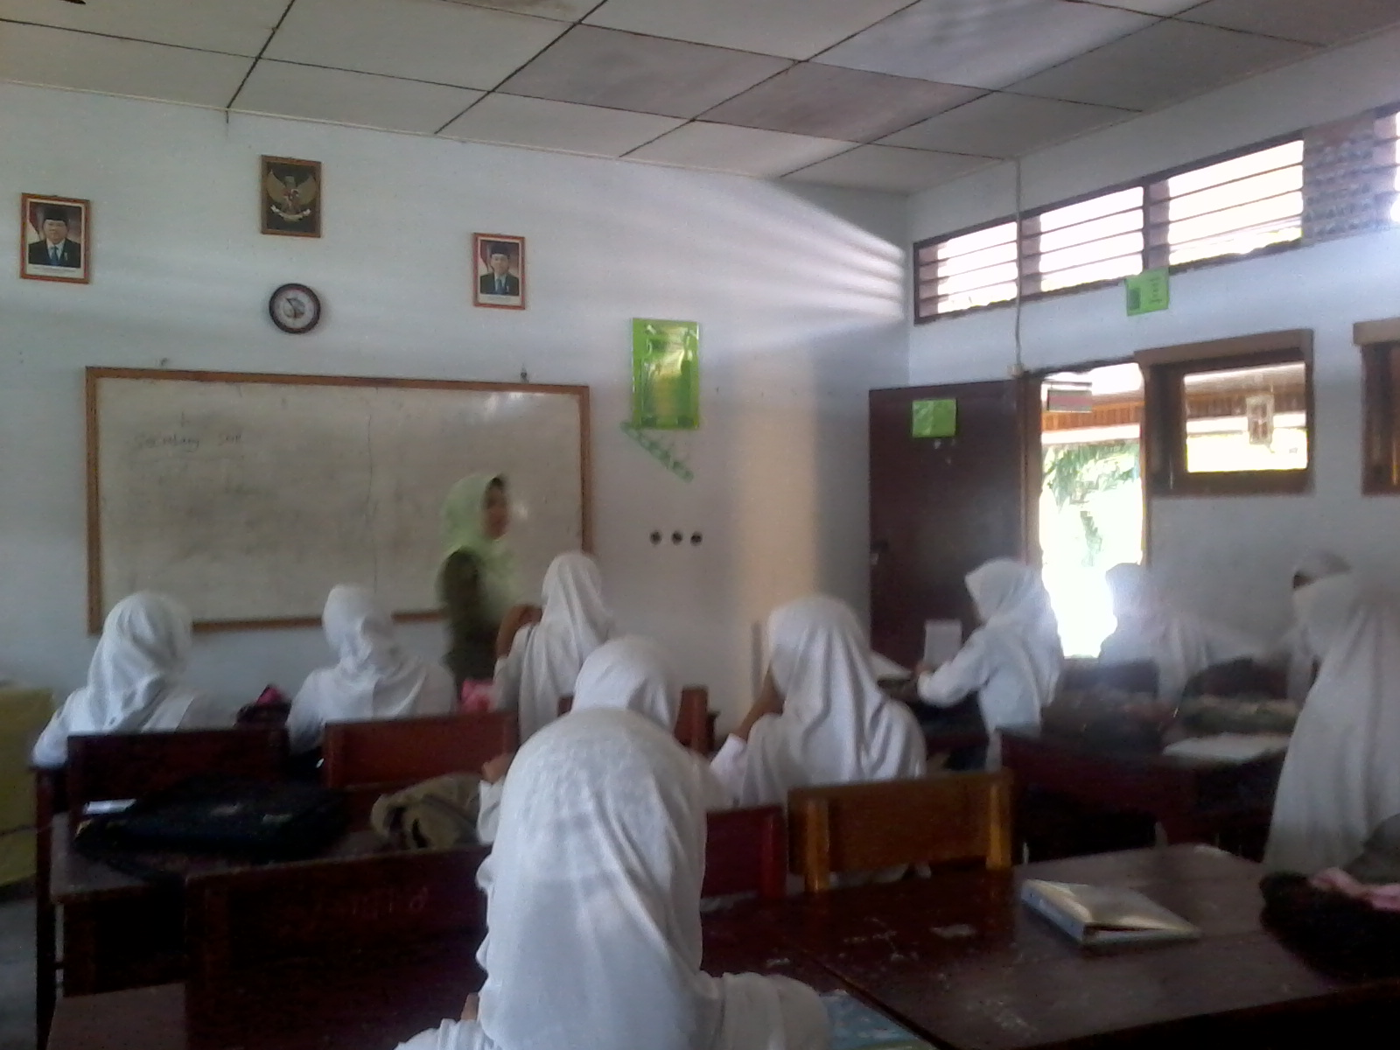
The Teacher Explained the Expression in Expressing Opinion, and the simple present tense as the Grammar Review
First Meeting: Monday, February 7th, 2011
The First meeting
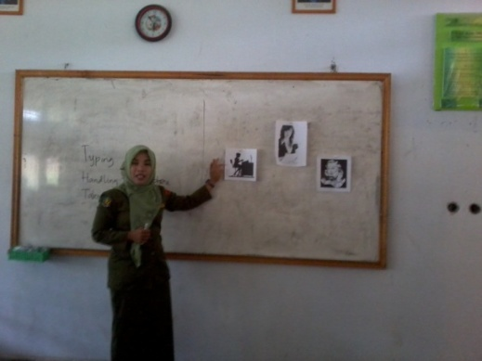
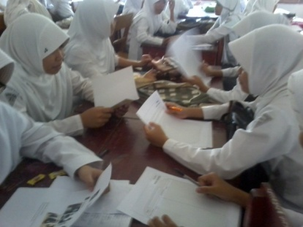
The Students discussed in Pairs. They still read their opinion and discussed used Indonesian

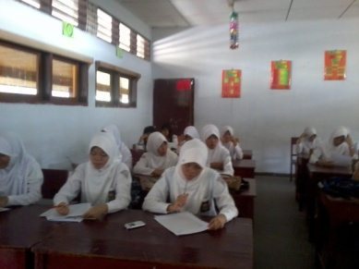

The implementation of Think-Pair-Share
The Teacher gave Sub-Topics and posed the question on Monday 14th, 2011
The Students “Think” by themselves. Some of them Still asked to the other and some still open the dictionary

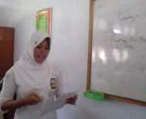

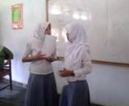
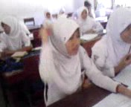
The Pairs Discussed and tried to find the answer of the questions
Some Students asked questions

Appendix 12. The Students’ Seating Chart use for Observation
Whiteboard

Cupboard
Teacher’s Desk and Chair
Door
Irma Husain
Friska Djafar
Fero Ridwan
Hesti Isa
Sintia Dewi Djunubi
Israwati Rauf
Astrid R. Blongkd
Rizka Limonu
Fahraini Halidu
Nurain Abudi

Zaenudin
Susan Tresano Sako
Febri Moha
Masita F. Yasin

Zulfiadi Madito
Faradila PoU
Ria S. Ishak
Yayu NgiU
Nita Djasri
Puspita Sari Hayati
Silvie Lusiana M.
Sri Armila Ladiku
Olivia Taha
Sunarti Djaini
Yunita M.
Fitri Yusuf
Siska M.
Israyanti Tamuu
Almi s. Harun
Nahrisa L.
Sri novanti
Yulianti Idrus
Herni Noho
Arina Kasim
Tirta Yunus
Elmi S. Harus
Appendix 13. Table of Observation Result of Cycle 1
No | Students’ Code | Aspects Observe |  |  |  |  |  | Total Score | % | Students’ Participation Criteria
No | Students’ Code | I | II | III | IV | V | VI | Total Score | % | Students’ Participation Criteria
1 | L_01 | 1 | 1 | 1 | 1 | 0 | 0 | 4 | 67 | D
2 | L_02 | 1 | 1 | 1 | 1 | 0 | 1 | 5 | 83 | B
3 | L_03 | 1 | 1 | 1 | 1 | 0 | 0 | 4 | 67 | D
4 | L_04 | 1 | 1 | 1 | 1 | 1 | 0 | 5 | 83 | B
5 | L_05 | 0 | 0 | 0 | 0 | 0 | 0 | 0 | 0 | D
6 | L_06 | 0 | 0 | 0 | 0 | 0 | 0 | 0 | 0 | D
7 | L_07 | 1 | 1 | 1 | 1 | 0 | 0 | 4 | 67 | D
8 | L_08 | 1 | 1 | 1 | 1 | 0 | 0 | 4 | 67 | D
9 | L_09 | 0 | 0 | 0 | 0 | 0 | 0 | 0 | 0 | D
10 | L_10 | 1 | 1 | 1 | 1 | 0 | 0 | 4 | 67 | D
11 | L_11 | 1 | 1 | 1 | 1 | 1 | 0 | 5 | 83 | B
12 | L_12 | 1 | 1 | 1 | 1 | 0 | 0 | 4 | 67 | D
13 | L_13 | 1 | 1 | 1 | 1 | 1 | 1 | 6 | 100 | A
14 | L_14 | 1 | 1 | 1 | 1 | 1 | 0 | 5 | 83 | B
15 | L_15 | 1 | 1 | 1 | 1 | 0 | 1 | 5 | 83 | B
16 | L_16 | 0 | 0 | 0 | 0 | 0 | 0 | 0 | 0 | 0
17 | L_17 | 1 | 1 | 1 | 1 | 1 | 0 | 5 | 83 | B
18 | L_18 | 1 | 1 | 1 | 1 | 1 | 1 | 6 | 100 | A
19 | L_19 | 1 | 1 | 1 | 1 | 0 | 0 | 4 | 67 | D
20 | L_20 | 0 | 0 | 0 | 0 | 0 | 0 | 0 | 0 | D
21 | L_21 | 1 | 1 | 1 | 1 | 1 | 1 | 6 | 100 | A
22 | L_22 | 1 | 1 | 1 | 1 | 0 | 1 | 5 | 83 | B
23 | L_23 | 0 | 0 | 0 | 0 | 0 | 0 | 0 | 0 | D
24 | L_24 | 1 | 1 | 1 | 1 | 0 | 1 | 5 | 83 | B
25 | L_25 | 1 | 1 | 1 | 1 | 1 | 1 | 6 | 100 | A
26 | L_26 | 1 | 1 | 1 | 1 | 0 | 1 | 5 | 83 | B
27 | L_27 | 1 | 1 | 1 | 1 | 1 | 0 | 5 | 83 | B
28 | L_28 | 1 | 1 | 1 | 1 | 0 | 0 | 4 | 67 | D
29 | L_29 | 1 | 1 | 1 | 1 | 1 | 1 | 6 | 100 | A
30 | L_30 | 1 | 1 | 0 | 0 | 0 | 0 | 2 | 33 | D
31 | L_31 | 1 | 1 | 1 | 1 | 0 | 0 | 4 | 67 | D
32 | L_32 | 1 | 1 | 1 | 1 | 1 | 0 | 5 | 83 | B

No | Students’ Code | Aspects Observe |  |  |  |  |  | Total Score | % | Students’ Participation Criteria
No | Students’ Code | I | II | III | IV | V | VI | Total Score | % | Students’ Participation Criteria
33 | L_33 | 1 | 1 | 1 | 1 | 1 | 1 | 6 | 100 | A
34 | L_34 | 0 | 0 | 0 | 0 | 0 | 0 | 0 | 0 | D
35 | L_35 | 1 | 1 | 1 | 1 | 0 | 0 | 4 | 67 | D
36 | L_36 | 1 | 1 | 1 | 1 | 0 | 0 | 4 | 67 | D
Sum |  | 29 | 29 | 28 | 28 | 12 | 11 | 137
Percentage |  | 80.56 | 80.56 | 77.78 | 77.78 | 33.33 | 30.56 | 380.56
Note:
I. Paying attention to the teacher
II. Checking for understanding by individual thinking
III. Discussing opinion in pairs
IV. Encouraging to share opinion to the other
V. Able to speak with their own words
VI. Interaction in asking and answering questions

Score
1 | Involved
0 | Not Involved

Criterion of Students’ Participation
A | 90 – 100% | Excellent level of participation
B | 80 – 89% | High level of participation
C | 70 – 79% | Satisfactory level of participation
D | 69% or below | Low level of participation
Gorontalo, February, 2011
The Observer,

Nur Endah Hawayanti

The Observer’s Notification: Few of the students participated and presented the task well, but most of them were the written expressive students. They like to organized their thinking on the paper and read their opinion.

Appendix 14. The Teacher’s Observation Sheet In the First Cycle
February 7th and 14th, 2011

Developed from : Mozkowitz (in Alwright et al., 1991: 204)
The Aspects Observe | Description | Yes (√) | No (√)
Pre-Activities | Opening activities by greeting and giving motivation | √
Deals With Feelings | Accepting, discussing, referring to, or communicating understanding feelings of students | √
Encourages | Encouraging students to continue, trying to give them confidence, confirming answers are correct | √
Uses Ideas of Students | Claryfing, using, interpreting, summarizing the ideas of students. the ideas must be rephrased by the teacher but still recognized as being student contribution. |  | √
Repeats Students’ response | Repeating the exact words of students after they participate. | √
Ask questions | Asking questions to which an answer is anticipated. | √
Gives information | Giving information, facts, own opinion or ideas, lecturing, or asking rhetorical questions. | √
Correct without rejection | Telling students who have made a mistake the correct response without using words or intonations which communicate criticsm. |  | √
Gives directions | Giving direction, requests, or commands which students are expected to follow.  Giving statements which students are expected to repeat exactly, to make substitution (substitution drills), or to change from one form to another (transformation drills) | √
Criticizes the students’ behaviour | Rejecting the behaviour of students; trying to change the non-acceptable behaviour; communicating anger, displeasure, annoyance, dissatisfactory with what students are doing. |  | √
Criticizes student response | Telling the student his response is not correct or acceptable and communicating by words or intonation criticism, displeasure, annoyance, rejection |  | √
Conclude the material | Conclude all the material learns at the end of teaching learning process. | √

Appendix 15. The oral Proficiency Score for First-Test
Date : 16th February, 2011
No | N A M E | Elements in Speaking |  |  |  |  |  | Score | Level | Learning Achievement | Note
No | N A M E | I | II | III | IV | V | VI
1 | Zaenuddin | 2 | 2 | 2 | 2 | 3 | 2 | 13 | 2+ | 43 | Not Passed
2 | Zulfiady M. | 3 | 2 | 2 | 2 | 3 | 2 | 14 | 2+ | 47 | Not Passed
3 | Almi S. Harun | 2 | 3 | 3 | 3 | 4 | 3 | 18 | 3 | 60 | Not Passed
4 | Arina A. Kasim | 2 | 4 | 4 | 3 | 4 | 2 | 18 | 3 | 60 | Not Passed
5 | Astrid Blongkod | 2 | 2 | 2 | 2 | 2 | 2 | 12 | 2 | 40 | Not Passed
6 | Israyanti Tamuu | 2 | 2 | 2 | 2 | 2 | 2 | 12 | 2 | 40 | Not Passed
7 | Elmi S. Harun | 4 | 4 | 3 | 3 | 4 | 3 | 22 | 3+ | 73 | Passed
8 | Fahriani Halidu | 2 | 3 | 3 | 2 | 3 | 2 | 15 | 2+ | 50 | Not Passed
9 | Faradila Pou | 1 | 1 | 1 | 1 | 2 | 1 | 7 | 1+ | 23 | Not Passed
10 | Febrianty Moha | 4 | 3 | 3 | 3 | 4 | 3 | 20 | 3+ | 67 | Not Passed
11 | Feronika Ridwan | 4 | 4 | 4 | 4 | 4 | 3 | 23 | 3+ | 77 | Passed
12 | Fitri Yusuf | 3 | 4 | 4 | 3 | 4 | 3 | 21 | 3+ | 70 | Passed
13 | Friska D. Djafar | 4 | 4 | 4 | 4 | 4 | 3 | 23 | 3+ | 77 | Passed
14 | Herny Noho | 4 | 4 | 4 | 4 | 4 | 4 | 24 | 4 | 80 | Passed
15 | Hesti Isa | 3 | 4 | 4 | 4 | 4 | 3 | 22 | 3+ | 73 | Passed
16 | Israwaty Rauf | 1 | 1 | 1 | 2 | 2 | 1 | 8 | 1+ | 27 | Not Passed
17 | Masita F. Yasin | 3 | 3 | 4 | 3 | 4 | 3 | 20 | 3+ | 67 | Not Passed
18 | Nahrisa L. | 0 | 0 | 0 | 0 | 0 | 0 | 0 | 0 | 0 | Not Passed
19 | Nitawati Djasri | 3 | 2 | 3 | 3 | 4 | 2 | 17 | 2+ | 57 | Not Passed
20 | Nurain Abudi | 2 | 2 | 2 | 3 | 2 | 2 | 14 | 2+ | 47 | Not Passed
21 | Oliviya O. Taha | 2 | 3 | 3 | 3 | 4 | 2 | 17 | 2+ | 57 | Not Passed
22 | PuspitaSari H. | 3 | 4 | 4 | 4 | 5 | 3 | 23 | 3+ | 77 | Passed
23 | Ria S. Ishak | 4 | 4 | 4 | 3 | 4 | 3 | 22 | 3+ | 73 | Passed
24 | Rizka Limonu | 4 | 4 | 3 | 3 | 5 | 3 | 22 | 3+ | 73 | Passed
24 | Silvie Mohamad | 4 | 4 | 4 | 4 | 5 | 3 | 24 | 4 | 80 | Passed
26 | Sintiya D.Djunubi | 5 | 3 | 4 | 4 | 5 | 2 | 23 | 3+ | 77 | Passed
27 | Siska Mohamad | 4 | 3 | 4 | 4 | 5 | 3 | 23 | 3+ | 77 | Passed
28 | Sri A. Ladiku | 4 | 4 | 4 | 4 | 4 | 3 | 24 | 3+ | 77 | Passed
29 | Srinovanti b. M. | 2 | 2 | 2 | 3 | 4 | 2 | 15 | 2+ | 50 | Not Passed
30 | Sunarty Djaini | 3 | 3 | 3 | 3 | 4 | 3 | 19 | 3+ | 63 | Not Passed
31 | Susan T. Sako | 3 | 3 | 3 | 3 | 4 | 2 | 18 | 3 | 60 | Not Passed
32 | Tirta Yunus | 4 | 4 | 4 | 4 | 4 | 3 | 23 | 3+ | 77 | Passed
33 | Irmawaty Husain | 4 | 4 | 4 | 4 | 5 | 4 | 25 | 4+ | 83 | Passed

No | N A M E | Elements in Speaking |  |  |  |  |  | Score | Level | Learning Achievement | Note
No | N A M E | I | II | III | IV | V | VI
34 | Yayu R. Ngiu | 1 | 2 | 2 | 1 | 2 | 1 | 9 | 1+ | 30 | Not Passed
35 | Yuliyanti Idrus | 2 | 3 | 2 | 3 | 4 | 2 | 16 | 2+ | 53 | Not Passed
36 | Yunita Mahajani | 3 | 3 | 3 | 3 | 4 | 3 | 19 | 3+ | 63 | Not Passed
Sum |  | 109 | 123 | 125 | 131 | 143 | 111 | 732
Average |  | 3.03 | 3.42 | 3.47 | 3.64 | 3.97 | 3.08 | 20.33 |  | 68.83
Note:
- Grammar
- Vocabulary
- Comprehension
- Fluency
- Pronunciation
- Task

The students’ Achievement = $\frac{The Students^{'}Total Score}{Maximum Score}X100\%=$

Number | Speaking Evaluation’s Aspects | Maximum Score
1 | Grammar | 5
2 | Vocabulary | 5
3 | Comprehension | 5
4 | Fluency | 5
5 | Pronunciation | 5
6 | Task | 5

Gorontalo, February 2011
The Writer The English Teacher

Nur Endah Hawayanti Yulin Mudi, S.Pd
NIP. 19760108 200501 2 019
Appendix 16. The Example of Analysis in the First Test

Name : FRISKA DEVITA DJAFAR
Grammar | Vocab. | Comp. | Fluency | Pronunciation | Task | Total Score | Level | Achievement
4 | 4 | 4 | 4 | 4 | 3 | 23 | 3+ | 77

- (Point to the left picture) Who is she?
The Content Analysis : THE ANSWER IS RELEVANT
Her answer : She is a secretary
The right Pronunciation : [ʃi: Iz ə ‘sekrətri:]

What is she doing?
The Content Analysis : THE ANSWER IS RELEVANT
Her Asnwer : She is typing, #mm #.1 searching the information.
[ʃi: Iz taIpIŋ, sɜ:’ʧIŋ ∂ə Infə’meIʃən]
The right pronunciation : [ʃi: Iz taIpIŋ sɜ:’ʧIŋ ∂I Infə’meIʃən ]

- (Point to the right picture) Who is she?
The Content Analysis : THE ANSWER IS RELEVANT
Her answer : She is a secretary [ʃi: Iz ə ‘sekrətri: ]
The right Pronunciation : [ʃi: Iz ə ‘sekrətri: ]

What is she doing?
The Content Analysis : THE ANSWER IS RELEVANT
Her answer : She is handles the telephone, handling the telephone and taking note.
[ʃi: Iz hændlIs telIfoʊn, hændlIŋ ∂ə telIfoʊn ænd teIkIŋ noʊt]
The right pronunciation : [ʃi: Iz hændlz telIfoʊn, hændlIŋ ∂ə telIfoʊn ænd teIkIŋ noʊt]

- (Point to the both pictures) Which one do you like most. Why?
The Content Analysis : THE ANSWER IS RELEVANT
Her Answer : I think like picture right, I like handling the telephone and learn how for doing two activities in one time I think it’s difficult.
.
Wrong pronunciation : -
The right pronunciation : -

- In your opinion, which one is more challenging?
The Content Analysis : THE ANSWER IS RELEVANT
Her answer : #.4 mmm, I think the right picture, the right picture doing two activity in one time #.1 do the activity in one time. I think it difficult for me takes to the activity to the one time
Wrong pronunciation : [cIŋk]
The right pronunciation : [θIŋk]

- (Point to the left picture) Do you think, typing is a difficult skill to master?
The Content Analysis : THE ANSWER IS RELEVANT
Her answer : Yes, eh, I think yes, I as a secretary, so I can doing typing for, I can doing typing for, for the activity, eh, for my activity in the office.
Wrong pronunciation : -
The right pronunciation : -

Appendix 17. The Lesson Plan in the Second Cycle
LESSON PLAN

Subject : English
Grade /Semester : XI/4
Time Allocation : 6 x 45 minutes
Standard Competence : Communicating in English
Level Elementary
Basic Competence : Expressing various Feelings
Topic : Expressing Opinion Related to the Secretary’s Job Activities
1. The Learning Aim
The students are expected to be able to:
- Understand the preferences
- Use the simple present tense form and Auxiliary Verbs
- Identify the object will express
- Express the opinion based on the situation given related to the job.
2. Learning Material
Expressing Opinions: Expression opinions related to the secretary’s Job Activities.
3. Learning Method
Cooperative Language Learning: Think-Pair-Share Technique
- Steps of Learning
First Meeting
- Pre-activities (around 10 minutes)
- Greet the students
- Check students’ presence (Write down the students who are absent)
- Give apperception and Motivation.

- Activities (75 minutes)
- Review the subjects learnt in the first meeting, the expression used to express opinion.
- Explain the use of auxiliary verbs to express the opinion.
- Give a chance to the students to compose an practice to use the expression and the auxiliary verbs to express the opinion.
- Explain generally about the secretary’s job activities.
- Give some vocabularies to the students related to the topic “Secretary’s Job Activities.”
- Ask the students to find the other words related to the secretary’s job activities and pronounce the words together.
c. Post-activities
- Ask whetheror not the students have difficulties
- Conclude the matter.

The Second Meeting
- Pre-activities (around 10 minutes)
- Greet the students
- Check students’ presence (Write down the name of the students who are absent)
- Give apperception and Motivation.

- Activities (75 minutes)
- Explain the model of Cooperative Learning, in this case is the step of Think-Pair-Share strategy.
- Pose the topic about “The Secretary’s Job Activity” and divide the topic into three sub-topics. The sub topics are: Handling the Guest, Presenting, and Composing Business Letter.
- Ask the students to choose one activity that they really like, and ask them to think about their opinion related to the skills.
- Ask the students to sit in pairs and discuss the topic they have chosen. They ask each other. Student A has to ask the student B’s opinion and student B do as the same thing.
- Give instruction to the students to share their friend’s opinion in front of the class. The students who are asked to come in front of the class are take randomly.
- Give a chance to the students to ask and answer the questions.
c. Post-activities
- Ask for the students’ difficulties
- Conclude the material.
- Greet the students.
The Third Meeting
- Evaluate the students ‘ speaking ability
5. Resources, Instruments, Media
Resources : Effective Communication, English in Progress.
Instruments: Recorder
Media : Pictures
6. Evaluation
Technique: oral test
Form : Picture-Cued Elicitation of Responses and Description

Task Type | Item Type | Focus
Intensive  Test-Taker see:  Test-Taker hear:  - (Point to the both picture) Where are the settings of these pictures?  - (Point to the both picture) What are they doing?  - (point to the woman on the left picture) If you were her, is it difficult for you to present something in front of the other people? Why?  - (point to the right picture) What should she do in handling the quest?  - Which one is more challenging for you? Why? | Picture-cued elicitation of responses and description | Identify specific information, elaborate opinion and to describe preferences in painting.



http://www.freeimagehosting.net/newuploads/ec65a.jpg
http://s1.postimage.org/56v7g41tx/public.jpg

The technique of evaluation as follows as:
- The score for every aspect in speaking is from 1 to 5 based on the criteria before.
- The total score get from the sum of all the score from all aspects
- The students’ achievement get from the formula:
$$Learning Achievement=\frac{The Student^{'}s Total Score}{Maximum Score} x 100\%=$$
Gorontalo, February 2011
Under the supervision of
The principle, The Teacher

Drs. Rustam Umalu, M.Si Yulin Mudi, S.Pd
NIP. 19670321 199703 1 005 NIP. 19760108 200501 2 019
Appendix 18. The Documentation in the Second Cycle
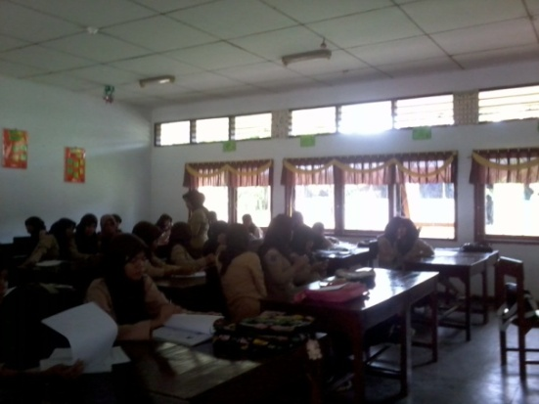
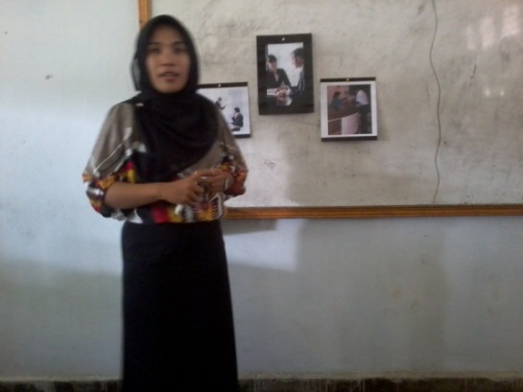

The Teacher Posed the question base on
the Sub-Topics
Second Meeting : Saturday, 26th Feb, 2011
The Second Meeting : Saturday, 5th March, 2011
The teacher reviewed the expression in Expressing Opinion, Grammatical Review and gived some vocabularies
The First Meeting : Wednesday, February 23rd, 2011

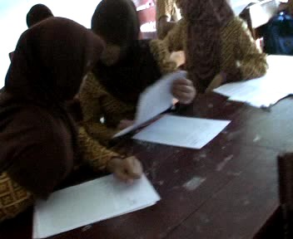
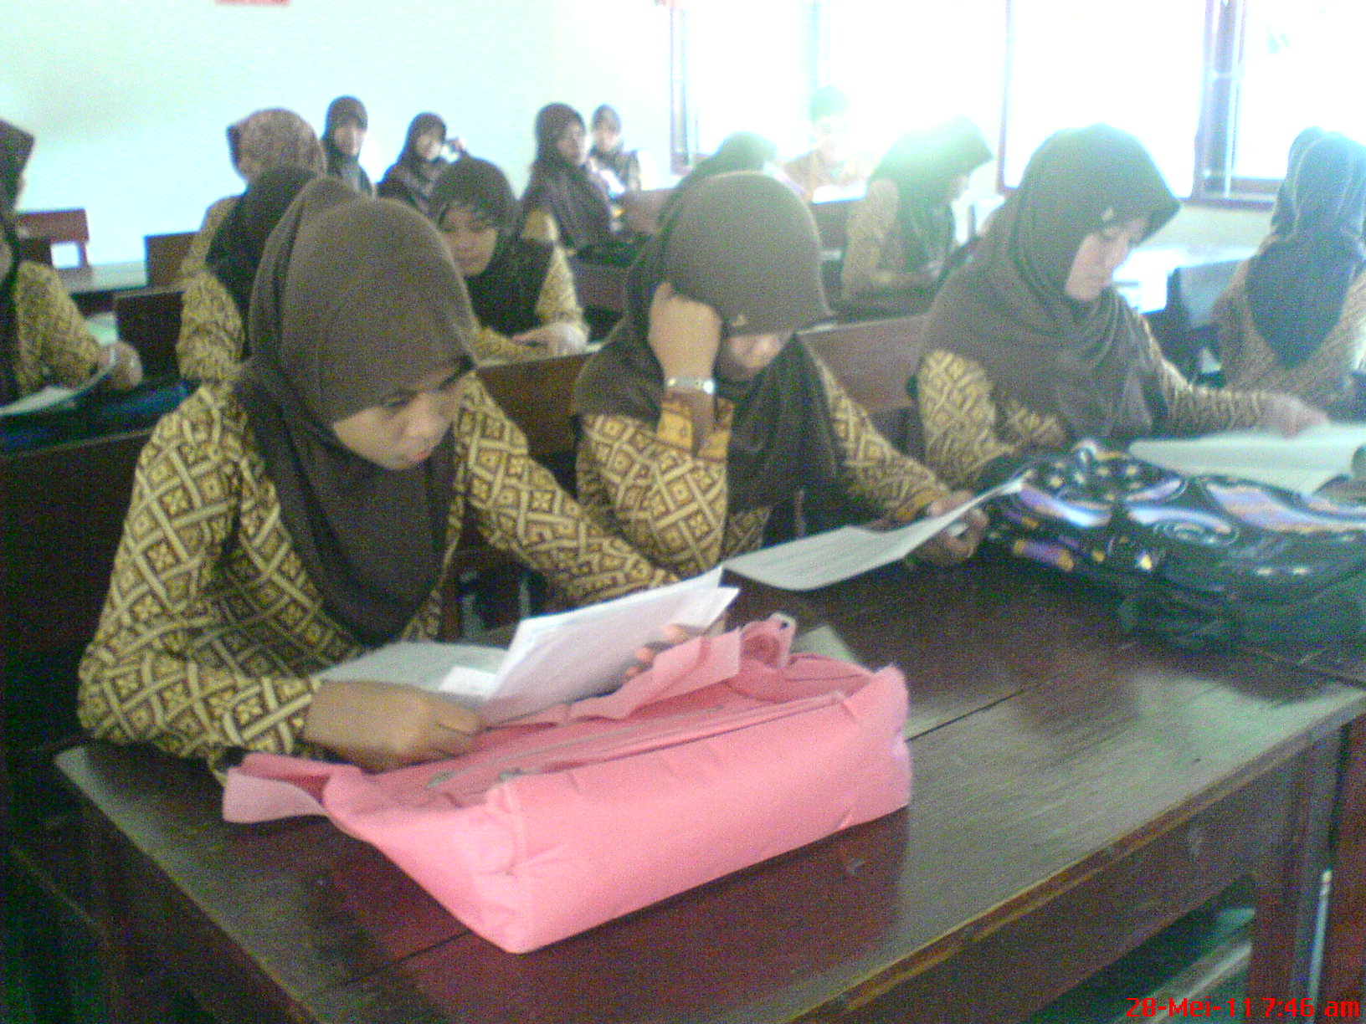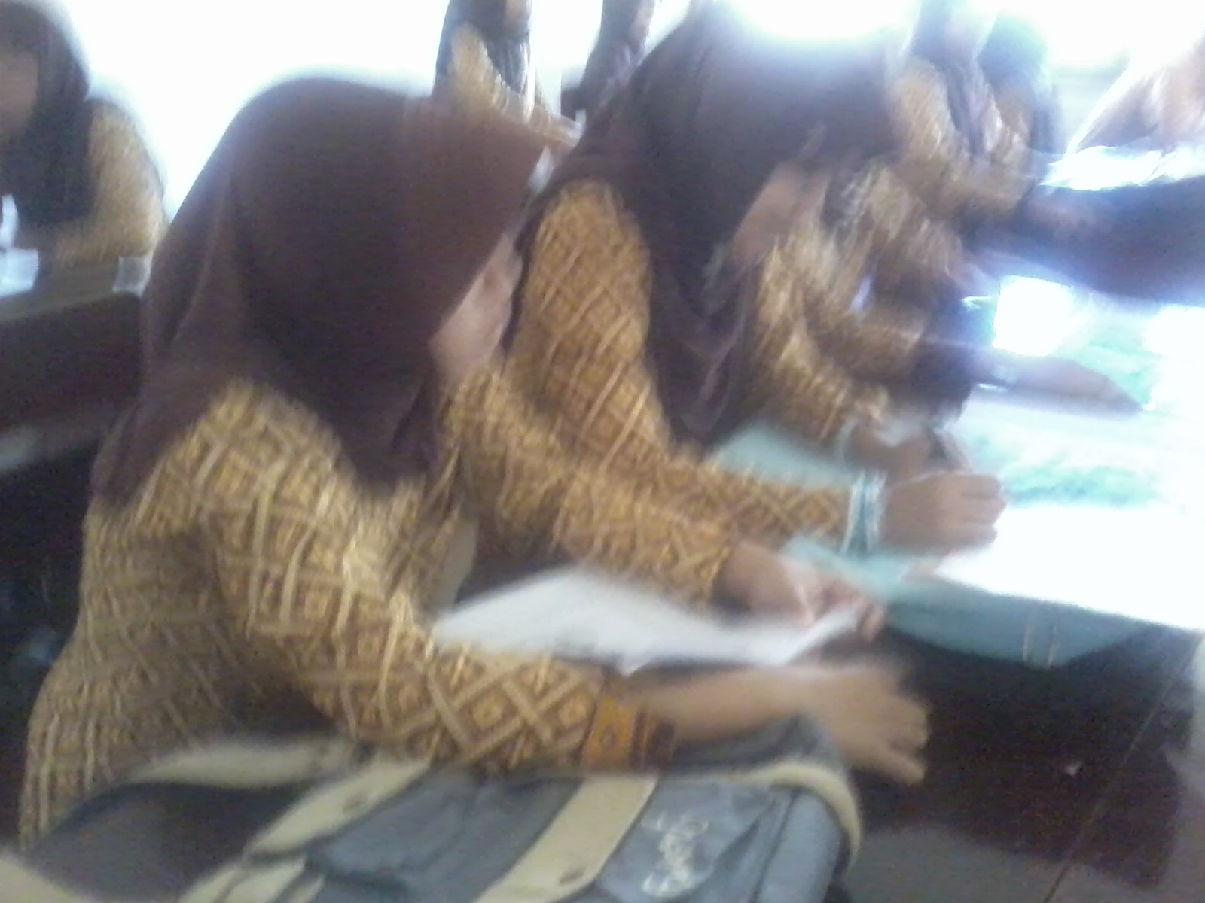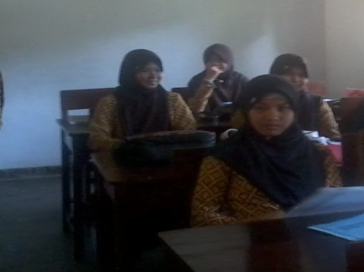
The students “Think” by themselves

The students discussed in pairs
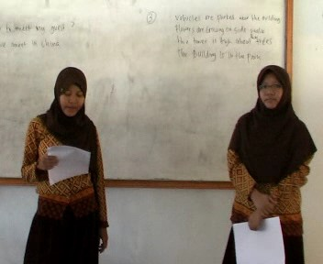
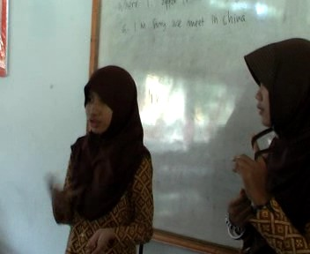
Some students shared the opinions
with their own words.

Some students read the opinions
The students participated more in answering the questions
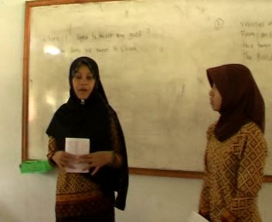
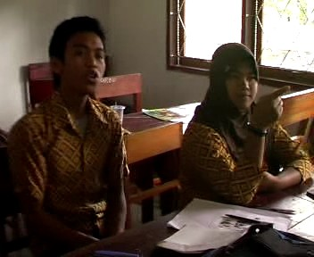
Some students were not afraid anymore in asking question
Appendix 19. Table of Observation Result of Cycle 2
No | Students’ Code | Aspects Observe |  |  |  |  |  | Total Score | % | Students’ Participation Criteria
No | Students’ Code | I | II | III | IV | V | VI | Total Score | % | Students’ Participation Criteria
1 | L_01 | 1 | 1 | 1 | 1 | 0 | 1 | 5 | 83 | B
2 | L_02 | 1 | 1 | 1 | 1 | 0 | 1 | 5 | 83 | B
3 | L_03 | 1 | 1 | 1 | 1 | 1 | 1 | 6 | 100 | A
4 | L_04 | 1 | 1 | 1 | 1 | 0 | 1 | 5 | 83 | B
5 | L_05 | 0 | 0 | 0 | 0 | 0 | 0 | 0 | 0 | D
6 | L_06 | 1 | 1 | 1 | 1 | 0 | 0 | 4 | 67 | D
7 | L_07 | 1 | 1 | 1 | 1 | 0 | 0 | 4 | 67 | D
8 | L_08 | 1 | 1 | 1 | 1 | 0 | 1 | 5 | 83 | B
9 | L_09 | 1 | 1 | 0 | 0 | 0 | 0 | 2 | 33 | D
10 | L_10 | 1 | 1 | 1 | 1 | 1 | 1 | 6 | 100 | A
11 | L_11 | 1 | 1 | 1 | 1 | 1 | 0 | 5 | 83 | B
12 | L_12 | 1 | 1 | 1 | 1 | 1 | 0 | 5 | 83 | B
13 | L_13 | 1 | 1 | 1 | 1 | 1 | 1 | 6 | 100 | A
14 | L_14 | 1 | 1 | 1 | 1 | 1 | 1 | 6 | 100 | A
15 | L_15 | 1 | 1 | 1 | 1 | 0 | 1 | 5 | 83 | B
16 | L_16 | 1 | 1 | 1 | 1 | 0 | 0 | 4 | 67 | D
17 | L_17 | 1 | 1 | 1 | 1 | 1 | 1 | 6 | 100 | A
18 | L_18 | 0 | 0 | 0 | 0 | 0 | 0 | 0 | 0 | D
19 | L_19 | 1 | 1 | 1 | 1 | 1 | 1 | 6 | 100 | A
20 | L_20 | 1 | 1 | 1 | 1 | 0 | 0 | 4 | 67 | D
21 | L_21 | 1 | 1 | 1 | 1 | 1 | 1 | 6 | 100 | A
22 | L_22 | 1 | 1 | 1 | 1 | 1 | 1 | 6 | 100 | A
23 | L_23 | 1 | 1 | 1 | 0 | 0 | 0 | 3 | 50 | D
24 | L_24 | 0 | 0 | 0 | 0 | 0 | 0 | 0 | 0 | D
25 | L_25 | 1 | 1 | 1 | 1 | 1 | 1 | 6 | 100 | A
26 | L_26 | 1 | 1 | 1 | 1 | 0 | 1 | 5 | 83 | B
27 | L_27 | 1 | 1 | 1 | 1 | 1 | 0 | 5 | 83 | B
28 | L_28 | 1 | 1 | 1 | 1 | 1 | 1 | 6 | 100 | A
29 | L_29 | 1 | 1 | 1 | 1 | 1 | 0 | 5 | 83 | B
30 | L_30 | 1 | 1 | 1 | 1 | 1 | 0 | 5 | 83 | B
31 | L_31 | 1 | 1 | 1 | 1 | 1 | 1 | 6 | 100 | A
32 | L_32 | 1 | 1 | 1 | 1 | 1 | 1 | 6 | 100 | A

No | Students’ Code | Aspects Observe |  |  |  |  |  | Total Score | % | Students’ Participation Criteria
No | Students’ Code | I | II | III | IV | V | VI | Total Score | % | Students’ Participation Criteria
33 | L_33 | 1 | 1 | 1 | 1 | 1 | 1 | 6 | 100 | A
34 | L_34 | 1 | 1 | 1 | 0 | 0 | 0 | 3 | 50 | D
35 | L_35 | 1 | 1 | 1 | 1 | 1 | 1 | 6 | 100 | A
36 | L_36 | 1 | 1 | 1 | 1 | 1 | 0 | 5 | 83 | B
Sum |  | 33 | 33 | 32 | 30 | 20 | 20 | 168
Percentage |  | 91.67 | 91.67 | 88.89 | 83.33 | 55.56 | 55.56 | 466.67
Note:
I. Paying attention to the teacher
II. Checking for understanding by individual thinking
III. Discussing opinion in pairs
IV. Encouraging to share opinion to the other
V. Able to speak with their own words
VI. Interaction in asking and answering questions

Score
1 | Involved
0 | Not Involved

Criterion of Students’ Participation
A | 90 – 100% | Excellent level of participation
B | 80 – 89% | High level of participation
C | 70 – 79% | Satisfactory level of participation
D | 69% or below | Low level of participation
The Observer’s Notification: Most of the students started to express their opinion with their own words and participated more, but some of them still organized their thinking on the paper and read that.

Gorontalo, February, 2011
The Observer,

Nur Endah Hawayanti
Appendix 20. The Teacher’s Observation Sheet In the Second Cycle

Developed from : Mozkowitz (in Alwright et al., 1991: 204)
The Aspects Observe | Description | Yes (√) | No (√)
Pre-Activities | Opening activities by greeting and giving motivation | √
Deals With Feelings | Accepting, discussing, referring to, or communicating understanding feelings of students | √
Encourages | Encouraging students to continue, trying to give them confidence, confirming answers are correct | √
Uses Ideas of Students | Claryfing, using, interpreting, summarizing the ideas of students. the ideas must be rephrased by the teacher but still recognized as being student contribution. | √
Repeats Students’ response | Repeating the exact words of students after they participate. | √
Ask questions | Asking questions to which an answer is anticipated. | √
Gives information | Giving information, facts, own opinion or ideas, lecturing, or asking rhetorical questions. | √
Correct without rejection | Telling students who have made a mistake the correct response without using words or intonations which communicate criticsm. | √
Gives directions | Giving direction, requests, or commands which students are expected to follow.  Giving statements which students are expected to repeat exactly, to make substitution (substitution drills), or to change from one form to another (transformation drills) | √
Criticizes the students’ behaviour | Rejecting the behaviour of students; trying to change the non-acceptable behaviour; communicating anger, displeasure, annoyance, dissatisfactory with what students are doing. | √
Criticizes student response | Telling the student his response is not correct or acceptable and communicating by words or intonation criticism, displeasure, annoyance, rejection | √
Conclude the material | Conclude all the material learns at the end of teaching learning process. | √

Appendix 21. The oral Proficiency Score for Second-Test

No | N A M E | Elements in Speaking |  |  |  |  |  | Score | Level | Learning Achievement | Note
No | N A M E | I | II | III | IV | V | VI
1 | Zaenuddin | 3 | 4 | 4 | 4 | 3 | 3 | 21 | 3+ | 70 | Passed
2 | Zulfiady M. | 3 | 4 | 4 | 4 | 5 | 3 | 23 | 3+ | 77 | Passed
3 | Almi S. Harun | 3 | 4 | 4 | 4 | 5 | 3 | 23 | 3+ | 77 | Passed
4 | Arina A. Kasim | 3 | 3 | 4 | 4 | 3 | 3 | 20 | 3+ | 67 | Not Passed
5 | Astrid Blongkod | 1 | 3 | 2 | 3 | 3 | 2 | 14 | 2+ | 47 | Not Passed
6 | Israyanti Tamuu | 3 | 4 | 3 | 3 | 3 | 2 | 18 | 3 | 60 | Not Passed
7 | Elmi S. Harun | 4 | 3 | 4 | 4 | 5 | 3 | 23 | 3+ | 77 | Passed
8 | Fahriani Halidu | 2 | 3 | 3 | 3 | 4 | 2 | 17 | 2+ | 57 | Not Passed
9 | Faradila Pou | 2 | 1 | 1 | 2 | 3 | 1 | 10 | 1+ | 33 | Not Passed
10 | Febrianty Moha | 4 | 5 | 5 | 4 | 4 | 4 | 26 | 4+ | 87 | Passed
11 | Feronika Ridwan | 3 | 4 | 4 | 4 | 4 | 4 | 23 | 3+ | 77 | Passed
12 | Fitri Yusuf | 4 | 4 | 3 | 4 | 4 | 4 | 23 | 3+ | 77 | Passed
13 | Friska D. Djafar | 4 | 4 | 5 | 5 | 4 | 4 | 26 | 4+ | 87 | Passed
14 | Herny Noho | 4 | 4 | 4 | 4 | 4 | 4 | 24 | 4 | 80 | Passed
15 | Hesti Isa | 3 | 3 | 3 | 3 | 4 | 2 | 18 | 3 | 60 | Not Passed
16 | Israwaty Rauf | 2 | 1 | 2 | 2 | 2 | 1 | 10 | 1+ | 33 | Not Passed
17 | Masita F. Yasin | 3 | 4 | 4 | 4 | 4 | 4 | 23 | 3+ | 77 | Passed
18 | Nahrisa L. | 2 | 2 | 2 | 3 | 4 | 2 | 15 | 2+ | 50 | Not Passed
19 | Nitawati Djasri | 3 | 4 | 4 | 4 | 4 | 4 | 23 | 3+ | 77 | Passed
20 | Nurain Abudi | 2 | 2 | 2 | 3 | 4 | 2 | 15 | 2+ | 50 | Not Passed
21 | Oliviya O. Taha | 4 | 5 | 4 | 4 | 5 | 4 | 26 | 4+ | 87 | Passed
22 | PuspitaSari Hayati | 3 | 4 | 4 | 4 | 5 | 4 | 24 | 4 | 80 | Passed
23 | Ria S. Ishak | 3 | 3 | 3 | 3 | 5 | 3 | 20 | 3+ | 67 | Not Passed
24 | Rizka Limonu | 3 | 4 | 4 | 4 | 5 | 4 | 24 | 4 | 80 | Passed
24 | Silvie L.Mohamad | 4 | 4 | 5 | 5 | 5 | 4 | 27 | 4+ | 90 | Passed
26 | Sintiya D.Djunubi | 4 | 4 | 4 | 4 | 4 | 3 | 23 | 3+ | 77 | Passed
27 | Siska Mohamad | 4 | 4 | 4 | 4 | 4 | 4 | 24 | 4 | 80 | Passed
28 | Sri A. Ladiku | 4 | 4 | 4 | 4 | 4 | 4 | 24 | 4 | 80 | Passed
29 | Srinovanti b. M. | 3 | 3 | 3 | 3 | 4 | 3 | 19 | 3+ | 63 | Not Passed
30 | Sunarty Djaini | 3 | 4 | 4 | 4 | 4 | 4 | 23 | 3+ | 77 | Passed
31 | Susan T. Sako | 3 | 4 | 4 | 4 | 4 | 4 | 23 | 3+ | 77 | Passed
32 | Tirta Yunus | 4 | 4 | 4 | 4 | 4 | 4 | 24 | 4 | 80 | Passed

No | N A M E | Elements in Speaking |  |  |  |  |  | Score | Level | Learning Achievement | Note
No | N A M E | I | II | III | IV | V | VI
33 | Irmawaty Husain | 4 | 5 | 4 | 4 | 5 | 4 | 26 | 4+ | 87 | Passed
34 | Yayu R. Ngiu | 1 | 1 | 2 | 4 | 3 | 1 | 12 | 2 | 40 | Not Passed
35 | Yuliyanti Idrus | 3 | 4 | 4 | 4 | 4 | 4 | 23 | 3+ | 77 | Passed
36 | Yunita Mahajani | 2 | 3 | 4 | 4 | 4 | 3 | 20 | 3+ | 67 | Not Passed
Sum |  | 110 | 126 | 128 | 134 | 145 | 114 | 757 |  | 2529
Average |  | 3.06 | 3.50 | 3.56 | 3.72 | 4.03 | 3.17 | 21.03 |  | 70.25
Note:
I | Grammar
II | Vocabulary
III | Comprehension
IV | Fluency
V | Pronunciation
VI | Task

X 100% =
Maximum Score
The students’ Achievement = $\frac{The Students^{'}Total Score}{Maximum Score}X100\%=$

Number | Speaking Evaluation’s Aspects | Maximum Score
1 | Grammar | 5
2 | Vocabulary | 5
3 | Comprehension | 5
4 | Fluency | 5
5 | Pronunciation | 5
6 | Task | 5

Gorontalo, February 2011
The Writer The English Teacher

Nur Endah Hawayanti Yulin Mudi, S.Pd
NIP. 19760108 200501 2 019

Appendix 22. The Example of Analysis of the Test in the Second Cycle

Name of the student : FRISKA DEVITA DJAFAR
Grammar | Vocab. | Comp. | Fluency | Pronunciation | Task | Total Score | Level | Achievement
4 | 4 | 5 | 5 | 4 | 4 | 26 | 4+ | 87

- (Point to the both picture) Do you think, where are the settings of these pictures?
The Content Analysis : The answer is relevant
Her answer : I think the left picture is in the office, and the right picture is in the hotel.
Wrong pronunciation : [∂ə]
The right pronunciation : [∂I]

- (Point to the both picture) What are they doing?
The Content Analysis : The answer is relevant
Her answer : The left picture is a # a woman is presenting something in the other people, and the right picture is a# handling the guest.
Wrong pronunciation : [∂ə ʌ∂ər]
The right pronunciation : [∂I ʌ∂ə’]

- (Point to the woman on the left picture) If you were her, is it difficult for you to present something in front of the other people?
The Content Analysis : The answer is relevant
Her answer : No, because I’m a secretary, I can present something in front of the other people, and I’m not nervous.
Wrong pronunciation : [∂ə ʌ∂ər]
The right pronunciation : [∂I ʌ∂ə’]

- (Point to the right picture) What should she do in handling the guest?
The Content Analysis : The answer is relevant
Her answer : Ask him or her-self meeting, meeting with who, give magazine and drink.

- Which one is more challenging for you? Why?
The Content Analysis : The answer is relevant
Her answer : If you ask me mom, I tend to think that no’, because am as, I, I as secretary, I can doing for presentation in front of and handles the guest, because, I, I already the foundation foundation the present something in front of the people or a # handles the guest in the first class, in second class in senior high school
Wrong pronunciation : [poʊndaʃIonz]
The right pronunciation : [faʊndeIʃənz]

Appendix 23. The Lesson Plan in the Third Cycle
LESSON PLAN

Subject : English
Grade /Semester : XI/4
Time Allocation : 6 x 45 minutes
Standar Competence : Communicating in English
Level Elementary
Basic Competence : Expressing various Feelings
Topic : Expressing Opinion: Update and Upgrade Secretary
1. The Learning Aim
The students are expected to be able to:
- Understand the preferences
- Use the simple present tense form and Auxiliary Verbs
- Identify the object will express
- Express the opinion based on the situation given related to the job.
2. Learning Material
Expressing Opinions: Expression opinions related to the Update and Upgrade Secretary.
3. Learning Method
Cooperative Language Learning: Think-Pair-Share
4. Steps of Learning
First Meeting
a. Pre-activities (around 10 minutes)
  - Greet the students
- Check students’ presence (Write down the students who are absent)
- Give apperception and Motivation.
b. Activities (75 minutes)
- Review the material about Simple Present Tense and the Expression used to express the opinion.
- Explain about Update and Upgrade Secretary to the students.
- Give some vocabularies related to update and upgrade secretary to the students.
- Pronounce the words together with the students.
- Ask the students to find the other words related to the secretary’s Update and Upgrade Secretary, and give a chance to the students to pronounce the words.
c. Post-activities
- Ask the students’ difficulties
- Conclude the material.

The Second Meeting
- Pre-activities (around 10 minutes)
  - Greet the students
- Check students’ presence (Write down the students who are absent)
- Give apperception and Motivation
- Activities (75 minutes)
- Explain the steps of Think-Pair-Share.
- Pose the topic about update and upgrade secretary.
- Ask the students to think about their thinking, “Why the secretary should update and upgrade?”
- Give the instruction to the students to sit in pairs and discuss
- Give the instruction to the students to share their opinion in front of the class. The students who are asked to come in front of the class are take a chance randomly.
- Give a chance to the students to ask and answer the questions.
c. Post-activities
- Ask for the students’ difficulties
- Conclude the material.
- Greet the students.
The Third Meeting
- Evaluate the students ‘ speaking ability
5. Resources, Instruments, Media
Resources : Effective Communication, English in Progress
Instruments : Tape Recorder
Media : Slides and Speaker
6. Evaluation
Technique: oral test
Form : Picture-Cued Elicitation of Responses and Description

Task Type | Item Type | Focus
Intensive | Picture-cued elicitation of responses and description | Identify specific information, elaborate opinion and to describe preferences in painting.
Test-Taker see:

Test-Taker hear:
- (Point to the Both pictures) Who are they?
- (point to the both pictures) What are they doing?
- (Point to the Right picture) What topic they discuss about? Please, explain why the secretary should be like that.
- Do you know why the secretary needs to update the information? Please explain your reason.
- (point to the left picture) Do you think, she needs to upgrade her ability? Please explain your reason.


As a good secretary, you should up date and up-grade…

http://i1229.photobucket.com/albums
http://img695.imageshack.us/img695/7226/3228744.jpg

The technique of evaluation as follows as:

- The score for every aspect in speaking is from 1 to 5 based on the criteria.
- The total score get from the sum of all the score from all aspects
- The students’ achievement get from the formula:
$$Learning Achievement=\frac{The Student^{'}s Total Score}{Maximum Score} x 100\%=$$

Gorontalo, January 2011
Under the supervision of
The principle, The Teacher

Drs. Rustam Umalu, M.Si Yulin Mudi, S.Pd
NIP. 19670321 199703 1 005 NIP. 19760108 200501 2 019
Appendix 24. The Documentation in the Third Cycle
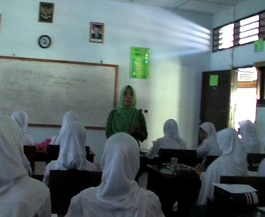
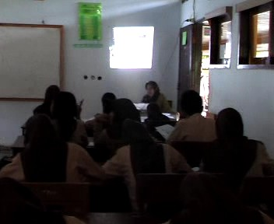

The teacher gave the topic and posed a question based on the topic “Update and Upgrade Secretary”
Monday, March 7th, 2011
The teacher explained the using of Auxiliary Verbs, and gave them new vocabularies, and pronunce them together.
Wednesday, March 2nd, 2011

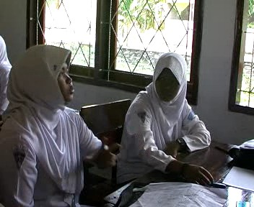
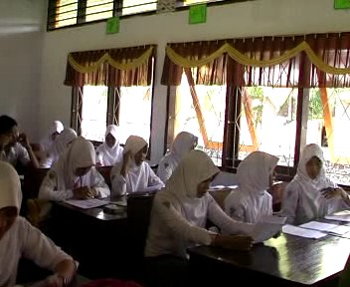

The students were discussed something in pairs
The students were thinking

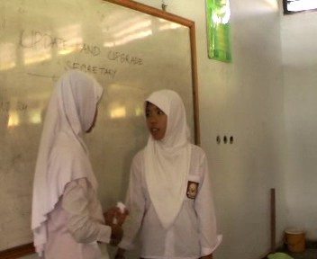
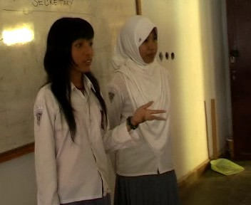
The Pair discussed to find answer
The students Shared
Appendix 25. Table of Observation Result of Cycle 3
No | Students’ Code | Aspects Observe |  |  |  |  |  | Total Score | % | Students’ Participation Criteria
No | Students’ Code | I | II | III | IV | V | VI | Total Score | % | Students’ Participation Criteria
1 | L_01 | 1 | 1 | 1 | 1 | 1 | 1 | 6 | 100 | A
2 | L_02 | 1 | 1 | 1 | 1 | 1 | 1 | 6 | 100 | A
3 | L_03 | 1 | 1 | 1 | 1 | 1 | 1 | 6 | 100 | A
4 | L_04 | 1 | 1 | 1 | 1 | 1 | 1 | 6 | 100 | A
5 | L_05 | 1 | 1 | 1 | 1 | 1 | 1 | 6 | 100 | A
6 | L_06 | 1 | 1 | 1 | 1 | 0 | 0 | 4 | 67 | D
7 | L_07 | 1 | 1 | 1 | 1 | 1 | 0 | 5 | 83 | B
8 | L_08 | 1 | 1 | 1 | 1 | 1 | 1 | 6 | 100 | A
9 | L_09 | 1 | 1 | 1 | 1 | 1 | 0 | 5 | 83 | B
10 | L_10 | 1 | 1 | 1 | 1 | 1 | 1 | 6 | 100 | A
11 | L_11 | 1 | 1 | 1 | 1 | 1 | 1 | 6 | 100 | A
12 | L_12 | 1 | 1 | 1 | 1 | 1 | 0 | 5 | 83 | B
13 | L_13 | 1 | 1 | 1 | 1 | 1 | 1 | 6 | 100 | A
14 | L_14 | 1 | 1 | 1 | 1 | 1 | 1 | 6 | 100 | A
15 | L_15 | 1 | 1 | 1 | 1 | 1 | 1 | 6 | 100 | A
16 | L_16 | 1 | 1 | 1 | 1 | 0 | 0 | 4 | 67 | D
17 | L_17 | 1 | 1 | 1 | 1 | 1 | 1 | 6 | 100 | A
18 | L_18 | 1 | 1 | 1 | 1 | 1 | 1 | 6 | 100 | A
19 | L_19 | 1 | 1 | 1 | 1 | 1 | 1 | 6 | 100 | A
20 | L_20 | 1 | 1 | 1 | 1 | 1 | 0 | 5 | 83 | B
21 | L_21 | 1 | 1 | 1 | 1 | 1 | 1 | 6 | 100 | A
22 | L_22 | 1 | 1 | 1 | 1 | 0 | 1 | 5 | 83 | B
23 | L_23 | 1 | 1 | 1 | 1 | 1 | 1 | 6 | 100 | A
24 | L_24 | 1 | 1 | 1 | 1 | 1 | 1 | 6 | 100 | A
25 | L_25 | 1 | 1 | 1 | 1 | 1 | 1 | 6 | 100 | A
26 | L_26 | 1 | 1 | 1 | 1 | 1 | 1 | 6 | 100 | A
27 | L_27 | 1 | 1 | 1 | 1 | 1 | 1 | 6 | 100 | A
28 | L_28 | 1 | 1 | 1 | 1 | 1 | 1 | 6 | 100 | A
29 | L_29 | 1 | 1 | 1 | 1 | 1 | 1 | 6 | 100 | A
30 | L_30 | 1 | 1 | 1 | 1 | 1 | 0 | 5 | 83 | B

No | Students’ Code | Aspects Observe |  |  |  |  |  | Total Score | % | Students’ Participation Criteria
No | Students’ Code | I | II | III | IV | V | VI | Total Score | % | Students’ Participation Criteria
31 | L_31 | 1 | 1 | 1 | 1 | 1 | 1 | 6 | 100 | A
32 | L_32 | 1 | 1 | 1 | 1 | 1 | 1 | 6 | 100 | A
33 | L_33 | 1 | 1 | 1 | 1 | 1 | 1 | 6 | 100 | A
34 | L_34 | 1 | 1 | 1 | 1 | 1 | 1 | 6 | 100 | A
35 | L_35 | 1 | 1 | 1 | 1 | 1 | 1 | 6 | 100 | A
36 | L_36 | 1 | 1 | 1 | 1 | 1 | 1 | 6 | 100 | A
Sum |  | 36 | 36 | 36 | 36 | 33 | 29 | 206
Percentage |  | 100 | 100 | 100 | 100 | 91.67 | 80.56 | 572.22
Note:
I. Paying attention to the teacher
II. Checking for understanding by individual thinking
III. Discussing opinion in pairs
IV. Encouraging to share opinion to the other
V. Able to speak with their own words
VI. Interaction in asking and answering questions

Score
1 | Involved
0 | Not Involved

Criterion of Students’ Participation
A | 90 – 100% | Excellent level of participation
B | 80 – 89% | High level of participation
C | 70 – 79% | Satisfactory level of participation
D | 69% or below | Low level of participation
Gorontalo, March, 2011
The Observer,

Nur Endah Hawayanti

The Observer’s Notification: All of the students have self-confidence to speak in front of the class, participated in all activities, and able to speak with their own words, even sometimes they just like tried to remember the words when they had to speak.

Appendix 26. The Teacher’s Observation Sheet in the Third Cycle

Developed from : Mozkowitz (in Alwright et al., 1991: 204)
The Aspects Observe | Description | Yes (√) | No (√)
Pre-Activities | Opening activities by greeting and giving motivation | √
Deals With Feelings | Accepting, discussing, referring to, or communicating understanding feelings of students | √
Encourages | Encouraging students to continue, trying to give them confidence, confirming answers are correct | √
Uses Ideas of Students | Claryfing, using, interpreting, summarizing the ideas of students. the ideas must be rephrased by the teacher but still recognized as being student contribution. | √
Repeats Students’ response | Repeating the exact words of students after they participate. | √
Ask questions | Asking questions to which an answer is anticipated. | √
Gives information | Giving information, facts, own opinion or ideas, lecturing, or asking rhetorical questions. | √
Correct without rejection | Telling students who have made a mistake the correct response without using words or intonations which communicate criticsm. | √
Gives directions | Giving direction, requests, or commands which students are expected to follow.  Giving statements which students are expected to repeat exactly, to make substitution (substitution drills), or to change from one form to another (transformation drills) | √
Criticizes the students’ behaviour | Rejecting the behaviour of students; trying to change the non-acceptable behaviour; communicating anger, displeasure, annoyance, dissatisfactory with what students are doing. | √
Criticizes student response | Telling the student his response is not correct or acceptable and communicating by words or intonation criticism, displeasure, annoyance, rejection | √
Conclude the material | Conclude all the material learns at the end of teaching learning process. | √

Appendix 27. The Oral Proficiency Score for Third Post-Test

No | N A M E | Elements in Speaking |  |  |  |  |  | Score | Level | Learning Achievement | Note
No | N A M E | I | II | III | IV | V | VI
1 | Zaenuddin | 3 | 4 | 4 | 4 | 4 | 4 | 23 | 3+ | 77 | Passed
2 | Zulfiady M. | 4 | 5 | 4 | 4 | 5 | 4 | 26 | 4+ | 87 | Passed
3 | Almi S. Harun | 4 | 4 | 4 | 5 | 4 | 4 | 25 | 4+ | 83 | Passed
4 | Arina A. Kasim | 4 | 4 | 4 | 4 | 4 | 4 | 24 | 4 | 80 | Passed
5 | Astrid Blongkod | 4 | 3 | 4 | 4 | 5 | 3 | 23 | 3+ | 77 | Passed
6 | Israyanti Tamuu | 3 | 4 | 4 | 4 | 4 | 4 | 23 | 3+ | 77 | Passed
7 | Elmi S. Harun | 4 | 4 | 5 | 4 | 5 | 4 | 26 | 4+ | 87 | Passed
8 | Fahriani Halidu | 3 | 4 | 4 | 4 | 4 | 4 | 23 | 3+ | 77 | Passed
9 | Faradila Pou | 3 | 4 | 4 | 3 | 4 | 3 | 21 | 3+ | 67 | Not Passed
10 | Febrianty Moha | 4 | 5 | 4 | 5 | 4 | 4 | 26 | 4+ | 87 | Passed
11 | Feronika Ridwan | 4 | 5 | 4 | 4 | 4 | 4 | 25 | 4+ | 83 | Passed
12 | Fitri Yusuf | 4 | 4 | 4 | 4 | 4 | 3 | 23 | 3+ | 77 | Passed
13 | Friska D. Djafar | 5 | 5 | 5 | 5 | 5 | 4 | 29 | 4+ | 97 | Passed
14 | Herny Noho | 4 | 4 | 5 | 5 | 5 | 4 | 27 | 4+ | 90 | Passed
15 | Hesti Isa | 4 | 4 | 4 | 4 | 4 | 3 | 23 | 3+ | 77 | Passed
16 | Israwaty Rauf | 3 | 4 | 4 | 4 | 4 | 4 | 23 | 3+ | 77 | Passed
17 | Masita F. Yasin | 3 | 4 | 4 | 4 | 4 | 4 | 23 | 3+ | 77 | Passed
18 | Nahrisa L. | 4 | 3 | 4 | 4 | 5 | 3 | 23 | 3+ | 77 | Passed
19 | Nitawati Djasri | 4 | 5 | 5 | 5 | 4 | 4 | 27 | 4+ | 90 | Passed
20 | Nurain Abudi | 4 | 4 | 4 | 4 | 4 | 3 | 23 | 3+ | 77 | Passed
21 | Oliviya O. Taha | 4 | 5 | 4 | 4 | 5 | 4 | 26 | 4+ | 87 | Passed
22 | PuspitaSari Hayati | 3 | 4 | 4 | 4 | 5 | 3 | 23 | 3+ | 77 | Passed
23 | Ria S. Ishak | 4 | 4 | 4 | 4 | 4 | 3 | 23 | 3+ | 77 | Passed
24 | Rizka Limonu | 3 | 4 | 5 | 4 | 5 | 4 | 25 | 4+ | 83 | Passed
24 | Silvie L.Mohamad | 5 | 4 | 5 | 5 | 5 | 4 | 28 | 4+ | 93 | Passed
26 | Sintiya D.Djunubi | 4 | 5 | 5 | 5 | 4 | 4 | 27 | 4+ | 90 | Passed
27 | Siska Mohamad | 4 | 5 | 5 | 5 | 4 | 4 | 27 | 4+ | 90 | Passed
28 | Sri A. Ladiku | 4 | 4 | 4 | 4 | 5 | 4 | 25 | 4+ | 83 | Passed
29 | Srinovanti b. M. | 4 | 4 | 4 | 4 | 4 | 3 | 23 | 3+ | 77 | Passed
30 | Sunarty Djaini | 4 | 4 | 4 | 3 | 5 | 3 | 23 | 3+ | 77 | Passed

No | N A M E | Elements in Speaking |  |  |  |  |  | Score | Level | Learning Achievement | Note
No | N A M E | I | II | III | IV | V | VI
31 | Susan T. Sako | 4 | 5 | 4 | 4 | 4 | 4 | 24 | 4+ | 83 | Passed
32 | Tirta Yunus | 4 | 5 | 5 | 4 | 4 | 4 | 26 | 4+ | 87 | Passed
33 | Irmawaty Husain | 5 | 5 | 5 | 5 | 4 | 4 | 28 | 4+ | 93 | Passed
34 | Yayu R. Ngiu | 3 | 4 | 4 | 3 | 4 | 3 | 21 | 3+ | 67 | Not Passed
35 | Yuliyanti Idrus | 3 | 4 | 4 | 4 | 4 | 4 | 23 | 3+ | 77 | Passed
36 | Yunita Mahajani | 3 | 4 | 4 | 4 | 4 | 3 | 22 | 3+ | 67 | Not Passed
Sum |  | 136 | 153 | 154 | 150 | 156 | 132 | 880 |  | 2941
Average |  | 3.78 | 4.25 | 4.28 | 4.17 | 4.33 | 3.67 | 24.44 |  | 81.69
Note:
- Grammar
- Vocabulary
- Comprehension
- Fluency
- Pronunciation
- Task
The students’ Achievement = $\frac{The Students^{'}Total Score}{Maximum Score}X100\%=$

Number | Speaking Evaluation’s Aspects | Maximum Score
1 | Grammar | 5
2 | Vocabulary | 5
3 | Comprehension | 5
4 | Fluency | 5
5 | Pronunciation | 5
6 | Task | 5

Gorontalo, March 2011
The Writer The English Teacher

Nur Endah Hawayanti Yulin Mudi, S.Pd
NIP. 19760108 200501 2 019

Appendix 28. The Example of Analysis of the Third Test
The name of student: FRISKA DEVITA DJAFAR
Grammar | Vocab. | Comp. | Fluency | Pronunciation | Task | Total Score | Level | Achievement
5 | 5 | 5 | 5 | 5 | 4 | 29 | 4+ | 97

- (Point to the both pictures) Who are they?
The content analysis : the answer is relevant
Her answer : #.1 The first picture, # she is a secretary, # and the second picture, they are secretary and manager.

- (Point to the both pictures) What are they doing?
The content analysis : the answer is relevant
Her answer : The first picture,# she is # typing something, and the second picture, they are discussing something about upgrade and update secretary.

- (Point to the Right picture) What topic do they discuss about? Please, explain why the secretary should be like that.
The content analysis : the answer is relevant
Her answer : a# They discuss about update and upgrade secretary. Mm#.1 I think the secretary must update and upgrade information because to expedite the job.

- Do you know why the secretary needs to update the information? Please explain your reason.
The content analysis : the answer is relevant
Her answer : Yes, I know. #.2 yes, I do. I think the secretary should up:: update the information, to support , to support the activities of the office, and I think the secretary must update the information to help the development of the company. And others information that #.1 important for secretary.
Wrong pronunciation : [sʊpɔ:’t]
The right pronunciation : [səpɔ:’t]

- (Point to the left picture) Do you think, she needs to upgrade her ability? Please explain your reason
The content analysis : the answer is relevant
Her answer : Yes, of course. I think she must upgrade her ability, because for expedite a job, and supo:: and support the activities of the office, and she must follow the # the development of techno:: technology. So, she must use computer now and not typewriter, because use computer is faster than #.1 use typewriter.

