MISSPELLING, MARKETING STRATEGY, OR COUNTER HEGEMONY?
The Language Usage on Public Sphere as Portrayed on Kepeleset

Prihantoro
Universitas Diponegoro
prihantoro2001@yahoo.com

Abstract

This paper aims on describing brands of some Indonesian local products, advertorials, and banners documented on a booklet entitled Kepeleset. Some of the local brands in this book resemble other imported or well known brands. This book actually aims on entertainment purpose of language usage on public sphere; however, there are some patterns that can be derived. In this paper, I will show how they are derived by a Skeleton Model. Some of the brands are reproduction from the original product with linguistic modification. Intended misspelling is often a strategy to avoid copyright issues of the original brand. Some products maintain the original brand, but assign it on totally different products, for instance: mobile phone brand for sandals. This book also documented incorrectly spelled expressions on banners and advertorials, especially those borrowed from English. Some of them are unintended, but some others are wrongly spelled to resemble the original product. When unintended, it might be caused by the orthographical representation of sound perception by Indonesian phonemic resource. Most of the modified brand names are considered errors in the original language. This can be considered an intended error. However, in the target language, it can be considered an effort to adjust with the target language linguistic features. Further, it can be analysed as a counter hegemony over west-origin imported product.
Keywords: Intended misspelling, counter hegemony, public sphere, language use.
- INTRODUCTION
The usage of language on public sphere is always an interesting issue to discuss. As for this research, I observe a documentation entitled Kepeleset (Regina, 2009). It is actually a not-too-serious book that documented language usage (with image) on public sphere that is considered improper (but humorous to some extent). For instance, the documentation includes some brands (or fake brands) that resemble the existing brands. Consider table 1:
Table 1. Existing and Fake Brand
Existing Brand | Fake Brand
Guess | Reguess
Adidas | Aridas
Sprite | Seprit
Lanvin | Lanin
Eagle | Eagel

In this paper, I convert the data from the printed form to digital text. The digital data is then categorized into brands of the same products, brands of different products and languages on public facilities. Another categorization of the same data is made to identify the gaps between the proper and the improper ‘language usage’. From the finding on brands, I can derive a so called -Skeleton Model- to show how the fake brand is derived from the existing brand. I also argue that the modelling is influenced by the first language -interference of L1-, for instance, seprit that derives from sprite is interfered by Indonesian phonotactic. I will also present my argument that the fake brand is an intended misspelling, and used as a marketing strategy to counter the hegemony of the existing brand as the domestic brand seems to be so powerless against the foreign/imported brand.

- MISSPELLING, MARKETING STRATEGY, OR COUNTER HEGEMONY

When a new product is launched to compete with already existing product, another brand is labelled to avoid copyright problem. For instance, to compete with the other well known brands like Samsung, LG, Acer and etc, a new brand ‘Advan’ is launched. The products are the same; smartphone, laptop, and PC. As for this paper, there are some products where the item is the same, but the brand is different (people are quite aware of the resemblance). Consider figure 1:
Figure 1. Guess and Reguess
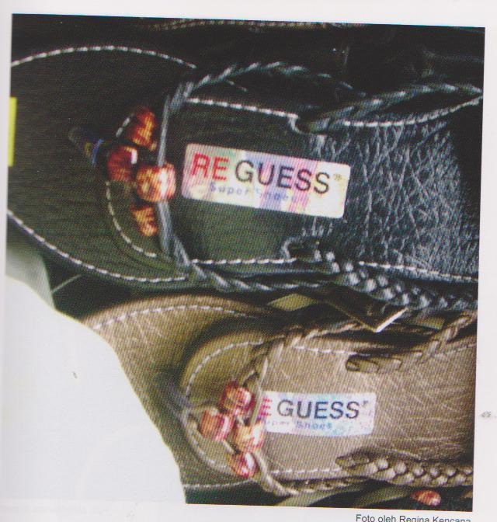

The products on figure are same to the original, but the brands are just similar. Another phenomenon is the similar brand that refers to different product. For instance, NOKIA is a brand for mobile phones, but there is another product (that is not mobile phone) labelled by NOKIA. Some jeans are labelled with ROLEX (watch), Braun Buffel (handbag), MERCEDEZ BENZ (car). Consider figure 2:
Figure 2. ROLEX for Jeans
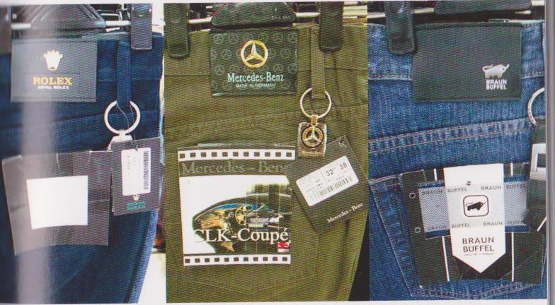

The motivation that drives the creation of these brands are not merely marketing, it is also a strategy to counter the hegemony, or the dominance, of the well known import brands. Consider SPRITE, an American dominating soft-drink. The creation of the brand, SEPRIT (the same product), was meant to compete with that. MISSONI is a famous, high class, fashion house. MISSANI, documented in Kediri, is a brand for a bag, the same product that MISSANI issue. Although most of so called fake brands are imported, but there are some domestic brand as well. One of them is TARA, a fake brand which is meant to compete with TARO, a well known snack food from Unilever.
There are also some of brands, where it is not the same like the original and the product is also different. They however have few, or at least one thing, in common. One of the examples is Mc.Errot, a liquid fertilizer for tuber-like plants (such as cassava, beet, potato and etc). This product is designed to grow the plant bigger and faster. The brand, however, resemble Mak Erot, a well-known alternative (non-medic) clinic that offers solution to overcome male impotency. The two products have at least one thing in common which is to grow one ‘particular section’ of the target bigger in relatively faster time than any other product. In this case, it is purely a marketing strategy. By using this, the designer expects that people will see the resemblance, make the analogy to the same reference (of making bigger, in relatively faster), a comedy effect is created and finally buy the product. Consider the visualization in figure 3:
Figure 3. Mc. Errot and Mak Erot
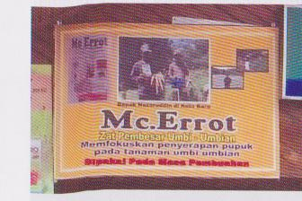
About the fake brands with different products, they are not meant to compete on the same segment. In this case, it can be considered as a pure marketing strategy. Consider NOKIA, which is a mobile phone brand, but used for sandals. AIR MAX, one of the Nike’s derivate products is labelled for mineral water. There are some effects that the creators of these brands want to achieve. The first one is a memory effect. By using the already existing brand, the creators expected that people will easily remember the brand. The second one is a comedy effect, where the same brand refers to different product.
These brands have a clear segmented market. They are not meant for high-class segment with affordances to purchase the original one. It is aiming for medium-low segment who cannot afford to buy the original product. This medium low is one level below the high segment, and they are a step closer (or not so close) to achieving that. They are not financially ready for that, but they want to behave like ones. So using the fake brand is one of the feasible options.
In section three, I will show that the selection of these brands and some of the forms of language usage in public sphere is not random. They are the result of the interference of the first language (L1) which is Indonesian. In section four I will show that the patterns can be mapped by using a Skeleton Model.
- INTERFERENCE
Interference is the cause why ‘interlanguage’ takes place. This term roots from second language learning, where learners’ second language module is not fully operational, and somehow they still use the partial patterns of the first language (Coetsem, 1988 and Brown, 2005) or the language (s) that they master before. Consider some of the linguistic features of English that do not exist in Indonesian such as plural marker or subject agreement morpheme. In Indonesian, these two are most frequently left for a beginning English learner. Consider also the dropping of the article as it does not exist in Indonesian.
Interference can take place on different levels, from phonology, syntax, semantics and etc. In the documentation, most of the interferences are caused by the phonological adaptation of imported brand to the fake Indonesian brand. One of the instances is SPRIT to SEPRIT.
The preference for SEPRIT is phonological. It does not preserve the syllable, where one syllables [sprait] is turned to two [sə.prit]. It does however, to some extent, complies with the Indonesian phonotactic, particularly consonant clusters (Chaer, 2009 and Alwi, et al 1998). Instead of syllabifying [sprait] to [sp.rit] (which is not possible [sp]), it gives a schwa [ə] after the initial sound and create a syllable boundary, hence dividing [sə] with [prit], and avoiding [sp] as syllable nuclei. Consider table 2:

Table 2. Candidates and Preference Consideration
Candidate | Consideration
[sə.prit] | Minimum insertion  Near to the number of original syllable
[spə.rit]* | The cost of [sp] is higher than [pr]
[sə.pə.rit]* | Too many syllables
Table 2 shows some reasons why some candidates are unacceptable, and why a candidate is selected. If you look at the selected candidate, it tolerates deviation from the original, but it has to be the least costly over the others (for further explanation, see Prince & Smolensky, 2004). To some extent (perhaps a large one), phonology has the impact to orthography. There are some foreign words, and when it is ORTHOGRAPHICALLY written in Indonesian IN THIS DATA, they reflect the phonological interference. But some others, to some extent, show a serious perception problem as presented by table 3:
Table 3. Gaps between the original/standard version and the data
Foreign [with IPA transcription] | Standard (KBBI if any) | Data
Spaghetti [spəˈget.i] | Spageti | Sepageti, Pasgeti
Welcome [wel.kəm] | - | Well come
Cafe [kæf.eɪ] | cafe | kafe
Hot dog [hɒt.dɒg ] | - | Hot dok
Family [fæməli] | - | Fimly
Flying [flaɪ.ɪŋ] | - | Flaying
Shirt [ʃɝːt ] | - | Shert
Best compilation [kɒm.pɪˈleɪ.ʃ ə n ] | - | Best Complication
Washbowl [wɒʃ boʊl ] | wastafel | fistafel
Laptop [læp.tɒp ] | laptop | Lettop
Pure Juice [pjʊr dʒuːs] | - | Pyur Jus
Flashdisk [flæʃ dɪsk ] | - | plestis
Frame [freɪm ] | - | frem
Perfume [pɝːˈfjuːm ] | parfum | farfum
The interference is shown by the orthographical representation in Indonesian that resembles the phonetic transcription in English, such as Flying [flaɪ.ɪŋ] flaying, Shirt [ʃɝːt ] Shert, and Pure Juice [pjʊr dʒuːs] Pyur Jus. Sometimes, phonotactic adaptation also takes place. One of the examples is the adaptation of Spaghetti [spə.ˈge.ti] to Sepageti [sə.pa.gɛ.ti]. The syllables have improved to four as they avoid consonant cluster [sp]. Perception problem is also shown by the production of the orthographical form. Hot Dok is one of the examples where listeners failed to hear the final sound [g] correctly in Hot dog [hɒt.dɒg ]. Some perception problem seems to be serious such as Fistafel (from Wastafel) and Best Complication (from Best Compilation).
- SKELETON MODEL
The term –Skeleton- model actually derives from Semitic Mode in the corpus processing tool that is used for corpus processing, Unitex (Paumier, 2008). In the Semitic mode, the root of Semitic languages such as Arabic is considered as consonantal skeleton. The skeleton then is inflected to create the inflected form. Therefore a root <ktb> can be inflected to generate these forms <kitab>, <katib>, <yakatobu> and etc. Note that the root is expressed by the boldfaced characters. This model can apply to some brands. Consider table 4:
Table 4. Original Product, Root, and Fake Brand
Original | Root | Fake Brand(s)
polo | pl | pqlq
bucherry | bbr | buberry
sprite | sprt | Seprit
Eagle | egl | eagel
Calvin Klein | clvn | calven
hugo boss | hg | hogo
missoni | mssn | missani
adidas | ads | adilas/adidos/aridas
taro | tr | tara
Table 4 indicates the original brand, root and fake brand. The root list mostly consists of consonants. The vowels are removed. The roots then inflected by inflectional graph, creating fake brands. Note that there are more than one fake brand is possible to create. Figure 4 describes the inflection of root <ads> creating some fake brands such as <adilas>, <adidos>, and <aridas>.
Figure 4. Inflectional Graph and Possible Inflected Forms
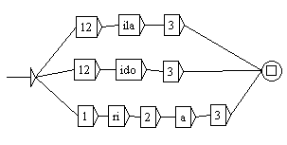

Figure 4 shows an inflectional graph to inflect <ila>, <ido> and <ria> to <ads> root, creating <adilas>, <adidos>, and <aridas>. This shows that the fake brands do not derive randomly. There are patterns that can be derived from the fake brands. By using this model, it is possible to create other combination; hence, other fake brands.
- CONCLUSION
In this paper, I have shown that there are a number of essential linguistic features conceived by brands and the usage of language in public sphere instead of its –comedy effect-. The data has shown some gaps to the original items as a result of L1 interference, some due to perception problem that generate wrong. Particularly for fake brands, the variants of the origin can be modelled by Skeleton Model. Lastly, the phenomena also indicate marketing strategy plus a counter hegemony to dominating (mostly) foreign brands.

REFERENCES
Alwi, H., Dardjowidjojo, S., Lapoliwa, H., & Moeliono, M. (1998). Tata Bahasa Baku Bahasa Indonesia (3rd Edition). Jakarta: Balai Pustaka.
Brown, D. (2005). Principle of Language Teaching and Learning (5th Edition). United States: Longman.
Chaer, A. (2009). Fonologi Bahasa Indonesia. Bandung: Rhineka Cipta Press.
Coetsem, F.-V. (1988). Loan Phonology and Two Transfer Types in Language Contact. Amsterdam: Foris Publication.
Flege, J.-E. (1995). Second language speech learning: Theory, findings, and problems. Speech perception and linguistic experience: Issues in cross-language research , 233-277.
Paumier, S. (2008). Unitex Manual. Paris: Universite Paris Est Marne La Valee & LADL.
Prince, A., & Smolensky, P. (2004). Optimality Theory: Constraint Interaction in Generative Grammar. United Kingdom: Blackwell Publishing.
Regina, K. (2009). Kepeleset. Jakarta: Gramedia.
Traboulsi, H. (2009). Arabic Named Entity Extraction: A Local Grammar Based Approach. Proceedings of the International Multiconference Science and Information Technology (pp. 139-143). Mragowo, Poland: Polish Information Processing Society.

The term ‘counterhegemony’ can be defined in several ways from politics, culture, to education. In this paper, hegemony refers to the domination of several (mostly) foreign brands. And counter hegemony is the act to against the domination. As for this paper, it is done by several domestic brands.

