Facebook as Cultural Representation of Post-Industrial Society
Arido Laksono
English Department, American Studies Section, Diponegoro University

Abstract
Culture is generally perceived as the collection of ideas and habits transmitted from generation to generation (Linton in Haralambos and Heald, 1980). It determines the characteristics of a certain group of people. In a post-industrial era, technology holds an important role as the medium to develop culture. Here, information technology is the key to the advancement of a society. The emergence of Facebook has given a space for those who cannot express their self-existence. Eventually, it creates a special social context among the users. Thus, Facebook presents a cultural contestation against the traditional concept of communication. The way viewers give comment or click on the thumb symbol portrays their cultural representation.

Key words: culture, representation, Facebook, social context

Introduction
The emergence of various social media like Friendster, MySpace, Hi5, Facebook, and Twitter has recently influenced the life styles of those who work with computer and internet connection in their daily activities. It is now part of an “early bird” routine before office hour starts. Some say they can re-connect their long lost relationship with friends from the secondary schools or distant relatives of their great grandparents. While others believe that, the social media help them promote their business. However, apart from those ideal purposes, social media also paves the way to the practice of self-existence in which a person has the opportunity to “show” his/her ideal and expects recognition from other (friends). Here, Facebook is taken as an object of analysis to explore how cultural background is perceived and elaborated into social representation. Facebook is chosen since it offers features to the users to up load photos, create events, make group and establish free promotion medium. Besides, Facebook is the leader in online social networking with 1.2 billion members worldwide (Browser Media, Socialnomics, MacWorld, 2012)
The way a Facebook-er promotes his/her self is an interesting fact due to the reality she/he represents. A person may write a status, a real status of his/her life, or give a comment on his friends’ status and at the same time he/she establishes a “connection” with his/her friends and others. The “connection” here refers to social context occurred as the result of interpretation toward the chat shown on the wall. The more comments come up, the stronger a person’s desire increases to get involved in the forum. This is what Barker says as “representation is how the world is socially constructed and represented to and by us” (2000:8). The Facebook-ers construct new social representation every time a new status is written down.
The social representation describes how a person would like to be considered by his/her friends in the same group. This phenomenon is in line with Perttii Alasuutari’s statement that,”…all cultural products reflect society and everyday life...” (1995:25). Further, Haralambos and Heald write that “Culture therefore has two essential qualities: firstly it is learned, secondly it is shared” (1980:3). Here, Facebook has successfully influenced millions of people to share things that used to be considered private into a public space. It becomes a new subculture for groups of people with common needs and interests. Those who actively join facebook will up-date their status frequently and expect others to, at least, click the thumb symbol as an evidence of attention and sympathy. It is also common to read a few words of despair that might be considered ridiculous by certain people. Some also take good advantages from Facebook by advertising products or services since it is free and no tax is charged.
The facts that Facebook has replaced the old ways of greeting parents and relatives through telephone, the tradition of an intimate encounter between friends, the use of printed media advertisement and the acceptance of values once considered taboo are some of the challenging evidences of the cultural contestation among the users or members of Facebook in terms of cultural representation.

Cultural Representation as seen in the status written by the members of Facebook
Chris Barker in Cultural Studies: Theory and Practice explains that
Cultural representations and meanings have a certain materiality; they are embedded in sounds, inscriptions, objects, images, books, magazines and television programmes. They are produced, enacted, used and understood in specific social context (2000:8)

Facebook for the users is the representation of their specific social context. Activities that cannot be done in the normal daily life are represented in the status, comment, events and pictures appeared on Facebook. The meaning can only be understood by the circle of friends involved in the forum, though sometimes other viewers who do not belong to the group jump into the forum and give their comments on a certain topic.
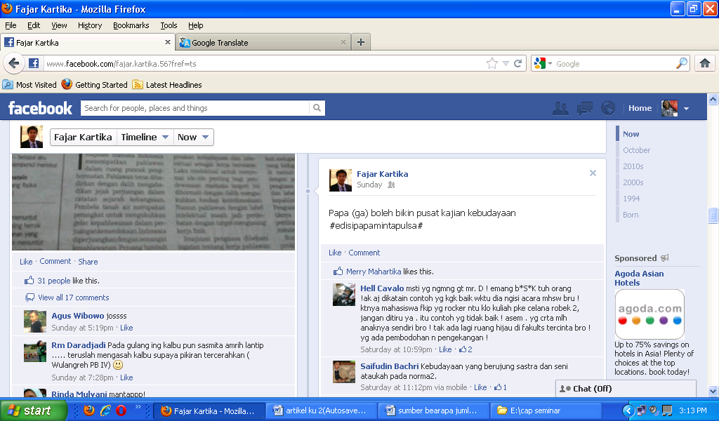

Transcript
Fajar Kartika
Papa (ga) boleh bikin pusat kajian kebudayaan
#edisipapamintapulsa#

[Papa (is not) allowed to establish Cultural Studies Centre]

Hell Cavalo
Msti yg ngmng gt mr. D! Emang b*s*k tuh orang!
Ak aj dikatain contog yg kgk baik wktu dia ngisi acara mhswa baru!
Ktnya mahasiswa yg rocker ntu klo kuliah pke celana robek 2,
Jangan ditiru ya. Itu contoh yg tidak baek! Asem. Yg crta mlh anaknya sendiri bro!
Tak ada lagi ruang hijau di fakkults tercinta bro!
Yg ada pembodohan n pengekangan!

[It must be Mr. D who said that. He is a f*#ck man! He said that I was not a good person, that’s when he gave speech to the freshmen. He said that rocker style student wearing torn jeans was not a good role model. He was not a good example. Shit! His son told me himself about it. There is no more green space here in our beloved faculty, Bro! It’s only ignorance and restraint here]
.
Saifudin Bachri
Kebudayaan yang berujung sastra dan seni
Ataukah pada norma2
[Culture that leads to literature and art, or norms)

The picture above is one of the status on Facebook, which represents special social context. The message can only be comprehended by the circle of friends. The user uses social networking but not a direct encounter with his friends because there must be things that prevent him from expressing his thought outspokenly. He feels secured in having intense dialogue with his friends. The status is produced and understood, and therefore, his goal is achieved.
The way Fajar Kartika says “Papa (is not) allowed to establish Cultural Studies Centre” is interesting since Papa refers to a relationship between a father, a wife and the children. Yet, the other person Hell Cavalo responses “It must be Mr. D who said that. He is a f*#ck man! He said that I was not a good person, that’s when he gave speech to the freshmen. He said that rocker style student wearing torn jeans was not a good role model. He was not a good example. Shit! His son told me himself about it. There is no more green space here in our beloved faculty, Bro! It’s only ignorance and restraint here” which I consider a special social context since Hell Cavalo mentions an initial Mr.D. It means that both speakers know what they are talking about. The question is who Hell Cavalo is since this person only uses nick name and this person greets Fajar Kartika with “Bro” which means they are close friend. Yet, Hell Cavalo writes that he feels unease when Mr.D says bad things about him which means Hell Cavalo may be a student. Then the third person joins the conversation and states “Culture that leads to literature and art, or norms”. It is Saifudin Bachri who writes such comment above and it is not clear whether he is a lecturer or a student. The complicated situation can only be understood by this group since they represent the same social context. Here, Facebook is used as a medium to share ideas, complaints, and criticism. Thus, the users tend to create a sub-culture as the representation of certain context they develop.
A different example of a status can also be seen below,
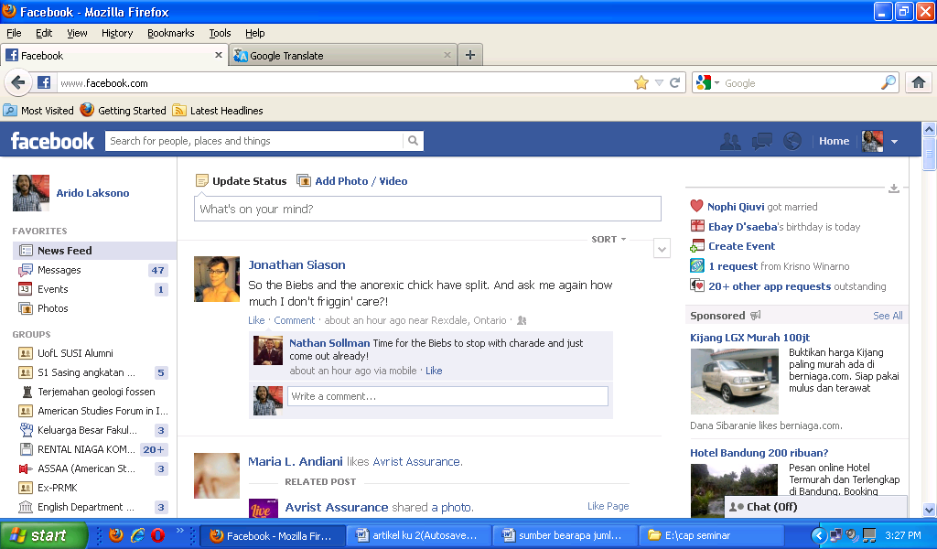
The status is written in English and the message conveyed is somehow difficult to understand. It needs further information to understand the status written on his account. Cultural representation is established among his friends, yet others are welcomed to give comment. The owner of this status prefers to express his thought and feeling on Facebook rather than to have a direct encounter with his friends. The circle of friends has established cultural representation and omitted the traditional way of communication.

Cultural Representation as seen in the pictures uploaded by the members of Facebook
It is not only a written status that establishes a cultural representation but also pictures that promote a certain social context comprehended by the users of Facebook.
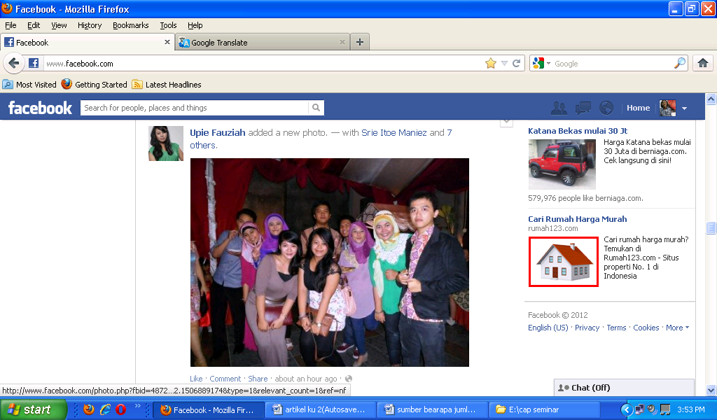
No one but the owner of the picture who understands the social context proposed in the picture. However, others can still ask the context of the picture by writing on the commentary space below the picture. Again, a social context is established to both the friends of the picture’s owner and others who do not belong to the group. Photo album is no longer important to keep pictures, and friends do not have to make a visit only to have a cup of tea and have a look on pictures.

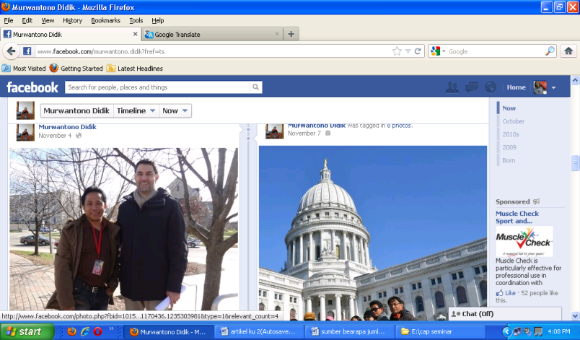
The owner of the picture does not need to explain anything. The setting of the picture has given a clear information on where it is taken. However, the message is unclear. The owner of the picture either invites us to ask questions or let us guess what he is doing there. A specific social context is developed to represent a certain cultural representation.

Cultural Representation as seen in the products uploaded by the members of Facebook
Nowadays, people tend to use Facebook in doing business. They advertise their products and use online trading without having to communicate orally. Market that used to be considered as a place to have business transcation has lost its function. A position in a company is not the only achievement for a fresh graduate. Online business has replaced the old way of selling and buying goods.
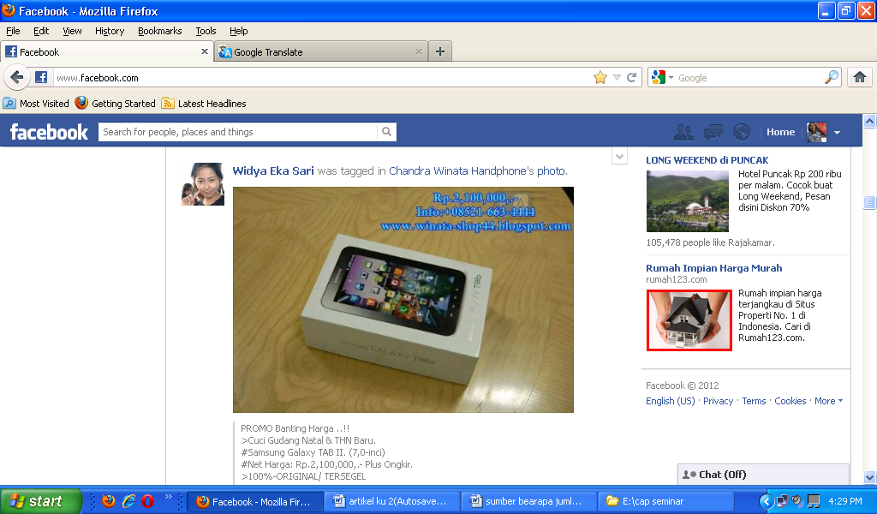

Cultural Representation as seen in events/organizations uploaded by the members of Facebook
Facebook is also used by prominent organizations or departments to promote their activities and events. It is an effective way to get attention from people around the world. Barker says that “meaning is produced in a variety of contexts” (2000: 8). The idea of using Facebook as a medium to disseminate programs, activities and information carries a certain meaning. The organizations or departments that upload information concerning their activities also have their own representation. They know the statistics of the users of Facebook and understand the benefit of uploading any information on Facebook. Shortly, the specific social context developed by those organizations is the representation of their policy in constructing perspectives and images toward society. The number of viewers clicking the thumb symbol can indicate public acceptance. The viewers can even contact the organization directly by writing on the comment or writing in the inbox. This surely is a smart technique of cultural representation in which the organization can gather information and input from the viewers fast and inexpensively.

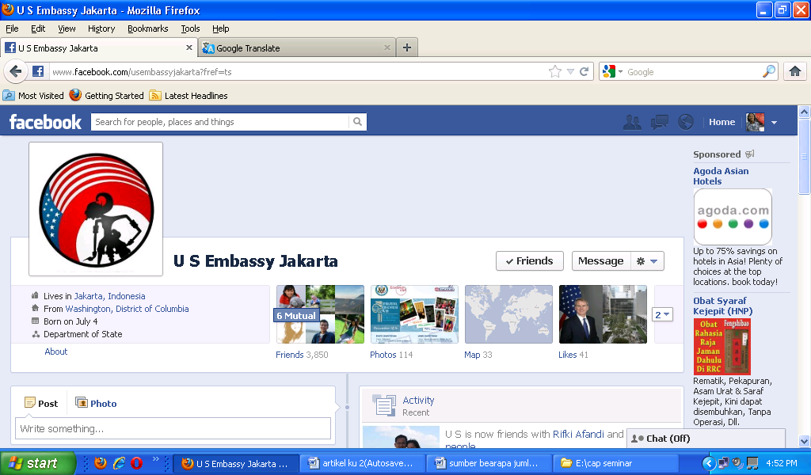

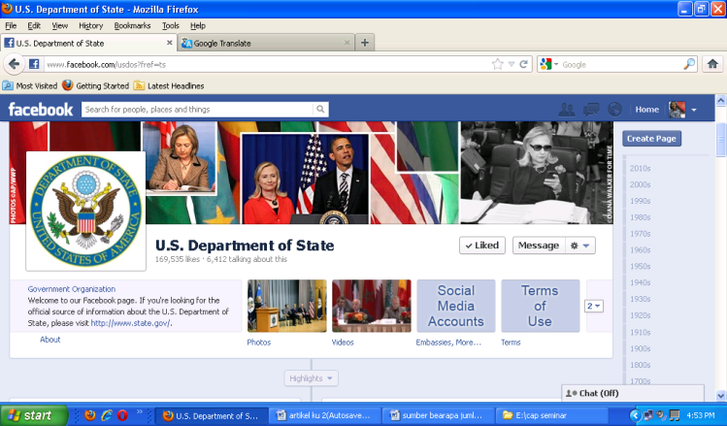

Conclusion
The emergence of Facebook has given special social context in terms of the uploaded status, pictures, products and events. Viewers have enjoyed the postindustrial culture in which information technology hold a very significant role in changing the old perspectives and ways of communication. The cultural representation embedded in the product of social networking services strengthens the fact that culture is evolving and updating its form. There is always an open possibility for the contestation of culture; however, the conclusion always comes to the representation of culture itself. Facebook has given evidences on how various interests blend into different group of people with one major point, cultural representation.

References
Alasuutari, Pertti. 1995. Researching Culture. Qualitative Method and Cultural Studies. London: SAGE Publications
Barker, Chris. 2000. Cultural Studies. Theory and Practice. London: SAGE Publications
Browser Media, Socialnomics, MacWorld. 2012. Last updated 11.12.2012. Downloaded 13 November 2012 at 11.30 a.m. http://www.statisticbrain.com/social-networking-statistics/
Haralambos, Michael and Robin Heald. 1980. Sociology. Themes and Perspectives.Slough: University Tutorial Press

